2. Building problem-solving skills

There are many ways to talk through problems. This structure shows one way.

With students, we read Jack Sprat and explore the nursery rhyme. Jack and his wife had that terrible problem – he didn’t want to eat fat meat, and she didn’t want to eat lean meat. We can see how they solved their problem, and that takes us to our own lives. We turn the reading into writing, now exploring how this may have happened in our own lives. Sandwiches with or without the crusts, cookie outsides/cookie fillings, donuts/donut holes. Students can talk through or write down their own win-wins, whether it’s about food or something else.

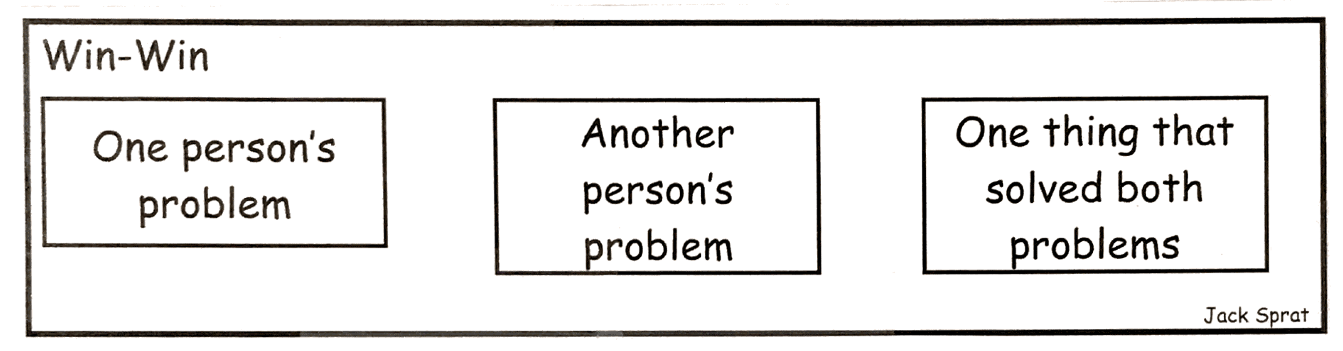

I like to hear music, but I don’t like to sing.
My sister likes to sing.
She sings to me on our road trips.

- Developing empathy
Essential to a civilized world is the ability to put ourselves into other people’s shoes. Many nursery rhymes offer us a chance to be curious about others and imagine their outlook.

For example, there’s Little Tommy Tucker. After we read it and enjoy the language, the rhythms, the silliness of it, we look again at the structure. We brainstorm with our students about times we have seem someone do something that made us curious.

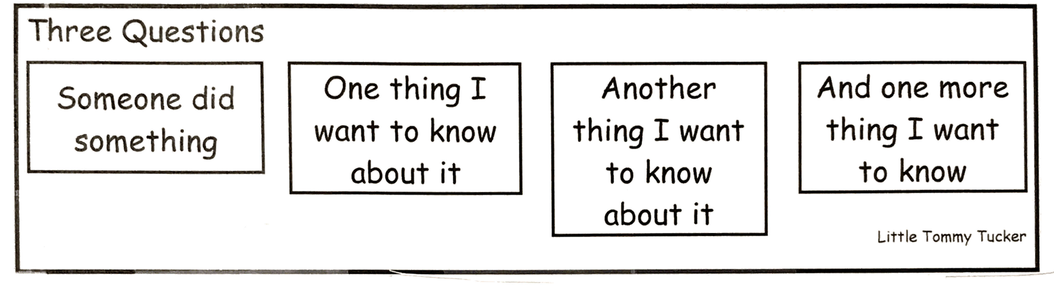

The lady at the drive-through window was laughing when she gave us our food.
What was funny?
Does she always have fun and laugh, even while she’s not at work?
Does she have laughing children?

