5 Ways that Nursery Rhymes Can Prepare Our Kids for Life
Gretchen Bernabei

For years, we have recognized the value of nursery rhymes, even beyond the treasure of lap-time entertainment: rhyme and rhythm can boost kids’ cognitive development; the rich language gives children vocabulary nuggets; children who know nursery rhymes become good readers. This information is not new.

But we are just beginning to see another powerful gift from nursery rhymes – in building young writers.

Using the structures from the nursery rhymes, we can show students how writers move from one point to another. It’s simple, it’s natural, and it’s fun. But these structures also acquaint students with a huge range of topics, giving them a wide variety of ways to use their words in many different situations. Here are a few examples.

- Naming feelings.

Many nursery rhymes deal with feelings that all children experience.

After reading and exploring the text from Old Mother Hubbard, for example, we brainstorm with students about their own disappointments: when the store didn’t have what they were looking for, when a movie wasn’t showing any more, when a restaurant was closed.

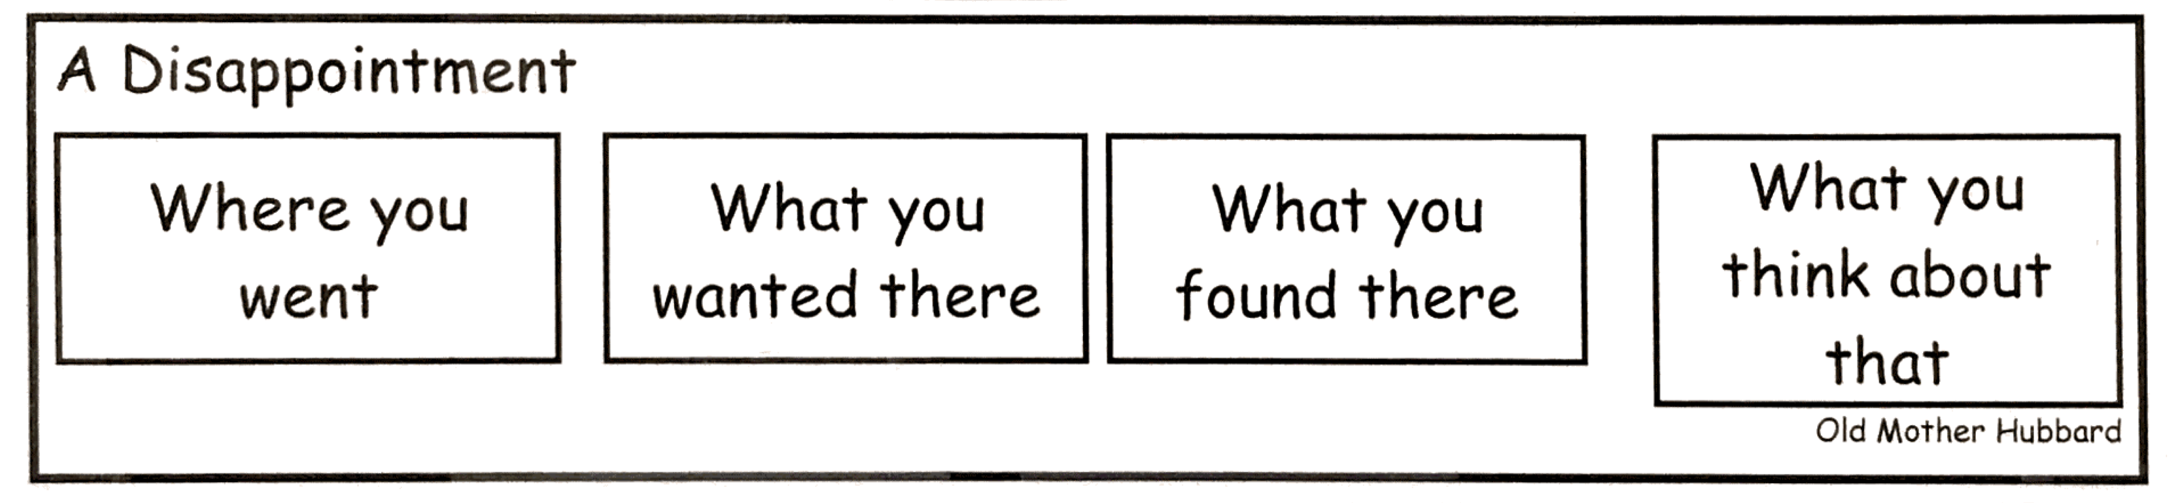

Then, making up one sentence for each of the boxes below, we have a tiny essay. A kernel essay, like this one:

We drove to the store.
My mom was didn’t going to buy me some black tennis shoes.
They didn’t have them in my size.
I felt so disappointed.

