Knights of Columbus
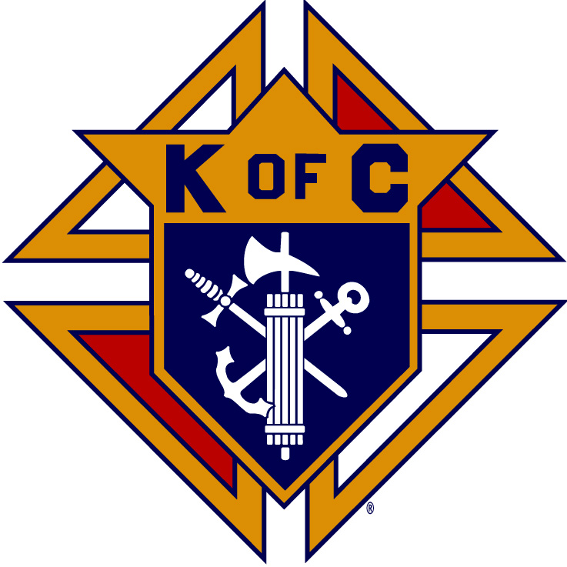

FREDERICKSBURG COUICIL No. 4034
P.O. Box 146
Fredericksburg, Virginia 22404

Conor Jerome Catholic Education Assistance Program
Scholarship Grant Application
Elementary School Student

Section 1. Background
The Conor Jerome Catholic Education Assistance Program (CJCEAP) is a need-based scholarship grant program developed and administered by Fredericksburg Council #4034 of the Knights of Columbus. The purpose of the program is twofold:
- To give deserving students the financial means to continue their Catholic school education, and
- To provide financial assistance in the form of grants to families who, because of financial difficulties, are unable to fully pay the current year’s tuition at Holy Cross Academy, Fredericksburg, VA.
The dollar value of the grants to be awarded under this program is between $1,000.00 and $2,000.00. The dollar value of each grant will depend on the number of grants that are awarded. Grants are for the current academic year only. Families may reapply for grants in succeeding academic years if financial difficulties persist or recur.
This program does NOT provide financial assistance for students enrolled in the Saint Mary of the Immaculate Conception Parish Religious Education Program.

Section 2. Eligibility
For a student and family to be eligible for consideration, the following criteria must be met:
- The family must be active parishioners registered with St. Mary of the Immaculate Conception Catholic Church in Fredericksburg, VA.
- The student must be attending Holy Cross Academy, Fredericksburg, VA.
- The family must demonstrate financial need.
- The student must demonstrate a potential for academic success.
- Parent(s) must volunteer/help at Holy Cross Academy.
Section 3. Grant Application Procedure
Parents must complete the enclosed Grant Application Form. Use the back of the form if additional space is needed to answer specific questions. If the back of the form is used, please indicate which question the additional information pertains to. Failure to use the Grant Application Form or provide requested information will result in rejection of the application.

Grant applications should be placed in an envelope marked CJCEAP – CONFIDENTIAL and mailed (postmarked) no later than Tuesday, September 30, 2019 to:

Fredericksburg Council #4034
ATTN: CJCEAP Scholarship Grants
Post Office Box 146
Fredericksburg, VA 22404

The information provided by the family will be reviewed by a Council committee to determine the eligibility of the student. All information provided will be held in strict confidence.

All families submitting grant requests will be notified by mail whether their grant request submissions were approved by October 30, 2019.

Scholarship grants awarded under this program are paid directly to Holy Cross Academy.

CJCEAP Scholarship Grant Elementary School Application Form
- Name, age and grade of the student: ____________________________________________
- Name(s) of parent(s): _________________________________________________________
- Names and ages of other dependent children: _____________________________________
___________________________________________________________________________
- Circumstances leading to family’s financial need (use back of form if more space is needed): ___________________________________________________________________________
___________________________________________________________________________
___________________________________________________________________________
___________________________________________________________________________
__________________________________________________________________________
- List the leadership positions held by the student: ___________________________________
___________________________________________________________________________
___________________________________________________________________________
___________________________________________________________________________
- List the student’s parish and school extracurricular activities: _________________________
___________________________________________________________________________
___________________________________________________________________________
___________________________________________________________________________
___________________________________________________________________________
- The parent(s) involvement with St. Mary’s Parish and Holy Cross Academy:______________
_________________________________________________________________________________________________________________________________________________________________________________________________________________________________
- Any additional information you deem appropriate for consideration: :__________________
_________________________________________________________________________________________________________________________________________________________________________________________________________________________________
In addition to the above information, please provide the following documentation:
- Proof that the family meets the school’s criteria for financial aid (a copy of the current school year (FACTS certification).*
- A copy of the student’s report card from previous school year.
- This application must be postmarked no later than September 30, 2019.

Parent’s Signature Date
* Holy Cross Academy will provide verification that the family has applied for financial aid through FACTS Grant & Aid and meets the school’s criteria. Parents should not submit any financial information with this application.

