The March 2025 CC’22 Status Summary shows the prioritized project list and estimated cost breakdown. This spreadsheet is being used as the on-going monthly Capital Campaign (CC) update. The update shows the projects for which we have accepted contractor quotes (light blue shading) and the difference between our estimate of costs and the accepted quote (not shaded). The spreadsheet shows the accepted quote costs that were lower as positive (more money available to spend) and the accepted quote costs that were higher as negative (we have less money to spend). The spreadsheet also shows how much money has been paid out (not shaded) and how much is still owed (red shading) for each of those projects. In addition, the spreadsheet shows contractor quotes that have been received but not accepted – we are hoping to do better! The amount of cash presently in the Capital Campaign account (yellow shading), amount still owed (red shading) and cash available to spend (light green shading) are updated each month. Dark green shading on the project name shows the projects that are complete. Purple shading on the project name shows the projects we have been working on, with the amount of shading growing to the right as the project nears completion. The ‘Notes' column provides some commentary on the projects with the text in Red, the most recent comments.

As mentioned in the last update in January, we have been given a higher estimated cost for air conditioning (AC) the barn than we had budgeted. Our estimate is now $260,000 for new HVAC for the entire barn, plus the cost of hiring a mechanical engineer for the system’s design, which is $11,500. We met with the mechanical engineer in October 2024 to find ways to reduce the cost of this work and get the mechanical engineer started on our project. The systems we plan to install will handle both air conditioning and heat. This is especially beneficial at the second floor of the barn where the present heating system is electric resistance heat. This type of heat is very inefficient and expensive. Replacing this heating system is a priority for Green Sanctuary and UUCNH’s becoming more planet-friendly.

We’ve had additional communications with the mechanical engineer and we have reviewed two sets of preliminary drawings, once in December and again more recently this past month (March 2025). Our latest comments have gone back to them and we hope to have another meeting to finalize the path forward so that they can complete the new HVAC system drawings for the barn ASAP.

The latest estimates of cost for most unfinished projects are reflected in the CC Status Summary Spreadsheet. If we have not talked with a contractor or had any other pricing info, the budgeted cost is assumed to be a close estimated cost. The CC Status Summary Spreadsheet now shows us needing $64,892 of additional funding to complete all of the projects in the Enhanced Plan approved by the congregation.

As mentioned at the semi-annual meeting in January, the CC Project Team is planning to meet with the congregation to discuss a path forward to completing the Capital Campaign (CC) with the money that has been pledged. We are not sure yet when this meeting will occur. It is imperative to get a more solid estimate of what the air conditioning (AC) for the barn will cost. I’m hoping we’ll have HVAC bid drawings in mid-May and hopefully have some bids back by mid-June. With hard bids from contractors, we will be in a position to understand the full cost of the air conditioning (AC) and how that cost might impact other projects in the CC. If the AC cost is substantially over budget, we have options. Here are a few:
- Reduce the amount of AC installed, or phase it over several years/campaigns.
- Eliminate some of the less important/desirable projects of the Enhanced Plan (But which ones?) to create more money for AC.
- Find a more economical AC solution that may not be as energy efficient (Green). This may include a system that does not replace the inefficient and expensive heat we presently have upstairs.
- We could ask the congregation for more money.
Please look for communications regarding this future ‘stakeholders’ meeting. Based on where we are now, we may not even be able to have it during the Annual Meeting in early June.
Other Updates
Interest Earned – While we have not been spending a lot of CC monies, the pledges have still been rolling in!! Thank YOU! The CC money has not been lazing around, but has been put to use in a couple of Certificates of Deposit (CDs) to earn a bit more funding. The amount of interest earned is now shown on the spreadsheet in brown shading.
Project #4c2: Stormwater Runoff – We have awarded a contract in the amount of $8,500 to Vento Landscaping to create swales and yard drains as a means to control the runoff that erodes some of the Celebration Garden paths and threatens to ruin the planned new sidewalk from the parking lot to the main entrance. This work is in addition to the gutters we added to the roof on 26Jan24. The gutters are diverting roof rainwater away from the Memorial Garden and the gravel paths, but there is still stormwater runoff on the gravel path to the parking lots, even when the rain is not heavy. This work should be getting underway within the next 6 weeks.
Project #5b1 – Bellwood Office has been closed down. No more funds will be spent on this project, as Bellwood has a new home – see Project #5.1 below.
Project #5b2: Entry Hallway Closet – Some of you may have noticed that the Main Entryway to the church has been enhanced by enclosing the coat rack. The clutter of walker/wheelchair and other items is now hidden. We believe the space is now more welcoming and user friendly. See Photo Below.
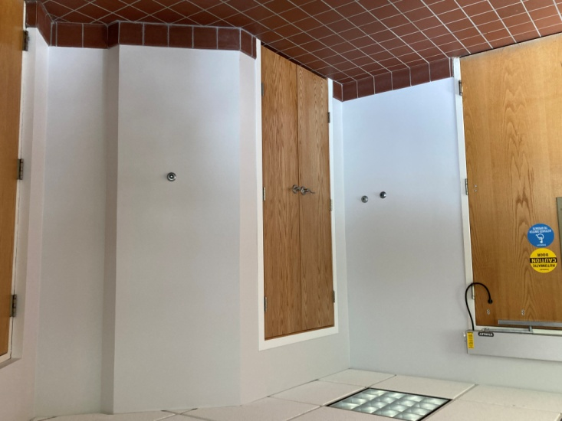
Project #5.1: Minister’s Office – In early December 2024, our UUCNH Board of Trustees (BoT) decided to relocate three of UUCNH’s four offices. The Minister’s office is now upstairs in a (former) classroom, and the DLFD’s office is in another classroom – sharing the space. The Bellwood Office has been moved from the downstairs silo room to the former Minister’s office. The former DLFD office is now a copier/supplies and mailbox room.
Project #5.1a – New Door (and Windows) has been closed down. A new door was added last year. New windows are now thought unnecessary.
Project #5.1b – Handles and Locks at Breezeway was also complete last year.
Project #5.1c – Improved Sound Isolation - Since last March, we have been building and installing sound absorbing panels in Friendship Hall. Just recently sound panels were added along the wall below the main stairs. This work was started as a means to reduce noise in the Minister’s office, but has continued for the benefit of noise reduction throughout the barn. Much of the work is complete, but even more sound panels are planned for the future. See Photo Below.
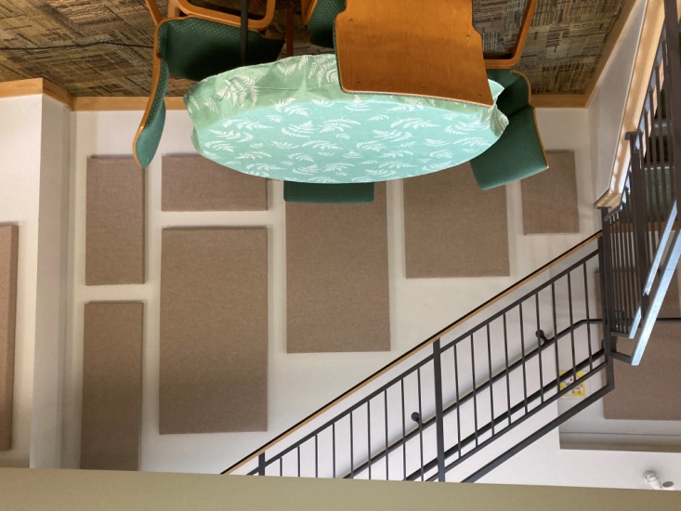
Project #7a: Gifted Solar Panels – Marsha Albright has graciously donated 22 lightly used 300W solar panels to UUCNH. She has been dealing with a long delay to her project, but it looks like it will be moving ahead starting in April. We have approved $12,604 for the installation of these panels.
Project #10: Celebration (former Memorial) Garden Walls – Last fall, Vento Landscaping nearly completed the construction of the Memorial Walls, on which the memorial plaques will be displayed, but winter weather came early last year. (Some would say winter came right on time.) We expect the capstones to be completed as construction to create swales and yard drains gets underway. See Item #4c2: Stormwater Runoff, above.
Project #11: Entrance Drive Paving – Mike Zak and Mark Swihart have been working to get contractor quotes for paving both the Entrance Drive and the Upper Parking Lot. Originally, the CC’22 had money for paving just the driveway, but it seems prudent to redo all the paving at the same time. See Projects 4d and 4e on the spreadsheet. We hope to select a contractor soon and schedule the work for sometime this spring/summer. So far the contractor’s estimated costs are just a little over our original cost estimate.

Lastly
We are trying to self-perform as much of the work as possible. Anyone with a desire to lend a hand is welcome to contact Joe Meier (see below). People with electrical wiring or carpentry skills would be especially welcome. Any questions or offers of help can be sent to Joe Meier at capitalcampaign@uucnh.org.

