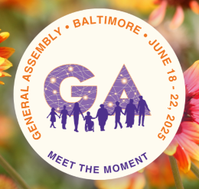
Call for Delegates to GA
Baltimore, Md. or online
June 18-22, 2025

The Denominational Affairs Committee is reaching out to all members of UUCNH to offer the opportunity to be a UUCNH delegate to GA 2025. It is an important year. Delegates will select the UUA moderator. The UUA moderator will help shape and hold the vision and mission of the UUA for the next 6 years. UUA Board nominated Candidates for UUA Moderator (2025-2031)

The UUA General Assembly 2025 will take place from Wed., June 18, 2025 until Sunday June 22, 2025. GA 2025 is both online and in person in Baltimore, MD. It is free to be a delegate and attend all General (business meeting) Sessions online. UUCNH will reimburse delegates for x - in person expenses and y - online expenses.

As with last year, there may be online delegate meetings in late May or early June to finalize the GA 2025 business agenda, primarily Actions of immediate resolution and Business resolutions. Participation of the delegates in these early meetings is optional. Here is the GA 2025 Tentative Business Agenda.

Each day, Wed. through Sat., the General Sessions will discuss the items to be voted on that day. At the close of the day’s session, voting will open for the items discussed that day. Delegates are responsible to cast their votes prior to the close of voting that evening.

Want to be a delegate? Express Interest or Ask Questions Here

Different than last year, UUCNH delegate candidates will be voted on at the UUCNH Annual Meeting on June 1, 2025. The four people who receive the most votes will be authorized by the UUCNH board to cast votes at GA on behalf of UUCNH.

