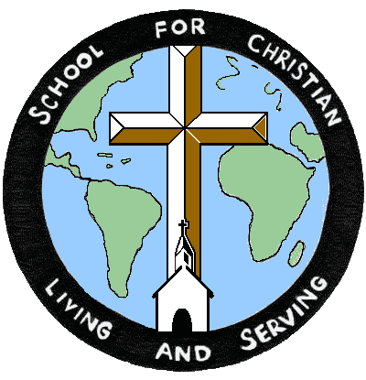

THE SCHOOL FOR CHRISTIAN LIVING AND SERVING
A Ministry of the Mid-Hudson and Orange Classes
FALL 2020 COURSE OFFERING

BOUNDARY AWARENESS TRAINING
Developing & Keeping the Sacred Trust

Healthy Boundaries are a gift, especially as faith leaders who serve and nurture others. They are helpful guides that give shape to our relationships. In ministry and teaching, boundaries clarify who is the pastor and who is the congregant so that safe spaces and safe relationships are created.

Part of Boundary Awareness is an honest conversation about sexual ethics (a course that was offered to RCA clergy several years ago), yet BAT introduces and converses about much more, including:
- a theological and biblical review of "boundaries", with focus on boundary-crossing versus boundary-violations
- overview of the use of power/authority and vulnerability in relationships
- dating as a clergyperson
- nature and complexity of relationships, like dual-relationships (ie: having a parishioner who is also your doctor or car mechanic or your kid's teacher), hugging and touching, and how to appropriately fulfill one's need for intimacy and closeness
- receiving gifts from parishioners
- realities of being in the pulpit... recognizing boundaries while preaching (ie: being overly demeaning or coercive, being overly political (and not in the Jesus-way!), inappropriate self-disclosure, disclosing another person's story without permission, etc)
- clergy self-care (which is also a good conversation for non-clergy to hear)
- since there's little time to cover everything, some additional options might include:
  - maintaining healthy boundaries online as an individual (ie: internet usage on the rise, how to use social media wisely, issues around online pornography, gambling, predation, etc)
  - maintaining healthy boundaries online as a church
  - leadership boundaries: termination of calls/contracts, covenants of separation, regular sabbath-taking and sabbaticals, etc

Some topics that BAT introduces, but does not cover in-depth are:
- NYS Sexual Harassment Prevention Training
- Safe Church policies and practices
- Insurance policies and requirements for churches
A standard for Boundary Awareness Training is roughly 10 hours or more of contact-time for initial training (initial = when an individual has not taken a BAT course at all or within the last 5 years). This contact time can be in the form of homework assignments (articles and videos with reflection questions to answer and hand in), presentations, group conversations, and self-evaluations and questionnaires.

For most BAT workshops, the in-person contact-time is 7 hours for the content discussed, leaving 3 hours for homework.

Once an individual has fulfilled the 10 hours of initial training, it is recommended to classes that additional review of BAT occurs every 3 to 5 years for individuals, with a minimum contact-time of 6 hours for follow-up training.

The details of each Classis’ policy concerning BAT may be different. If the training is required by your classis, a certificate of completion must be obtained from the facilitators. To receive a certificate of completion for Boundary Awareness Training a participant must demonstrate that they have fully engaged the material by:

- purchasing or obtaining the FaithTrust Institute Healthy Boundaries 201 Course Workbook through their store or through Amazon (only a kindle version is currently available)
- being present and undistracted for the full duration of every session (for online sessions, cameras must be turned on, when appropriate, to verify presence),
- handing in all homework assignments before any listed deadlines, and
- fully participating in both large-group and small-group conversations.

If any participant cannot complete the above, the facilitator(s) will be obligated to withhold a certificate and ask the participant to re-take the training.

Instructor: The Rev. Greg Town & Lesley Mazzota, RCA Spiritual Director
Dates: Wednesday, November 11, 9:30 a.m. – 12:30 p.m. and
Thursday, November 12, 9:30 – 1:30 p.m.
Location: Zoom.us and Google Classroom
Tuition: $45, plus the cost of Healthy Boundaries 201 Course Workbook
(See above)

**************
Course registrations need to be received by the Registrar one week prior to the course unless otherwise stated. All registrations and tuition need to be mailed to the Registrar unless other arrangements are made in advance. Please register in time to insure the class will run. Scholarships are available from the School. Please contact the Registrar for financial assistance, (518) 537-4221 or albizu@gtel.net.

SCLS Registration Form

Name__________________________________ Phone no. ______________________

Postal address___________________________________________________________

Email address___________________________________________________________

Church affiliation________________________________________________________

Course names___________________________________________________________

CONTACT INFORMATION:
Mail: Desiree Albizu, SCLS Registrar
575 County Route 19, Hudson, NY 12534
Phone: (518) 537-4221
Email: albizu@gtel.net

