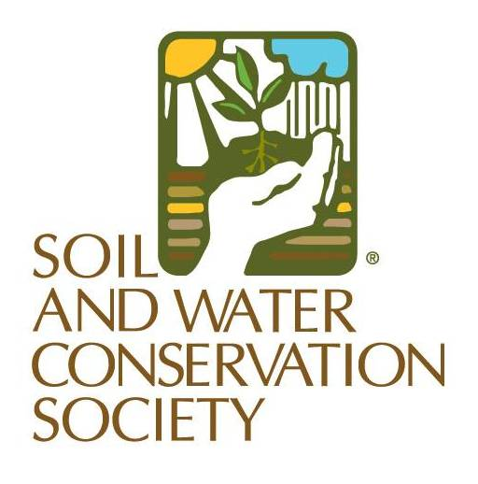

News from SWCS

Contact:

Clare Lindahl, CEO
Soil and Water Conservation Society
clare.lindahl@swcs.org
515-289-2331 ext. 113

Soil Health Films Document Conservation Work of Southwestern Farmers and Conservationists

(Ankeny, Iowa – July 26, 2019) The Soil and Water Conservation Society (SWCS) has released two short films that showcase the efforts of farmers and conservationists in the San Luis Valley of Colorado to address agricultural challenges through improved soil health.

“There are a lot of resources regarding soil health in the midwestern and eastern regions, but we identified an opportunity to share the unique challenges that farmers in the West face in improving their soils and the important role the conservation professional plays in creating a path forward for soil health in the region,” says Clare Lindahl, CEO of SWCS.

“We realize the benefits of soil health in the extremes much more than when everything is just right for growing conditions,” adds Patrick O’Neill, a soil scientist and agronomist with Soil Health Services in Alamosa, Colorado.

Soil Health in the West: The San Luis Valley features the work of farmers Lyle and Erin Nissen, ranchers George Whitten and Julie Sullivan, and their conservationist partners to efficiently use limited water resources and reduce soil erosion through crop rotations, increased biodiversity, and innovative rangeland management practices.

Conservation Professionals: Inspiring a Movement highlights the essential role of conservation professionals in the soil health movement by documenting the lasting impact that one conservationist—Mike Collins, USDA Natural Resource Conservation Service—had on the landscape and his community. Collins, a soil health advocate within the region and SWCS Board of Directors member, passed away in 2016, but left behind an active conservation network.

“A lot of what we're doing now with soil health is because of him [Mike Collins]. I don't think we'd have the strong group that we have in the San Luis Valley if it wasn't for Mike,” says San Luis Valley rancher George Whitten.

The films were funded in part through contributions to the Mike Collins Memorial Fund, directed by Jody Thompson, and produced by SWCS. Both are available online at swcs.org/watch.

###

About SWCS
With more than 3000 members around the world, the Soil and Water Conservation Society (SWCS) is a nonprofit scientific and educational organization that serves as an advocate for conservation professionals and for science-based conservation practice, programs, and policy.
The SWCS mission is to foster the science and art of natural resource conservation. We work to discover, develop, implement and constantly improve conservation practices and systems that sustain the productive capacity of the land while protecting environmental quality.
We pursue our mission through a combination of research, education and advocacy aimed at promoting state-of-the-art conservation practices and science-based conservation policy.

