Chamber Talks: 7 X 7
The Lasting Transportation Impact of the Pandemic

What will traffic congestion and public transit look like over the next year and beyond? What lasting impact will remote working have on commute behavior? How do these factors influence transportation policies and infrastructure decisions being made today? Hear about these topics and how best we can prepare for the uncertainties of the future.

Eric Bourassa
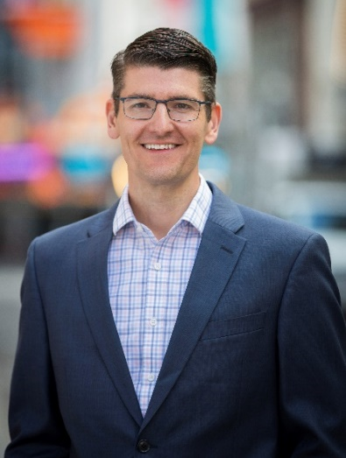
Eric Bourassa is the Director of Transportation at the Metropolitan Area Planning Council (MAPC), where he oversees an interdisciplinary team of planners that conduct regional transportation studies, provide technical assistance to municipalities, and research critical transportation policy issues facing Greater Boston. He also serves as the Vice Chair of the Boston Metropolitan Planning Organization (MPO). In this role Mr. Bourassa works alongside planning staff from the Massachusetts Department of Transportation, MBTA, Central Transportation Planning Staff, City of Boston, and other agencies and municipalities to develop a transportation vision for Greater Boston—from public transit to pedestrian/bicycle needs to roadway projects—and then dedicate federal and state funding to specific transportation improvements.
Prior to joining MAPC, Mr. Bourassa managed the transportation advocacy program for the Massachusetts Public Interest Research Group (MASSPIRG) where he lead a grassroots effort for better transportation funding in the Commonwealth and authored several reports on transportation finance and policy.
Mr. Bourassa holds a Masters degree in American Civilization from Brown University, a Bachelor of Arts degree in American Studies from Dickinson College, and has training in facilitation and facilitative leadership from the Interaction Institute for Social Change.

How to Be More Productive/Happy When Working from Home

One of the long-term consequences of the COVID-19 Pandemic will be more virtual meetings at the expense of face-to-face. More knowledge work will be done working from home.

In seven minutes, Dr. Larry Stybel will give you seven ideas to improve your effectiveness at work and improve your family life.

LARRY STYBEL
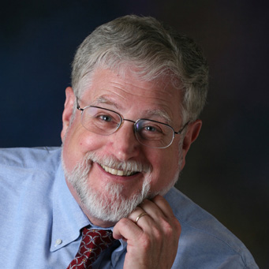
Larry is a licensed doctoral level psychologist and co-founder of two companies, Stybel Peabody Associates, Inc. and Board Options, Inc. Larry also serves as Executive in Residence for Lexington Growth Funds, a private equity firm.

Board Options, Inc. does retained search for Board members. Stybel Peabody Associates, Inc. does retained search for CEOs, COOs, and CFOs. The firm does executive level outplacement work for leaders who should be networking at Board levels.

Larry is listed in Marquis Who’s Who in Business and Who’s Who in America. In 2019, Marquis Publishing presented Larry with the “Marquis Lifetime Achievement Award” for “enduring contributions to leadership.”

He received his doctorate in psychology from Harvard University.

Serving the Most Vulnerable
Sheryl will explore the range of elder care issues experienced during the pandemic and how care across the continuum had to adapt to serve the most vulnerable in a time when they needed us most. She will also explore concerns moving forward and expectations for the long-term impact of the pandemic on the industry as a whole.
Sheryl Leary, LSW, Director of Planning and Community Development, HESSCO
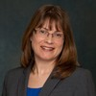
Sheryl Leary, LSW has over 20 years of experience in the aging and gerontology field. She is currently the Director of Planning and Community Development for HESSCO, the Aging Services Access Point and Area Agency on Aging for South Norfolk County. In this role, Sheryl oversees federally funded and grant funded programs for HESSCO. As a senior manager at HESSCO, Sheryl participates in all strategic agency decisions and develops the HESSCO Area Plan on Aging.
Sheryl also provides HESSCO representation and leadership on several area elder and public health related boards and committees. Prior to joining HESSCO, Sheryl was a Program Administrator for Healthcentric Advisors, the New England Quality Innovation Network-Quality Improvement Organization. In this role, Sheryl developed coalitions of healthcare providers to implement improvement programs related to transitions in care and quality of care for Medicare beneficiaries.
Sheryl also worked for HESSCO from 2005 – 2013 in a variety of positions, serving on the Home Care Department supervisory team, implementing a strengths-based approach to family caregiver support and developing systems and processes related to care transitions.

IT Security in the COVID age
Paul will explore the new security landscape (higher exposure to threats) that every organization and industry will now face, the safeguards to mitigate this (security frameworks, policies), and the power of using IoT and Cloud the right way in your organization. He will also touch on such topics as:
- Bring Your Own Device (BYOD) results in cost-savings, but it also causes exposure to a breach.
- Written policies are more important than ever in this new security landscape we're living in.
- Internet of Things (IoT) and Cloud solutions are critical to be successful in the digital normal.

Paul Smith
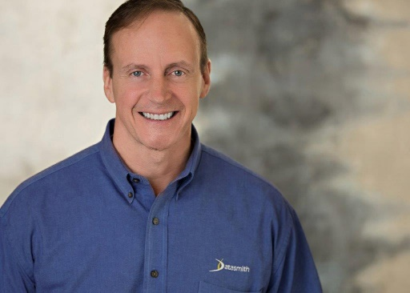
Paul Smith has led Datasmith Network Solutions since 2000. Under his leadership, DNS has become an IT firm that provides superior value to clients through best-in-class, customized technology solutions. Success derives from helping customers cut costs, ensure business continuity, and increase their technology ROI. Paul is a vocal advocate for strong customer service and business integrity along with evolving technology. He served on the Ingram Micro's advisory council for their Cloud Division and is very active in Trust X Alliance, a global IT community.​

Creating Opportunities in an uncertain climate
- Belief
- Letting Go
- Doubling down on myself

Dave Turano
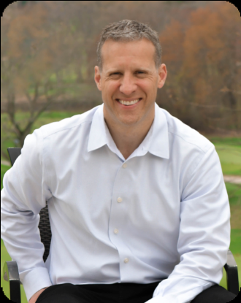
Dave Turano founded JCE Consulting in 2013. The company is named after his three children: Jack, Christopher and Emma.
Dave specializes in communication coaching for business professionals that appreciate straight talk. He has coached and trained leadership professionals of all levels and across many industries.
The mission of JCE is to help every client achieve incremental improvement by developing teams that are driven and self-directed. Our vision is for all people to communicate with confidence. JCE works with companies to address challenges that primarily result from breakdowns in communication and trust. Our clients rely on us for ongoing coaching & training for their leaders, midlevel staff and new hires alike. They hire us to help them eliminate the barriers that get in the way of progress and growth. Managing personalities, managing up & down, breaking down silo's between departments, motivating people or having tough conversations are some of the more common challenges that we are asked to tackle.

Defining Moments
What determines whether a leader comes forth to meet the challenges of the hour? Sarah believes the determining factor is how we handle certain critical moments in our lives and businesses. Our response to defining moments will determine who we are as a person and a leader.
Sarah Smith
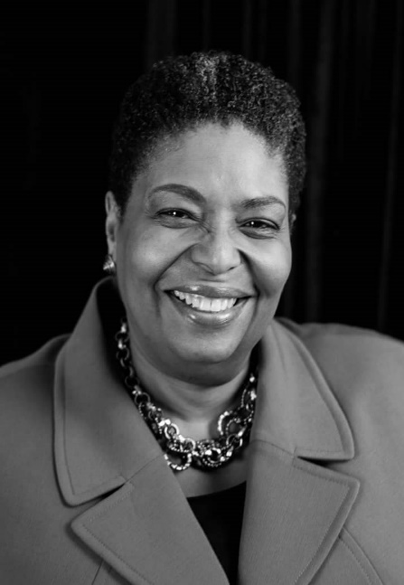
Sarah is the CEO and Owner of Unlimited Success Services LLC. As a professional leader and Certified John Maxwell Team Member, Coach, Speaker, DISC Trainer and Consultant, she has mastered the skill sets that separates her from others and has dedicated her life to empower leaders through practical applications of proven methods.

For over two decades she worked at one of the world’s largest financial institution, where she held various positions as an Executive Assistant to C-Suite Executives. She also has over three decades of experience in working with nonprofits.

While working in both Corporate America and the nonprofit sector, she has witnessed the impact of great leadership in people, as well as organizations.

Sarah is convinced that in order to grow as a leader, we must grow our level of effectiveness. And if we want to change the direction of our organization, we must grow our leaders. Therefore, she is fully equipped with the tools needed to grow individuals, communities, organizations, teams and businesses both personally and professionally.

