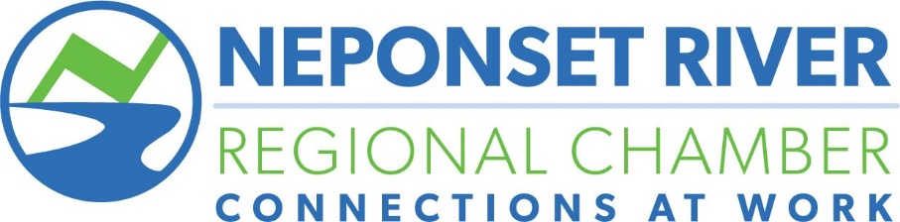

ChamberTalks

The Chamber will host a variety of speakers who will share their “big ideas” on topics such as technology, business leadership, healthcare, transportation and more in a fast-paced, “Ted Talk” style setting, followed by a networking cocktail reception.

Date: November 6, 2025
Venue: Grazina Event Space
Anticipated Attendance: 50 to 100 chamber members.
Leadership Sponsor - $3,000
- Exclusive category sponsor
- Opportunity for two minutes speaking time at the event
- List of all event attendees
- Recognition during introductions and closing remarks of the event
- Logo and name recognition on all event marketing materials
- Sponsorship Recognition on Chamber's website
- Six tickets to each event

Premier Sponsor - $1,500
- Recognition during introductions and closing remarks of the event
- List of all event attendees
- Logo and name recognition on all event marketing materials
- Sponsorship Recognition on Chamber’s website
- Three tickets to each event

Supporting Sponsor - $1,000
- List of all event attendees
- Recognition during introductions and closing remarks of the event
- Logo and name recognition on all event marketing materials
- Sponsorship Recognition on Chamber's website
- Two tickets to the event

2025 Sponsor Registration Form

Company:_________________________________________________________

Address:__________________________________________________________

City:_________________________State:________________Zip:____________

Contact:__________________________________________________________

Phone:___________________________________________________________

Email:____________________________________________________________

Package or Event to Sponsor: Level of Sponsorship:

1/________________________________ _____________________________

2/_______________________________ _____________________________

3/_______________________________ _____________________________

Method of Payment:

Make checks payable to: Neponset River Regional Chamber
83 Morse Street, Suite 6, Norwood, MA 02062

Amount of check: __________
Or
Charge my: Visa ______ MC ______ Disc ______ Amex ______

Card #:____________________________________ Exp. Date: ___________________

Amount to charge to credit card: $___________________________ CVV#_________

Billing Address:_________________________________________________________

Signature:_______________________________________________Date:___________

Signature and payment is a binding confirmation of sponsorship. For more information, or questions, please contact Tom O’Rourke at 781-769-1126 or tom@nrrchamber.com

