**Exciting Sales Career Opportunity!**

We offer industry-leading sales and lead-generation training, access to thousands of affinity partnerships, sponsorship of required licensing exams, and much more. Perhaps most appealing of all? We offer **uncapped earning potential** and a **clear path for advancement from day one**.

Where you go and how far you take it is completely up to you!



At Liberty Mutual Insurance, our dedication to doing the right thing is at the heart of all we do. With this in mind, we are committed to providing our people with challenging work and opportunities for growth. **We pay for performance, promote from within, and foster an environment that is inclusive and supportive.**

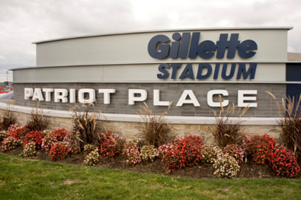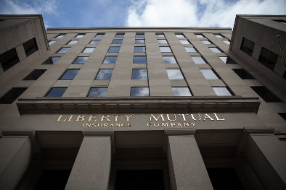***Join us on February 15th for one of three sessions at Gillette Stadium to learn more about the benefits we offer, and find out why a career at Liberty Mutual is right for you!***

**February 15th, 2018**

* **3:45pm-5:15pm**
* **5:00pm-6:30pm**
* **6:15pm-7:45pm**

**Club Lounge Southwest**

**1 Patriot Place, Foxboro, MA 02035**

Bring a few copies of your resume and plan to participate in an informative session about Liberty Mutual Insurance with local managers and sales representatives from throughout Massachusetts and also a **tour of Gillette Stadium!**

Light snacks and refreshments will be served.

**RSVP by February 14, 2018**

[**mark.lovuolo@LibertyMutual.com**](mailto:mark.lovuolo@LibertyMutual.com) **or (781) 223-2032**

