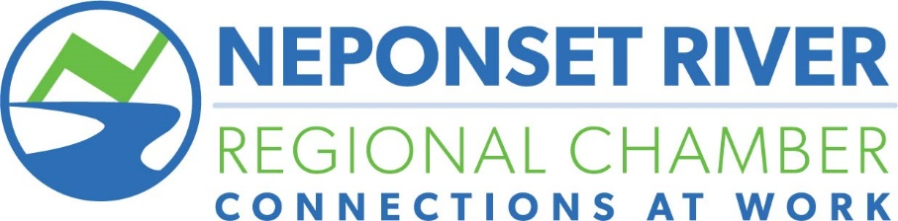

Golf Tournament 2022

Over 100 golfers participate annually in the chamber’s golf tournament, which is a great day of golfing and fun. The tournament is an excellent opportunity to mix and mingle with local business leaders and promote your business.

Date: 8:00 AM Monday, August 8, 2022
Venue: Brookmeadow Country Club, Canton

Anticipated attendance: 80 – 100

Tournament Title Sponsor $2,500
- 2 Foursomes
- 4 Lunch Reception Tickets (additional to golfers)
- Special Tournament Sponsor sign at Hole #1
- Recognition throughout event and on promotional materials
- Recognition on Sponsor Board
- Logo with a link to your website on the event listings page on Chamber website
- Opportunity to provide item for golfer goodie bag
- Opportunity for event on-site set up

Gold Sponsors: $1,500
- 1 Foursome
- Tee sign recognition
- Recognition on Sponsor Board
- Recognition on all marketing materials
- Logo with a link to your website on the event listings page on Chamber website
- Opportunity to provide item for golfer goodie bag

Putting Contest Sponsor - $1,500
- 1 Foursome
- Company name on signage at the Putting Contest
- Present award to winner of the contest with photo
- Logo placement on all event marketing materials
- Logo with a link to your website on the event listings page on Chamber website
- Opportunity to provide item for golfer goodie bag

Golf Tournament 2022 (cont.)

Lunch Reception Sponsor: $750 (1 available)
- Logo projected during reception
- Opportunity to provide information to each participant
- 2 Tickets to Lunch Reception
- Recognition on Sponsor Board
- Recognition on all marketing materials

Breakfast Sponsor: $500 (1 available)
- Logo projected during reception
- Opportunity to provide information to each participant
- 2 Tickets to Lunch Reception
- Recognition on Sponsor Board
- Recognition on all marketing materials

Hole in One Sponsor - $500
- Sponsorships is exclusive, only one available
- Name and/or logo included on event invitation
- Company Name & Logo recognition in tournament program
- Company name on hole-in-one signs

Cart Sponsor: $500
- Sign with Logo on each golf cart
- Recognition on all marketing materials
- Opportunity to provide item for golfer goodie bag

Beverage Cart Sponsor: $300
- Sign with Logo on beverage cart
- Recognition on all marketing materials
- Opportunity to provide item for golfer goodie bag

Tee Box Sponsor: $300
- Set up a tent on a tee box to meet golfers and distribute information
- Offer a raffle prize to golfers

Exclusive Tee Sign Sponsor: $175
- 18x24 Full color Tee Sign at assigned hole with Sponsor Logo (only one per hole)
- Recognition in event program

Tee Sign Sponsor: $125
- 18x24 Full color Tee Sign at assigned hole with Sponsor Logo
- Recognition in event program

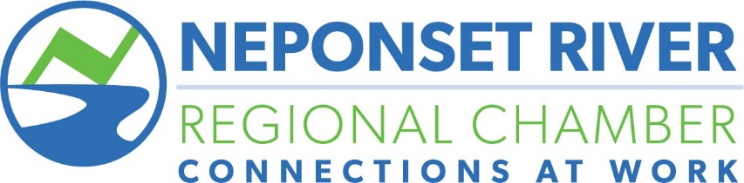

2022 Sponsor Registration Form

Company:_________________________________________________________

Address:__________________________________________________________

City:_________________________State:________________Zip:____________

Contact:__________________________________________________________

Phone:___________________________________________________________

Email:____________________________________________________________

Package or Event to Sponsor: Level of Sponsorship:

1/________________________________ _____________________________

2/_______________________________ _____________________________

3/_______________________________ _____________________________

Method of Payment:

Make checks payable to: Neponset River Regional Chamber
83 Morse Street, Suite 6, Norwood, MA 02062

Amount of check: __________
Or
Charge my: Visa ______ MC ______ Disc ______ Amex ______

Card #:____________________________________ Exp. Date: ___________________

Amount to charge to credit card: $___________________________ CVV#_________

Billing Address:_________________________________________________________

Signature:_______________________________________________Date:___________

Signature and payment is a binding confirmation of sponsorship. For more information, or questions, please contact Tom O’Rourke at 781-769-1126 or tom@nrrchamber.com.

