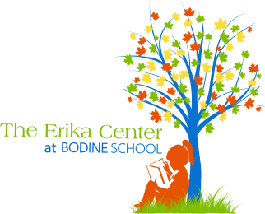

Dyslexia Resources:

Books for students:

Your Fantastic Elastic Brain by JoAnn Deak

It’s Called Dyslexia by Jennifer Moore-Mallinos

Tom’s Special Talent by Kate Gaynor

The Alphabet War by Diane Burton Robb and Gail Piazza

Thank you, Mr. Falker by Patricia Polacco

Hank Zipper series by Henry Winkler

Two Minute Drill by Mike Lupica

My Name is Brain/Brian by Jeanne Betancourt

Fish in a Tree by Lynda Mullaly Hunt

Percy Jackson book series by Rick Riordan

Looking for Heroes by Aidan Colvin and Liisa Ogburn

The Wild Book by Margarita Engle
Knees: The mixed-up world of a boy with dyslexia by Vanita Oelschlager and Joe Rossi

If you’re so smart why can’t you spell Mississippi? By Barbara Esham and Mike Gordon

Dyslexic Legends Alphabet book by Beck Feiner

Magnificent Meg by Andra Harris

Books for parents:

Overcoming Dyslexia by Sally Shaywitz (2nd Edition)

The Dyslexic Advantage: Unlocking the Hidden Potential of the Dyslexia Brain by Brock L. Eide

The Gift of Dyslexia by Ronald David

The Dyslexia Checklist by Sandra Rief

Proust and the Squid: The Story and Science of the Reading Brain by Maryanne Wolf

The Dyslexia Empowerment Plan: A blueprint for renewing your child’s confidence and love of learning by Ben Foss

Dyslexia Wonders: Understanding the Daily Life of a Dyslexic from a Child’s Point of View by Jennifer Smith

Seeing What Others Cannot See: The Hidden Advantages of Visual Thinkers and Differently Wired Brains by Thomas G. West

Uncovering the Logic of English by Denise Eide

Dyslexia Explained without the need for too many words by Mike Jones

Teaching a struggling reader: One mom’s experience with dyslexia by Pamela Brookes

Dyslexia Outside-the-Box by Beth Ellen Nash

Basic Facts about Dyslexia and other Reading Problems by Louisa Moats and Karen Dakin

Reading Development and Difficulties by David Kilpatrick, R. Malatesha Joshi, and Richard Wagner

Reader Come Home: The Reading Brain in a Digital World by Maryanne Wolf

