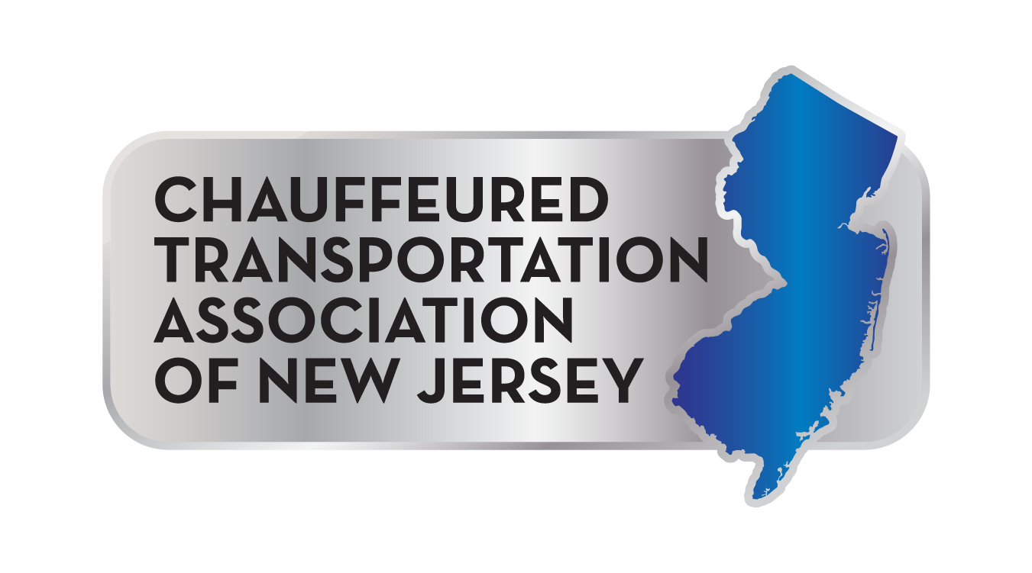
Chauffeured Transportation Association of New Jersey
Donation for May 20, 2025 Auction Fundraiser

Name _______________________________________________________________________________________

Company ___________________________________________________________________________________

Email _______________________________________________________________________________________

Telephone _______________________________________________________________________________

YES!
I would like to donate the item(s) described below to the 2025 CTANJ Auction.

Item(s) Description:

_________________________________________________________________________________________________

Item(s) Value: ______________________ Minimum Bid: ___________________

Please forward this completed form to
Barry Trabb at Complete Fleet Livery Sales by 5/12/25.

Email: barrytrabb@yahoo.com

Or call Barry at (908) 964-4400 with questions or
to make arrangements for your donation.

Thank you!

