1.0 General Information
- System Overview:
Suddath Vendor portal is a web-based application that will allow authorized users to access information 24/7

- Point of Contact
For additional information, please contact Caleb Mixon at CMixon@Suddath.com

- Registration
Vendor will receive an invitation to register for Suddath Vendor Portal. Once the registration process finishes, you will receive a confirmation email informing that your registration was successful, and you are ready to start using the portal.

2.0 System Features
- Login
Input the email address and password you used to register in Suddath Vendor Portal

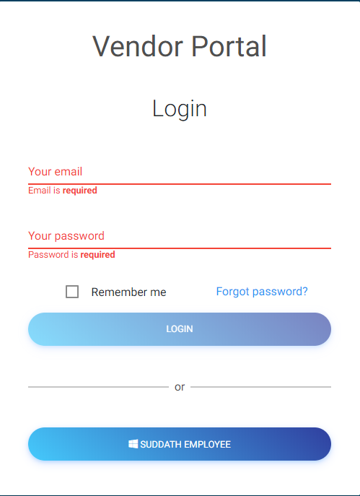

- Landing Page:
This page will list the main features available in the portal. Once you input your credentials, you will see the following menu items.
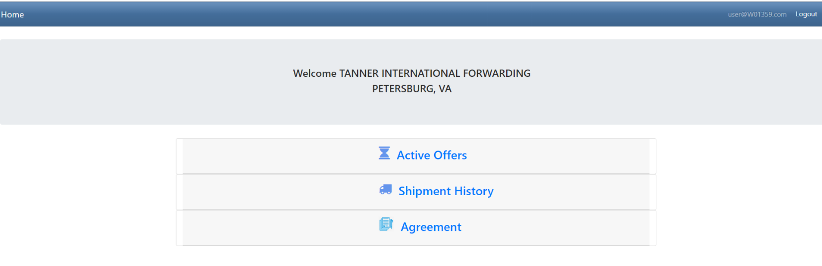

  - Active Offers:
This menu item will take you to the offer opportunities sent to you.
By using this page, you will be able to accept or refuse offer opportunities.

  - Shipment History
This option will allow you to monitor the shipments you accepted.
Please allow 24 hours for shipment to be visible in this list.

Once shipment is registered in our system, you will see additional information such as order number. This information will be available 24/7.

  - Agreement
This option will take you to the compensation schedule agreement we have in our system.

- Active Offers
This user interface will allow you to access offer opportunities as well as accept or refuse them.
It is important to mention that once you accept the offer, you will receive an offer confirmation via email

  - Visibility of offer opportunities
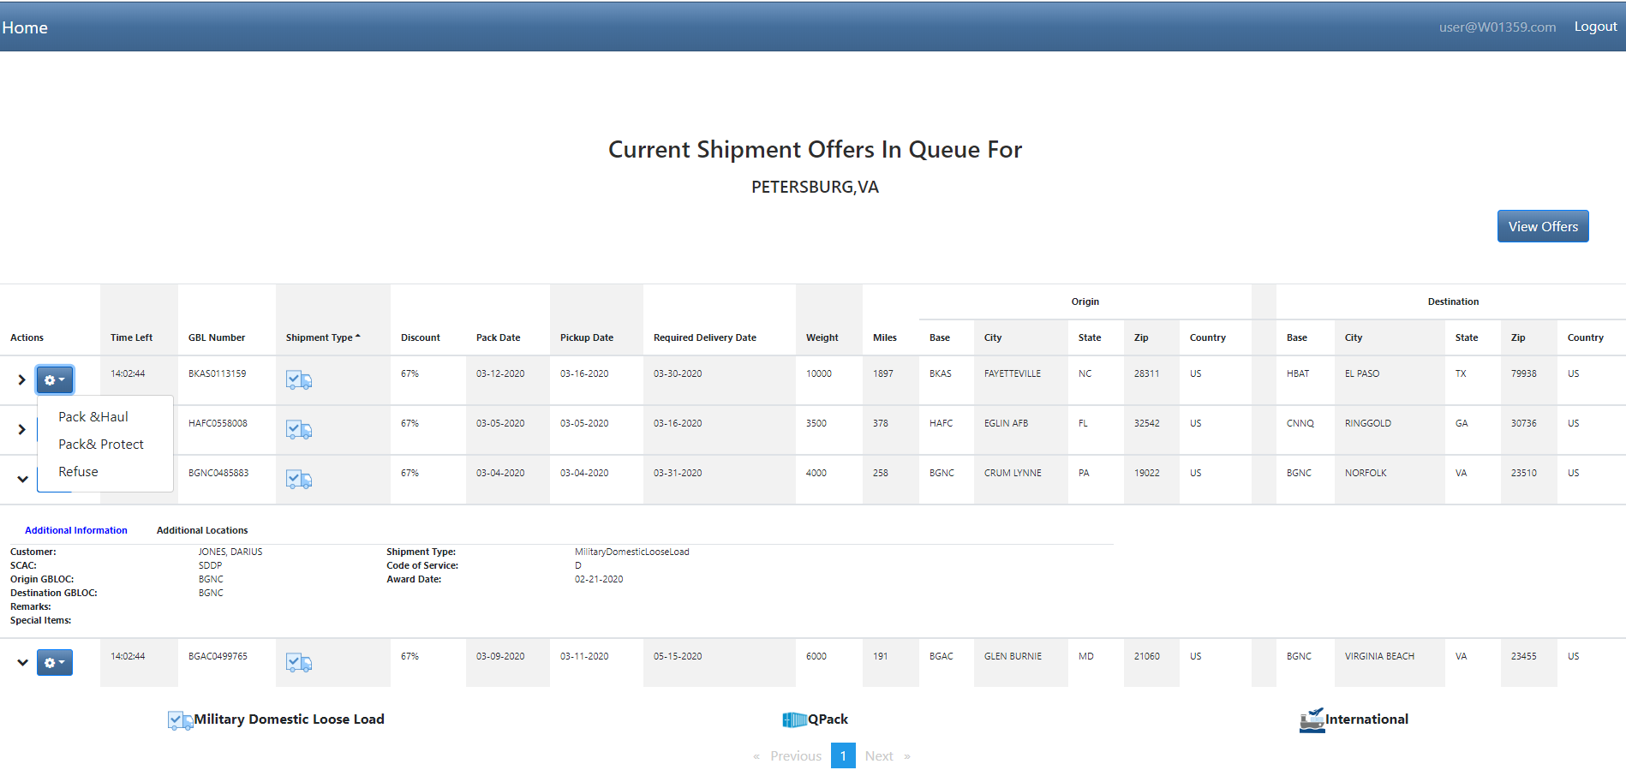
The offers are also sent via email. You can open the email and click on the link listed in the body of the email. It will take you to the portal where you will be able to accept or refuse the shipment(s).
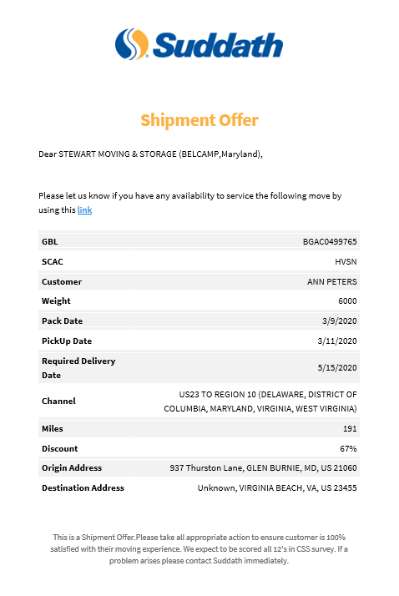

  - Acceptance of offers
The user interface you will see when you are about to accept an offer is shown below:

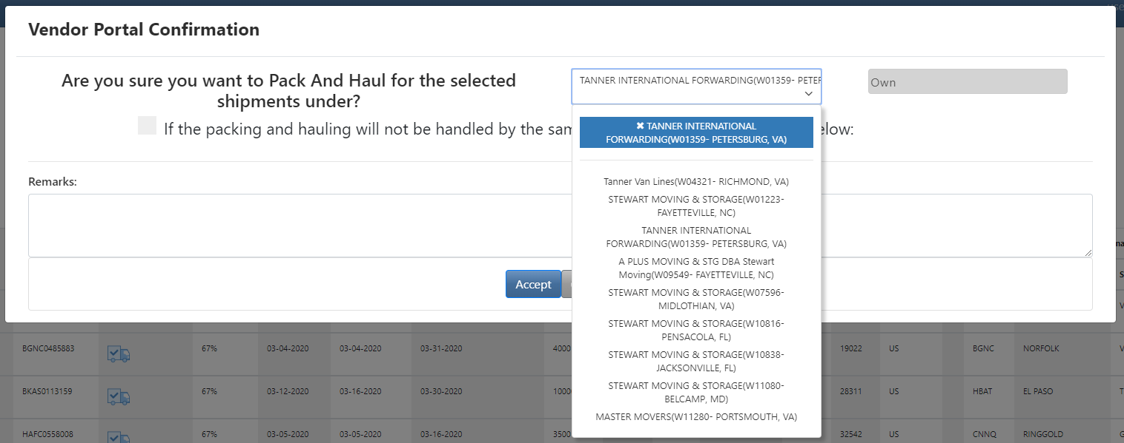

  - Offer Confirmation
Once shipment is accepted, you will receive a confirmation email.

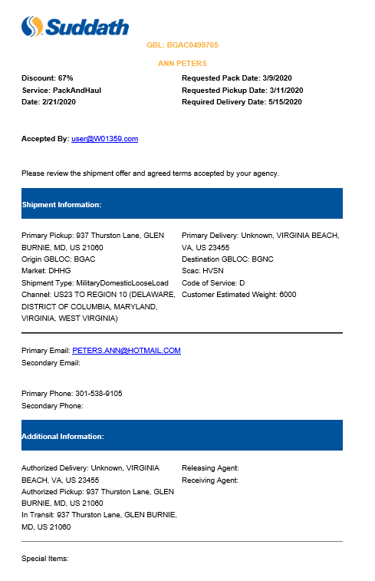

- Shipment History
This page will allow vendors to monitor shipments accepted as well as access some relevant documents such as Reweigh weight tickets, Pre-move survey request, offer confirmation email, inventory at destination, inventory at origin and more.
Please allow 24 hours for shipment to be visible in this list.

