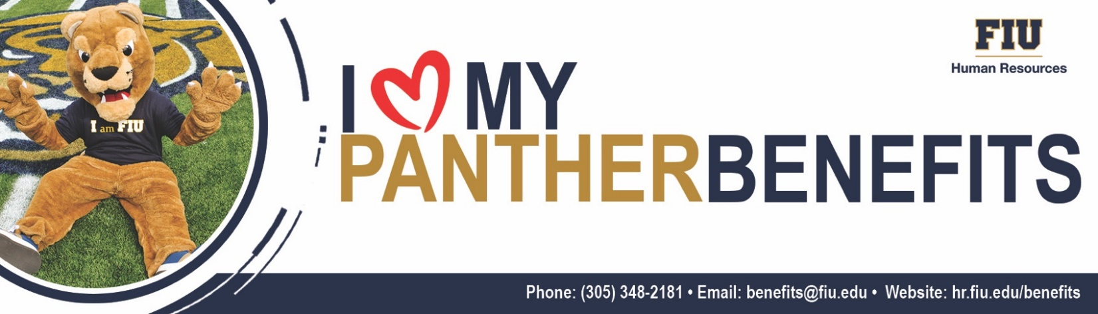
Benefits Updates – May 8, 2023
Wellness Bite Webinar: Better Sleep with Baptist Health
Register for our upcoming Wellness bite-sized webinar with Baptist Health taking place on Wednesday, May 24, 2023, at 12:00pm. Join us for this great session presented by Baptist Health expert, Amy Exum, as we discuss the ins and outs of how to get a better night sleep and wake up feeling refreshed and ready to start your day. Stay tuned for more upcoming events!

Address Review & Update Reminder
The Division of State Group Insurance (DSGI) is implementing measures to enhance employee communication and benefit awareness. Over the next few weeks, employees will be receiving notifications via email, U.S. Mail, and social media encouraging them to review their contact information in People First and update, as needed.

In order to receive communication materials regarding your State-Sponsored Benefits, it is very important to keep your address on record up to date in our Panther Soft System. If you have experienced any changes in address, please update your information on file immediately. As a reminder, an address change may trigger a Qualifying Status Change Event.

TIAA’s New Spanish-Language Experience for Your Retirement Well-being
TIAA understands that everyone has unique needs when it comes to planning for the future, and they are focused on helping you reach your retirement goals. We are pleased to announce TIAA’s New Spanish-Language Experience for Your Retirement Well-Being. To support your growing need for greater access and information surrounding your retirement plan, TIAA’s new bilingual (English & Spanish) experience includes the following education and support:

- On-Demand: TIAA’s experienced retirement readiness team will provide you with education and advice by video, phone appointment or on-demand to help you understand the benefits of participating in your TIAA FIU retirement plan.
- Phone: TIAA’s dedicated team of bilingual financial consultants will host retirement-planning meetings with you.

Call today to speak with a financial consultant at 800-414-5180 to help you prepare for your retirement. Special Note: the TIAA team will not proactively reach out to you. They are available to take your call Monday through Friday, 8:00am to 7:00pm EST.
TIAA is an authorized Retirement vendor and investment provider company, for a current list of authorized providers/vendors, visit our HR.FIU.EDU website.

Questions? Contact Benefits Administration at 305-348-2181 or email benefits@fiu.edu.

