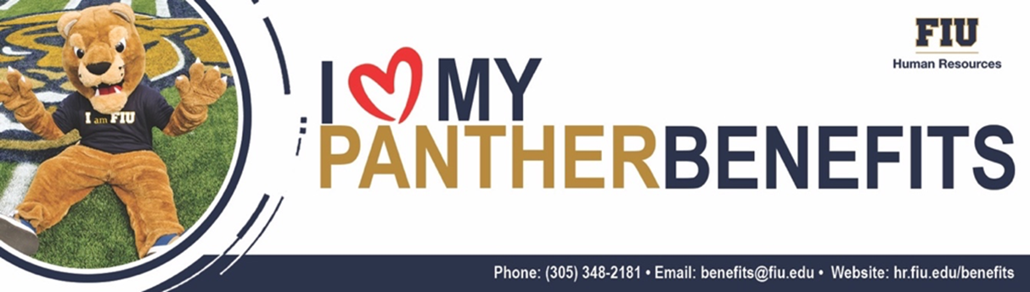

Perks Updates – May 8, 2023

Commute & Transportation
- NEW! Brightline: FIU saves with Brightline! Things just got Brighter with new bi-directional shuttle pricing. Brightline guests can now enjoy a ride to and from FLL and MIA Airports, plus Miami Beach for $10 for the first guest and $5 for every additional guest in the same party. Remember to access your FIU discount by simply using your “@FIU.EDU” email address when creating your NEW Brightline Corporate Account.

Financial Wellness
- NEW! FIU KOFE: Check out KOFE’s May Newsletter – 10 Tips for How to Sell Out at Your Garage Sale. Remember KOFE’s FREE Financial Education Resources are available to you through fiu.kofetime.com. Simply log in with your FIU credentials.

Fitness
- NEW! Planet Fitness: FIU Affiliates and their Friends & Family enjoy special discounts + waived signing fees at participating Planet Fitness Locations! Check out FIU exclusive offers on Planet Fitness Classic and Black Card Memberships. Join online or in-club, use the FIU discount flyer to redeem the offer.

Recreation & Family Entertainment
- NEW! Miami Attractions & Museums: During the month of May, culture seekers and families in search for adventure can visit Greater Miami and Miami Beach's Website to discover various attractions and museums special offers ranging from incredible admission savings, BOGO deals, and more!

Shows, Entertainment, & Cultural Events
- NEW! Adrienne Arsht Center: To get your May performance and Broadway presale tickets before they go on sale to the public, visit arshtcenter.org and enter promo code FIUPANTHER prior to selecting your seats! Discount available with advance purchase only.

For a complete list of employee perks, please visit the FIU’s Employee Perks Site. For more information, contact Benefits Administration at (305) 348-2181.

