LAGUNA HONDA
COMPUTER CLUB
ART OPENING
Wednesday, February 1^{st,} 1-3pm.

"Freedom 2017"
On display opposite
the Art Studio 1st floor through February

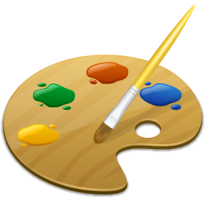

14 original digital artworks created on computers by five
Laguna Honda artist residents and community members!

Come see how a computer can inspire your own freedom and meet members of the Laguna Honda Computer Club Refreshments will be served

