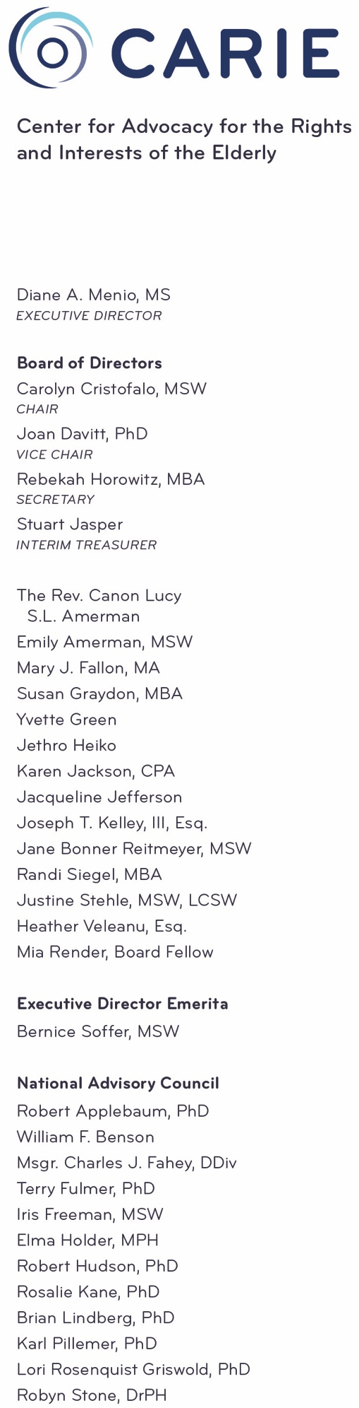
JOB DESCRIPTION
ADVOCATE

Background:
CARIE, the Center for Advocacy for the Rights and Interests of the Elderly, is a non-profit organization based in Philadelphia, dedicated to improving the quality of life of older adults. CARIE was founded in 1977, primarily as an advocacy organization for the frail elderly. Its initial program, "the CARIE LINE," quickly became recognized throughout the region as a resource for a wide range of people and institutions seeking to resolve elder care issues. Today, the agency's telephone consultation service is just one aspect of a coordinated array of programs. CARIE’s mission is: to promote the well-being, rights, and autonomy of older adults through advocacy, education, and action.

Position:
The advocate will be responsible for direct service, program development, education and outreach, public policy, and data collection and analysis. This position is particularly focused on CARIE’s advocacy around Pennsylvania’s shift from a fee for service to a managed care model for long term services and supports referred to as Community HealthChoices (CHC). Bilingual, bicultural background helpful. Reports to the CARIE LINE Supervisor.

Duties and Responsibilities:
Direct Service:
- Investigate and resolve complaints and concerns of older adults, their families, professionals working with them, and others who are involved with caring for their well-being; follow-up on all complaints, requests, etc. as necessary.
- Educate callers about CHC, services, benefits, and rights of older adults.
- Respond to calls about CHC and track issues and challenges associated with CHC.
- Update and maintain CARIE’s resource files.
- Data entry.
- Assist in collecting information needed to complete outcomes measurement.

Policy (under the direction of the Director of Advocacy Initiatives):
- Research and gather information about issues related to older adults as assigned.
- Draft comments related to proposed legislation, regulation, etc.
- Attend meetings on various issues related to the wellbeing of older adults.

Education/Training:
- Present seminars and workshops for older adults, caregivers, and professionals.
- Assist in the development of educational brochures, materials, and public service announcements (PSAs).
- Provide support for webinar development and management.

Other:
- Review literature and articles on a regular basis to stay current on long term care issues.
- Attend staff meetings, appropriate community meetings and training.
- Help update website and social media.
- Other related duties as assigned.

Educational Requirements:
Master’s degree in social work, public health, or other related field and at least three years related experience. Bachelors’ degree with additional experience may be considered.

Experience/Skill Requirements:
- Experience in and/or knowledge of aging policy, resources for older persons and their caregivers, and the long-term care system.
- Experience in negotiating or resolving problems.
- Excellent verbal and written communication skills.
- Public speaking/training expertise.

Required Screening:
- Criminal background check
- Professional references

Physical and Mental Demands:
Must work well under pressure and be creative and analytical. Will be expected to operate office equipment including but not limited to computer, telephone, fax, copier; move freely around the office; sit or stand at a desk and telephone for long periods of time; communicate in person, and over the telephone, with individuals and groups. This position may require occasional work outside of normal office hours and includes travel locally and in Pennsylvania. Some lifting of 10-20 pounds may be necessary.

Salary:
Competitive salary, excellent benefits.

Please mail, email or fax cover letter, resume and a short writing sample to:
Kathy Cubit
Director of Advocacy Initiatives
2 Penn Center
1500 JFK Blvd, Suite 1500
Philadelphia, PA 19110
cubit@carie.org
No calls please.

CARIE is an Equal Opportunity Employer.

