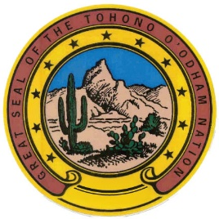 Tohono O’odham Nation Chairman Verlon M. Jose is from the Tecolote Community of the Nation’s Chukut Kuk District. He has dedicated over twenty years to serving the Tohono O’odham community, including tenures on the Tohono O’odham Legislative Council and as Chairman of the Chukut Kuk District. He served as Vice Chairman of the Tohono O’odham Nation from 2015-2019, and most recently represented the O’odham communities in Mexico as Governor of the Traditional O’odham Leaders. In addition, he previously spent eight years as a Legal Assistant for the Tohono O’odham Nation’s Office of Attorney General and served as a Tribal Advocate in the Tohono O’odham Justice Courts.

