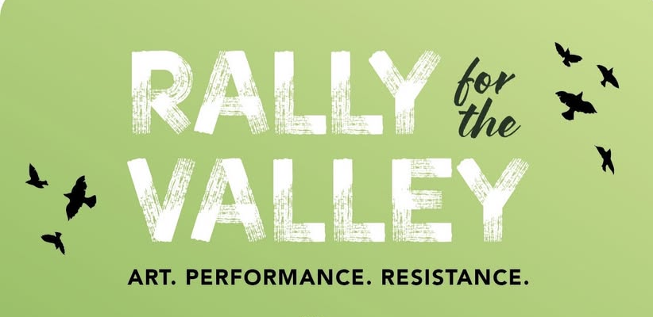

When?
November 15th, 12 noon to 4 pm
Where?: Event Location
How do I get there? NOTE: Sierra Vista route is less challenging, but a 2WD Honda CRV did fine from Parker Canyon and Montezuma Pass.
Option 1 Coming from Patagonia AZ
Option 2 Parker Canyon route [shortest coming from Tucson]
Option 3 Montezuma Pass route coming from Sierra Vista
Do I need 4x4? No, but high clearance is recommended, plan to drive slowly and carpool when possible.
Will there be restrooms? Yes, we will have porta potties near the site
Is there phone reception? It is spotty, you can get a signal not far from the site of the event.
Can I camp? Not at the site of the event as it is an active construction area, other places are available near Patagonia.
What should I bring with me? Chair, sun protection, hat, reusable water bottle, lunch or snacks if needed.
Optional: Animal mask and a shirt or something you can print on as we will have live printing
(depending on availability of resources, donations to artist are appreciated)

