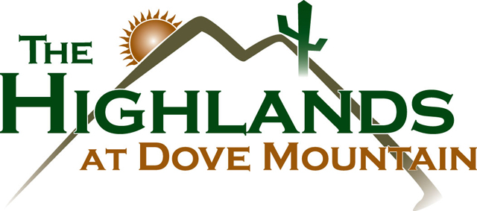
Upcoming Events and Activities
Click here to see all upcoming events!

Edited to include both event times. Thank you!
Dear Residents,
The Highlands at Dove Mountain is pleased to host two upcoming candidate forums featuring individuals running for election and reelection to the Marana Town Council. These forums provide an opportunity for residents and public to hear directly from the candidates and learn more about the issues, priorities, and vision they have for Marana and the Dove Mountain area.
Wednesday, June 17 | 5pm
Candidates Attending:
Jon Post
John Officer
Herb Kai
Terri Murphy
Write In- Jackie Craig

Thursday, June 18 | 6pm
Candidates Attending:
Greg Johnsen
Jackie McQuire
Sue Ritz
Julie Prince
The Highlands does not endorse any candidate or campaign. These forums are being offered as a community service to help residents make informed decisions and engage in the local election process.
We recognize that elections often inspire passionate opinions and meaningful discussion. We ask all attendees to help maintain a welcoming environment by treating candidates, fellow residents, staff, and guests with courtesy and respect. Our goal is to provide every candidate with a fair opportunity to share their perspectives and every resident with an opportunity to listen, learn, and ask thoughtful questions.
To ensure a productive experience for everyone, disruptive behavior, personal attacks, interruptions, or conduct that prevents the event from proceeding as scheduled will not be permitted and may result in removal from the forum.
Thank you for helping us foster a respectful and informative community conversation. We look forward to seeing you there.
Sincerely,
Kelsey Christiansen
Events Director
If you have questions, please email me at kchristiansen@highlandsdm.com

