How it works:
Items are offered by Donor/Seller with total price, percentage of sale to UUCFM, and contact information. Donors/Sellers determine their own percentage of the sale to UUCFM. Delivery/pickup of item is between Buyer & Seller. Buyers write two checks, one to the seller and the other to UUCFM for the percentage of sale going to the church, with fundraiser in the memo line.
Example:
Dining Table, $25. 50% to UUCFM. Contact Suzanne at suzanneziemer@gmail.com, 239-463-9020. (include photo if you want)
How to Participate:
Send email to newsletter@uucfm.org with item description, photo (if possible), price, percentage going to UUCFM, and contact information. Your offer will run for a month or until sold. Limit of 2 items per week per person, thank you.
Questions?
Contact Ways & Means Chair, Suzanne Ziemer, 239-463-9020, suzanneziemer@gmail.com

Items for Sale

Cooler - Coleman -- 21” X 13” & 12.5” deep. Price $10.00 -- 20% to UUCFM
Joy Sokeitous JoySokeitous@comcast.net
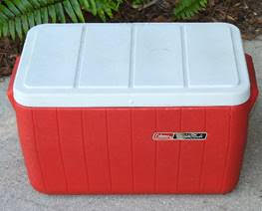

Foam Roller: by AmazonBasics. 35” x 6” $10. 50% to UUCFM. 239-634-2310 uuchurch@uucfm.org
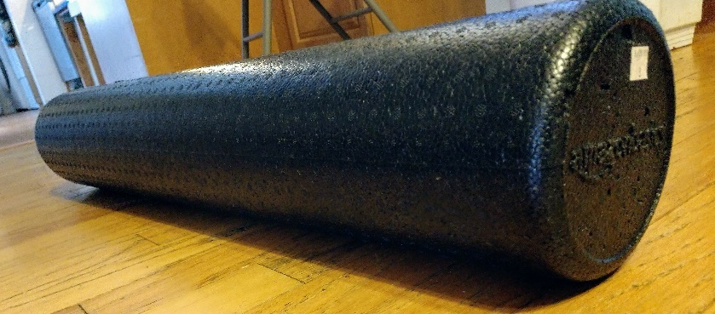

Apple Watercolor: $20 to UUCFM dorothyvanhowe@icloud.com
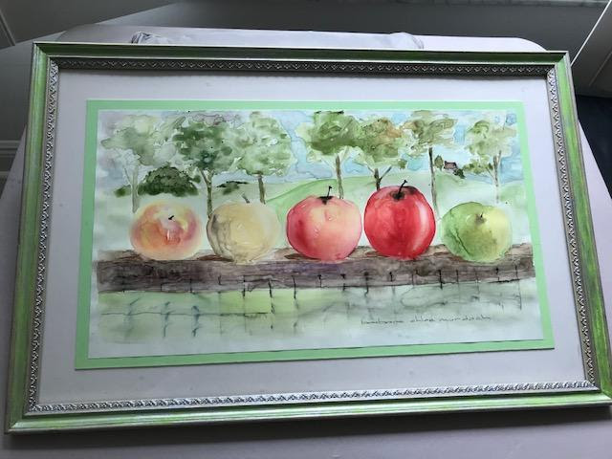

Cooler: Igloo Polar Roller with Handle & Wheels -- 24” x 14” & 19.5” Deep. $15.00. 20% to UUCFM. Contact: Joy Sokeitous JoySokeitous@comcast.net
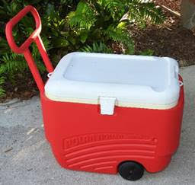

Sears Sport 20-SV Rooftop Cargo Carrier: 67.5" (L) X 36.25" (W) X 20.25" (H) $30.00 Joy Sokeitous –JoySokeitous@comcast.net
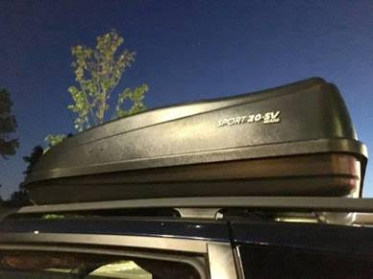

Brocade Trundle Bed Cover with bed skirt: three large back pillows, two round bolsters pillows and coverlet for sale, 100% to the church for the price of $40.00 dorothyvanhowe@icloud.com
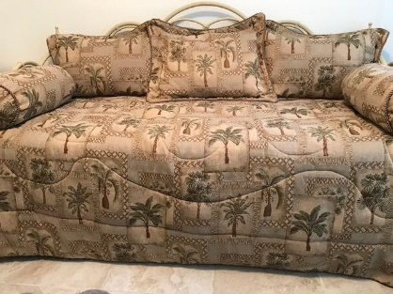
2 brown suede & bronze chairs. Price: $30.00 Both -- 20% to UUCFM

Contact: Joy Sokeitous JoySokeitous@comcast.net

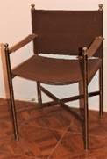

Tilting floor fan with settings for low, medium or high, 22 W x 25 H. Price: $20.00 -- 20% to UUCFM. joysokeitous@comcast.net

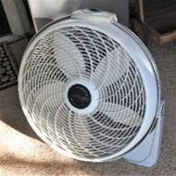

Countertop Oven - Oster Extra Large Digital
- Stainless Steel housing & finish
- 2 rack positions & Removable crumb tray
- Digital Controls: toast, bake, broil, pizza, warm, defrost.
- Outside Dimensions: Width: 21.65", Height: 12.91", Depth: 19.2" Price: $40.00 -- 20% to UUCFM

Contact: Joy Sokeitous JoySokeitous@comcast.net

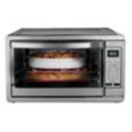
Yamaha PSR-320 Portable Keyboard including Music Stand, Keyboard Cover, Keyboard Stand, Carrying Case + Beginner Song Books. Price: $75.00 -- 20% to UUCFM Contact: Joy Sokeitous JoySokeitous@comcast.net
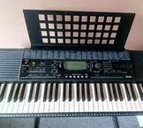

Electric Grill with folding side shelves & cover. Price: $30.00 00 -- 20% to UUCFM Contact: Joy Sokeitous JoySokeitous@comcast.net

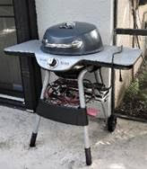

Floral 3-seat sofa Price $40.00
Floral Lamp Price $20.00
Art Price $20.0020% to UUCFM.
Contact: Joy Sokeitous JoySokeitous@comcast.net

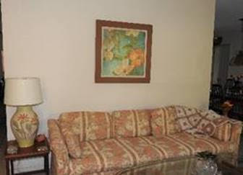

2 Electric Recliner Chairs beige ultra suede. Price: $25.00 each -- 20% to UUCFM

Contact: Joy Sokeitous JoySokeitous@comcast.net

