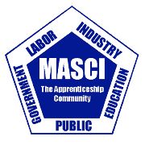
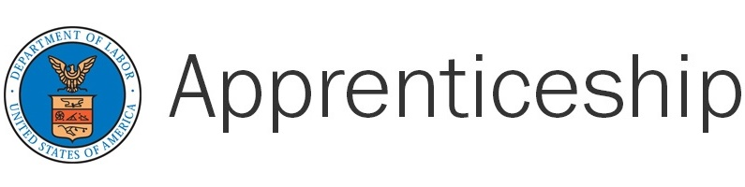
November 9, 2020
National Apprenticeship Week Celebration

“USDOL, OA Registered Apprentices Around Michigan”

9:00 – 9:10 a.m. – Opening Remarks/Welcome
Russell W Davis, Michigan State Director, USDOL, OA

9:10 – 9:15 a.m. – Dean Guido, Regional Director, Chicago Office of Apprenticeship Employment & Training, USDOL

9:15 – 9:20 a.m. – MASCI Proclamation
Lee Graham, President, Michigan Apprenticeship Steering Committee, Inc.

9:20 – 9:25 a.m. – Garlin Gilchrest, Michigan Lieutenant Governor

9:25 – 9:35 a.m. – Patrick Devlin, Secretary-Treasurer, Michigan Building & Construction Trades Council

9:35 – 9:40 am – Tony Retaskie, Executive Director, Upper Peninsula Construction Council

9:40 – 10:50 am – USDOL, OA Registered Professional Construction Trades Presentation

10:50 – 11:00 a.m. – Closing Remarks/Questions
Russell W Davis, Michigan State Director, USDOL, OA

Join Zoom Meeting
https://zoom.us/j/98613028711

Meeting ID: 986 1302 8711
One tap mobile
+16465588656,,98613028711# US (New York) 13017158592,,98613028711# US
+(Germantown)

Dial by your location
+1 646 558 8656 US (New York)
+1 301 715 8592 US (Germantown)
+1 312 626 6799 US (Chicago)
+1 669 900 9128 US (San Jose)
+1 253 215 8782 US (Tacoma)
+1 346 248 7799 US (Houston)
Meeting ID: 986 1302 8711
Find your local number: https://zoom.us/u/ackSZNmaGp

