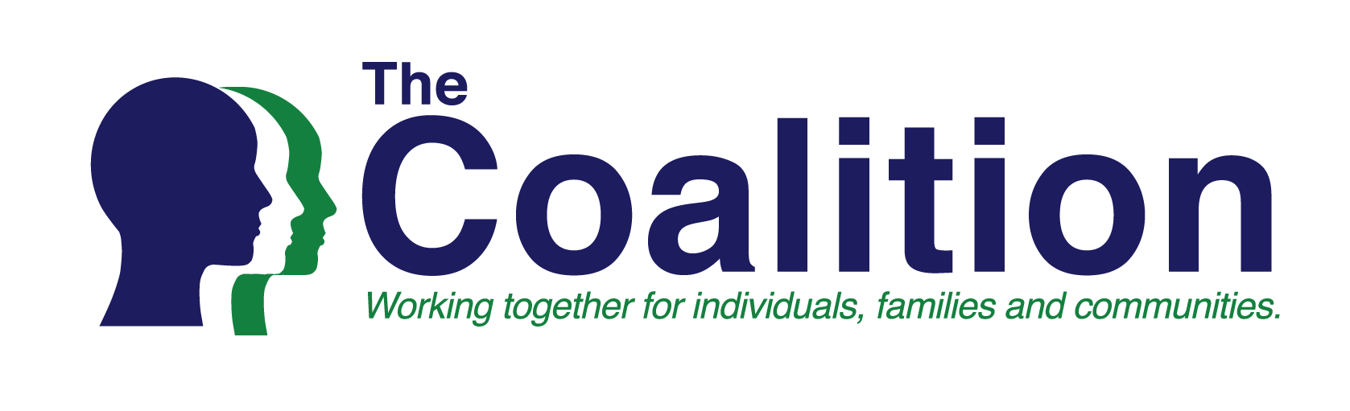

The Coalition is composed of organizations representing consumers, families, advocates, providers and professionals who are committed to assuring the availability of the services and supports for men, women and children who experience addictive diseases, mental illness, developmental disabilities in North Carolina, and for the millions of family members, friends and others whose lives are also affected.

The Coalition seeks leadership on the following budget priorities as we are concerned with:

- No funding for the Suicide Prevention Lifeline- need approximately $350,000 since funds can no longer be used from the Mental Health Block Grant. On average, nearly 5,000 calls are received monthly to this hotline. Calls are received 24/7/365 with lives saved, attempts thwarted of all ages, abilities, ethnicities, and all 100 counties from across the state.
- No funding for Mental Health First Aid Training- need $350,000. Like the Suicide Prevention Lifeline, this program is no longer funded by the Mental Health Block Grant. As of February 2018, 49,314 individuals have been trained: 35,000 in adult and 13,637 in youth first aid. These funds would purchase manuals, deliver 3 Instructor Certification trainings, pay National Council for Behavioral Health annual member dues, and support contracted activities to manage the organization of instructors, training, and purchasing of materials.
- Broughton Hospital: We are concerned with only $5 million in recurring funds to fund up to 169 FTE positions associated with the opening of the new hospital as well as costs to transition patients from the old hospital to the new hospital, and costs to operate new beds at the new hospital.
- No funding for additional opioid staff- need $780,425. This supports the Opioid Action plan by aiding in monitoring and the assuring that quality services are provided. Staff are also needed to coordinate Substance Abuse Block Grant and Cures money to ensure compliance with Federal rules.
- Additional cuts to Single Stream Funds while maintaining the service-level requirement is untenable. If additional cuts are going to happen – service levels should be re-baselined.

All of these investments help our state build a robust, innovative system to better serve clients and families. Further, these investments help us create a sustainable future for mental health, developmental disabilities, and substance use disorder services.
Contact: Kay Castillo, BSW, Interim Coalition Chair
advocacy.naswnc@socialworkers.org or 919-559-2896

