

First Lutheran Church
An ELCA Congregation

The Twenty Second Sunday after Pentecost
November 9, 2025
10:00 am
Welcome!
Really, WELCOME!
There is a space for you in this place and God rejoices in your presence here.

We worship on the first day of the week because Jesus was raised on that day. Every Sunday is a little Easter. This Sunday feels more like Easter than many as the appointed texts celebrate the reality of the resurrection. Live it up this Lord’s day. Our God is the God of the living.

☩ indicates to make the sign of the cross.

The Twenty Second Sunday after Pentecost
ELW Holy Communion Setting Four
Sunday, November 9, 2025
PRELUDE

Gathering
The Holy Spirit calls us together as the people of God.
Please stand as able.
Confession and Forgiveness
In the name of the Father, and of the ☩ Son, and of the Holy Spirit.
Amen.
Almighty God, to whom all hearts are open, all desires known, and from whom no secrets are hid; cleanse the thoughts of our hearts by the inspiration of your Holy Spirit, that we may perfectly love you and worthily magnify your holy name, through Jesus Christ our Lord.
Amen.

Please kneel or be seated as able.
Gracious God,
have mercy on us. We confess that we have turned from you and given in to the power of sin. We are truly sorry and humbly repent. In your compassion forgive us our sins, known and unknown, things we have done and things we have failed to do. Turn us again to you, and uphold us by your Spirit, so that we may live and serve you in newness of life through Jesus Christ, our Savior and Lord.
Amen.

In the mercy of almighty God, Jesus Christ was given to die for us, and for his sake God forgives us all our sins. As a called and ordained minister of the church of Christ, and by his authority, I therefore declare to you the entire forgiveness of all your sins, in the name of the Father, and of the ☩ Son, and of the Holy Spirit.
Amen.

Please stand as able and turn to follow the processional cross.

Gathering Song Jerusalem, My Happy Home ELW 628
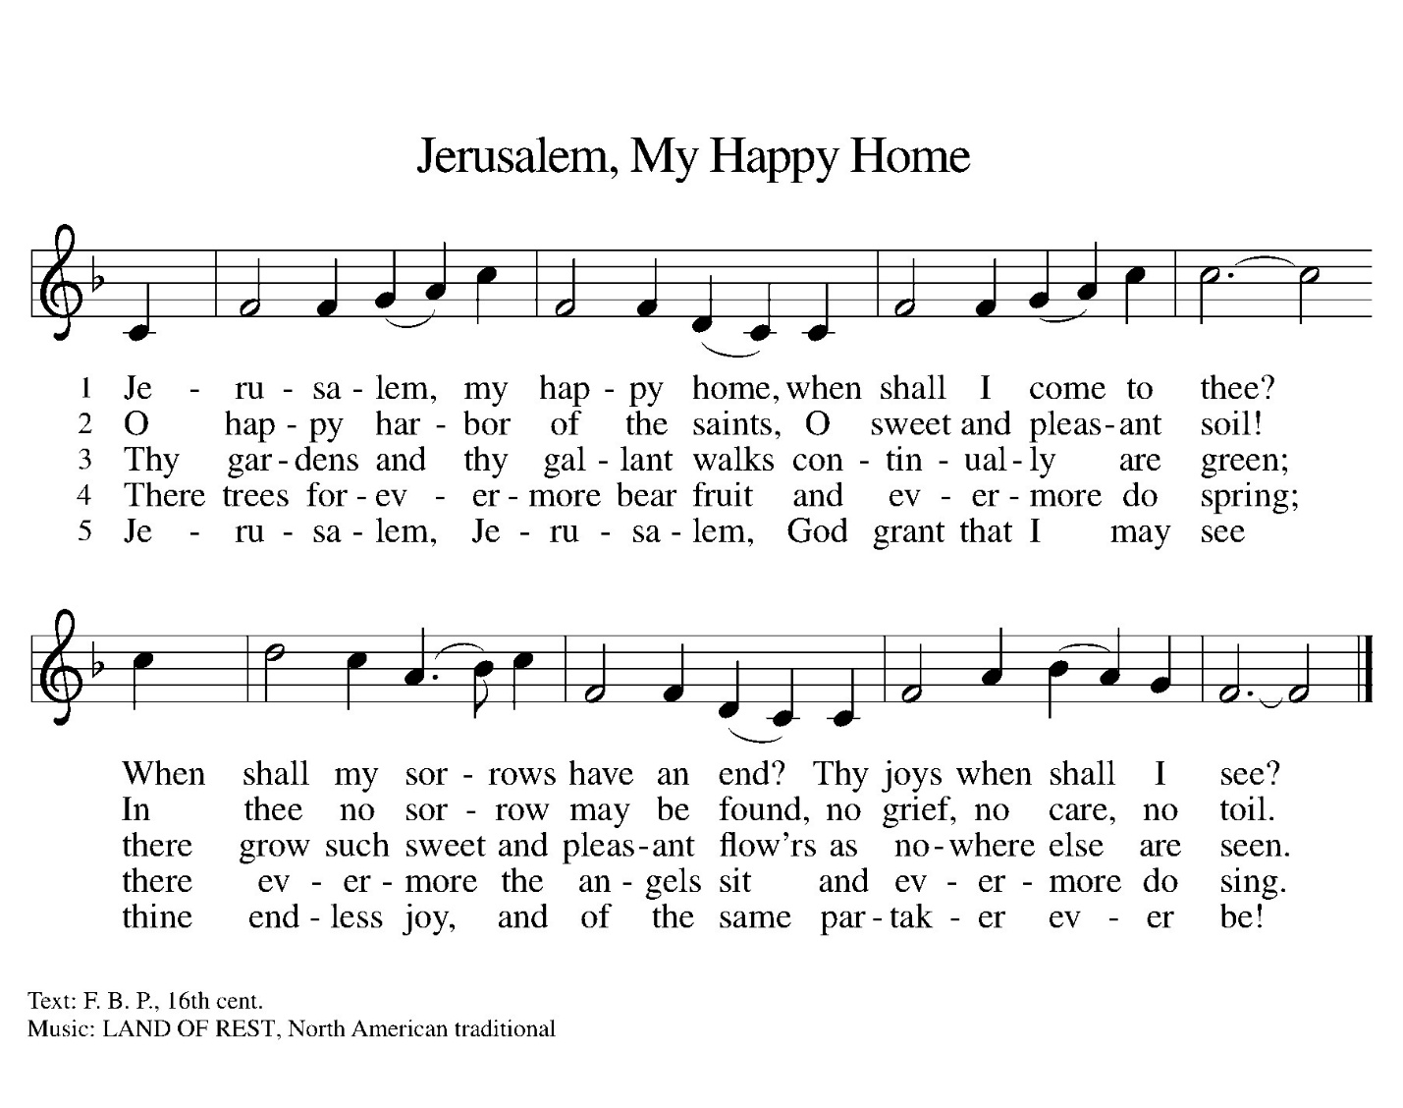



Greeting
The grace of our Lord Jesus Christ, the love of God,
and the communion of the Holy Spirit be with you all.
And also with you.
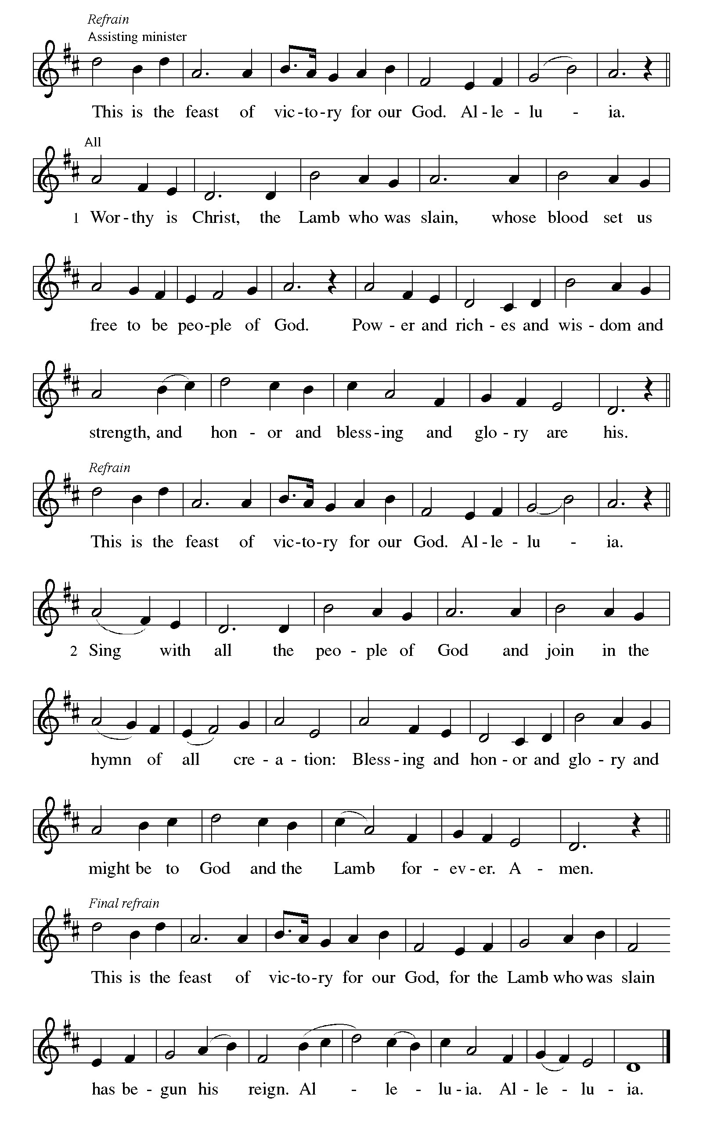

Prayer of the Day
O God, our eternal redeemer, by the presence of your Spirit you renew and direct our hearts. Keep always in our mind the end of all things and the day of judgment. Inspire us for a holy life here, and bring us to the joy of the resurrection, through Jesus Christ, our Savior and Lord. Amen.
The congregation is seated.

Children’s Message
Children are invited forward for a special message. After the Children’s Message, children are welcome to go to Faith Formation and return prior to Holy Communion.

Word
God speaks to us in scripture reading, preaching, and song.

First Reading: Job 19:23-27a
A reading from Job the 19th chapter.
Job suffers the loss of children, wealth, and health. Accused by his companions of wrongdoing, he knows himself to be innocent. Here, in the midst of his suffering, Job clings to the radical hope that his vindicator, his redeemer, lives; and that one day he himself will see God.
²³ “O that my words were written down!
O that they were inscribed in a book!
²⁴ O that with an iron pen and with lead
they were engraved on a rock forever!
²⁵ For I know that my vindicator lives
and that in the end he will stand upon the earth;
²⁶ and after my skin has been destroyed,
then in my flesh I shall see God,
²⁷whom I shall see on my side,
and my eyes shall behold, and not another.”
Word of God, word of life.
Thanks be to God.

Psalm: Psalm 17:1-8
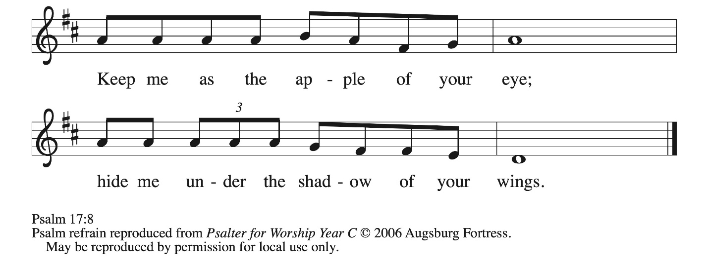

¹Hear a just cause, O Lord; give heed | to my cry;
listen to my prayer, which does not come from | lying lips.
²Let my vindication come forth | from your presence;
let your eyes be | fixed on justice.
³Examine my heart, visit | me by night,
melt me down; you will find no impuri- | ty in me.
⁴I have not regarded what | others do;
at the word of your lips I have avoided the ways | of the violent. R
⁵My footsteps hold fast to your | well-worn path;
and my feet | do not slip.
⁶I call upon you, O God, for you will | answer me;
incline your ear to me and | hear my words.
⁷Show me your marvelous | lovingkindness,
O Savior of those who take refuge at your right hand from those who | rise up against them.
⁸Keep me as the apple | of your eye;
hide me under the shadow | of your wings, R

Second Reading: 2 Thessalonians 2:1-5, 13-17
A reading from 2 Thessalonians the Second chapter.
This portion of the letter provides encouragement for the church at Thessalonica during a time of confusion and opposition, as some allowed their concern over Jesus’ imminent return to divert them from the central teachings of the gospel.
¹ As to the coming of our Lord Jesus Christ and our being gathered together to him, we beg you, brothers and sisters, ² not to be quickly shaken in mind or alarmed, either by spirit or by word or by letter, as though from us, to the effect that the day of the Lord is already here. ³ Let no one deceive you in any way, for that day will not come unless the rebellion comes first and the lawless one is revealed, the one destined for destruction. ⁴ He opposes and exalts himself above every so-called god or object of worship, so that he takes his seat in the temple of God, declaring himself to be God. ⁵ Do you not remember that I told you these things when I was still with you?
¹³ But we must always give thanks to God for you, brothers and sisters beloved by the Lord, because God chose you as the first fruits for salvation through sanctification by the Spirit and through belief in the truth. ¹⁴ For this purpose he called you through our gospel, so that you may obtain the glory of our Lord Jesus Christ. ¹⁵ So then, brothers and sisters, stand firm and hold fast to the traditions that you were taught by us, either by word of mouth or by our letter.
¹⁶ Now may our Lord Jesus Christ himself and God our Father, who loved us and through grace gave us eternal comfort and good hope, ¹⁷ comfort your hearts and strengthen them in every good work and word.

Word of God, word of life.
Thanks be to God.

Please stand as able to receive the Holy Gospel.
Gospel Acclamation (ELW p. 151)

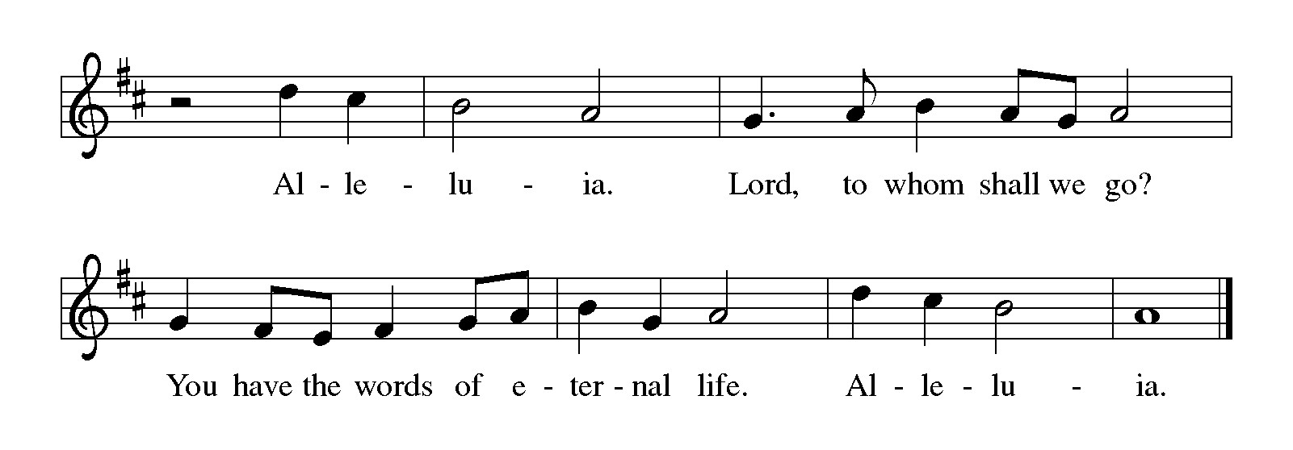

Gospel: Luke 20:27-28
The Holy Gospel according to St. Luke the 20th chapter.
Glory to you, O Lord.
Some Sadducees, who do not believe in the resurrection of the dead, try to trap Jesus. They formulate the convoluted case of a serial widow who marries a succession of seven brothers. Jesus responds by teaching about God to whom all are alive and in whom all relationships are fulfilled.

²⁷Some Sadducees, those who say there is no resurrection, came to [Jesus] ²⁸ and asked him a question: “Teacher, Moses wrote for us that if a man’s brother dies leaving a wife but no children, the man shall marry the widow and raise up children for his brother. ²⁹ Now there were seven brothers; the first married a woman and died childless; ³⁰ then the second ³¹ and the third married her, and so in the same way all seven died childless. ³² Finally the woman also died. ³³ In the resurrection, therefore, whose wife will the woman be? For the seven had married her.”
³⁴ Jesus said to them, “Those who belong to this age marry and are given in marriage, ³⁵ but those who are considered worthy of a place in that age and in the resurrection from the dead neither marry nor are given in marriage. ³⁶ Indeed, they cannot die anymore, because they are like angels and are children of God, being children of the resurrection. ³⁷ And the fact that the dead are raised Moses himself showed, in the story about the bush, where he speaks of the Lord as the God of Abraham, the God of Isaac, and the God of Jacob. ³⁸ Now he is God not of the dead but of the living, for to him all of them are alive.”

The gospel of the Lord.
Praise to you, O Christ.
Please be seated

Sermon Rev. Richard A. Rhoades

Please stand as able.
Hymn of the Day I Know that My Redeemer Lives ELW 619
Verses 1-4
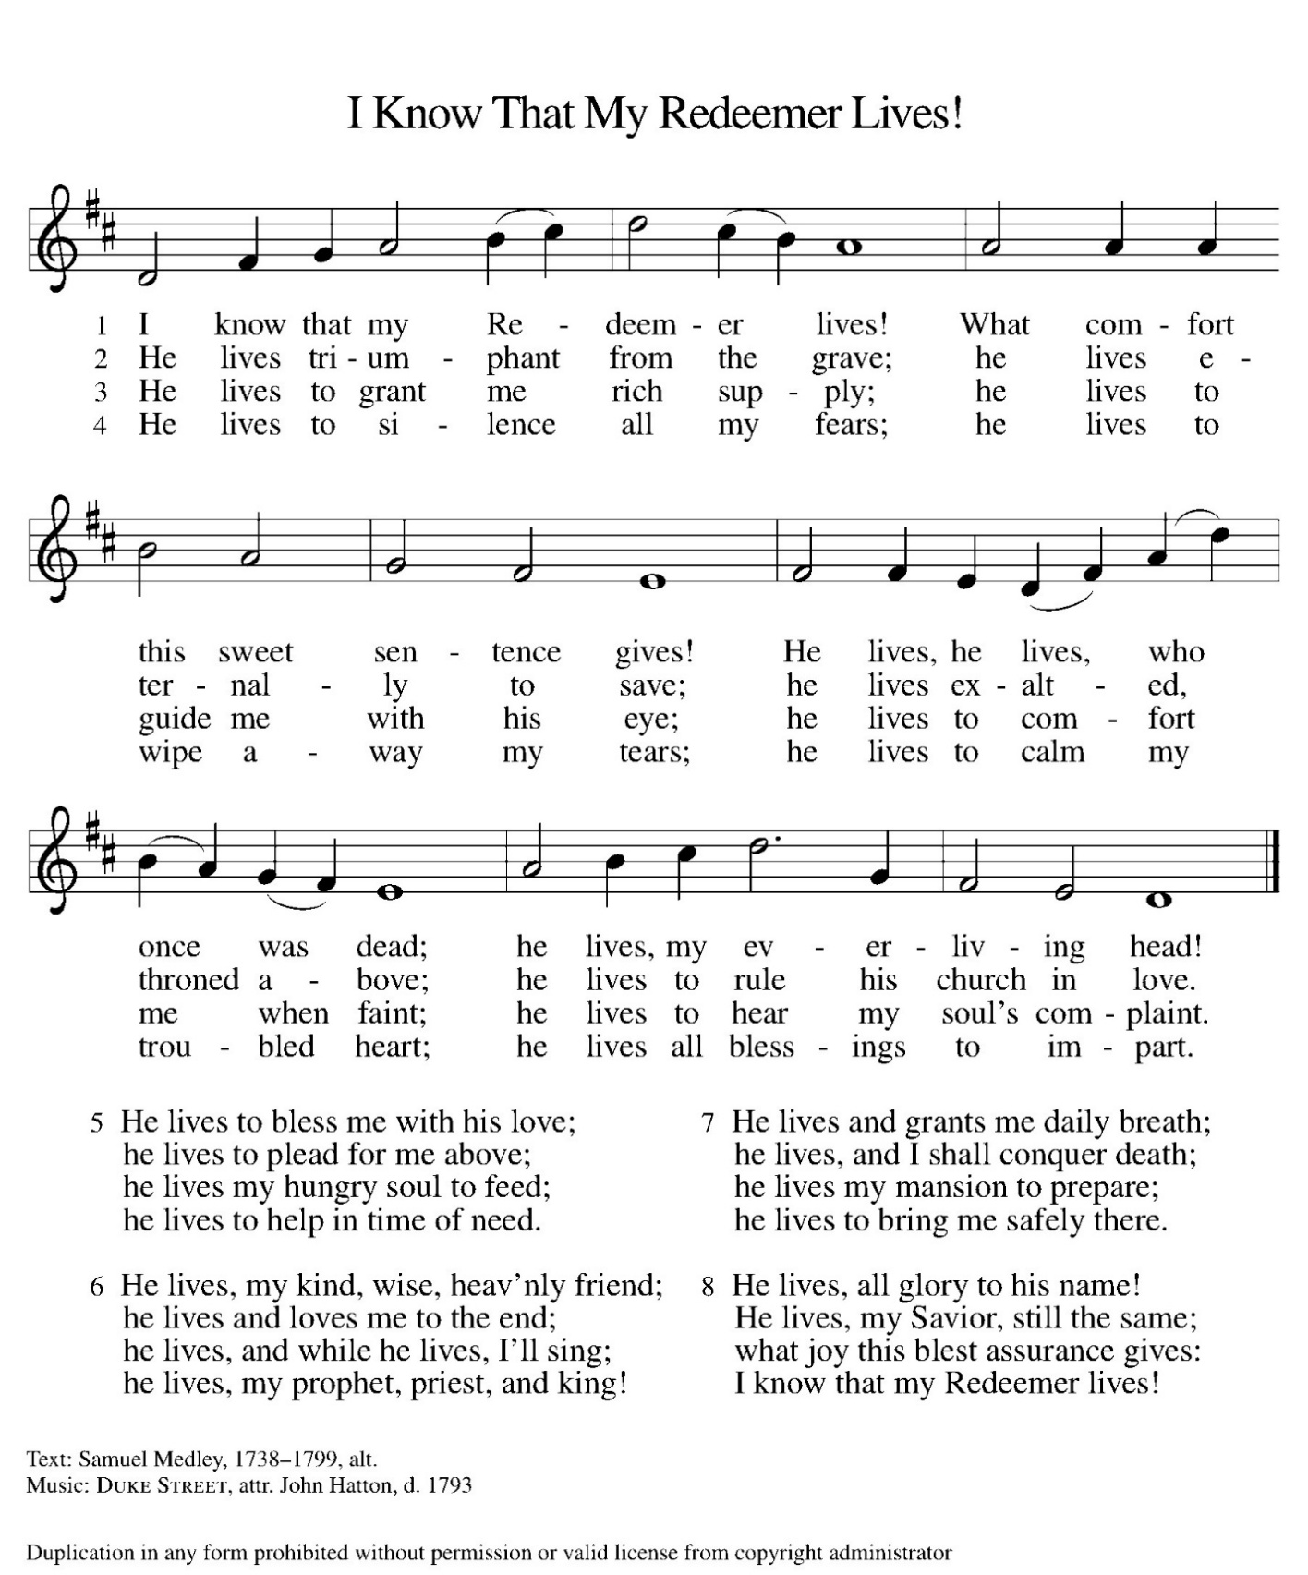

Apostles’ Creed
I believe in God, the Father almighty,
creator of heaven and earth.
I believe in Jesus Christ, God’s only Son, our Lord,
who was conceived by the Holy Spirit,
born of the virgin Mary,
suffered under Pontius Pilate,
was crucified, died, and was buried;
he descended to the dead.
On the third day he rose again;
he ascended into heaven,
he is seated at the right hand of the Father,
and he will come to judge the living and the dead.
I believe in the Holy Spirit,
the holy catholic church,
the communion of saints,
the forgiveness of sins,
the resurrection of the body,
and the life ☩ everlasting. Amen.

Prayers of Intercession
Prayers of Intercession
Gathered with one voice, we offer our prayers for the church, the world, and all who are in need.
A brief silence.
God our Redeemer, bless your church universal and its leaders. Build up the faith of the baptized empowering them to share the Good News. Set all hearts on you from generation to generation in anticipation of Christ’s return. Hear us, O God.
Your mercy is great.
God of life, we give thanks for the fruits and grains of harvest, for streams and seas, for all that is made of rock and iron. Renew the earth’s natural resources and the lands from which they come. Hear us, O God.
Your mercy is great.
God of justice, we give thanks for the service of our veterans and pray for those needing support for wounds of any kind. Strengthen those charged with the governance and protection of vulnerable populations. Bring an end to war throughout the world. Hear us, O God.
Your mercy is great.
God who leads us to belief and truth, we give thanks that you are always and already here. Nurture and support those who are unsteady in mind, unsafe in spirit, or unwell in body including Deacon Brandi, Debbie, those on our sustaining prayer list, and those we name now… . Comfort those who suffer from trauma and exposure to traumatic events. Hear us, O God.
Your mercy is great.
God who gathers us together, we give thanks for our pastors and deacons, teachers and musicians, administrators, and building caretakers. May they find joy in leadership as we grow in faith together. Hear us, O God.
Your mercy is great.
God of love, you bless us with friendships and partnerships near and far. We pray for Bishops Curry and Breashears Schultz, Lutheran Campus Ministries and our seminaries, along with our international partners in the Central African Republic, Peru and the Maasai in Tanzania. Hear us, O God.
Your mercy is great.
God of the saints, we give thanks for all who have died in faith. Uplift us as we honor their memory and await your coming in glory. Hear us, O God.
Your mercy is great.
We offer these and all our prayers to you, O God, trusting in your grace and unyielding love; through Jesus Christ, our Lord.
Amen.

Please stand as able.
Peace
The peace of Christ be with you always.
And also with you.

Meal
God feeds us with the presence of Jesus Christ.

Offering
For those who wish to donate online the QR code will take you to the online giving page.


Please stand as able to sing.
offering hymn Only Verse 1

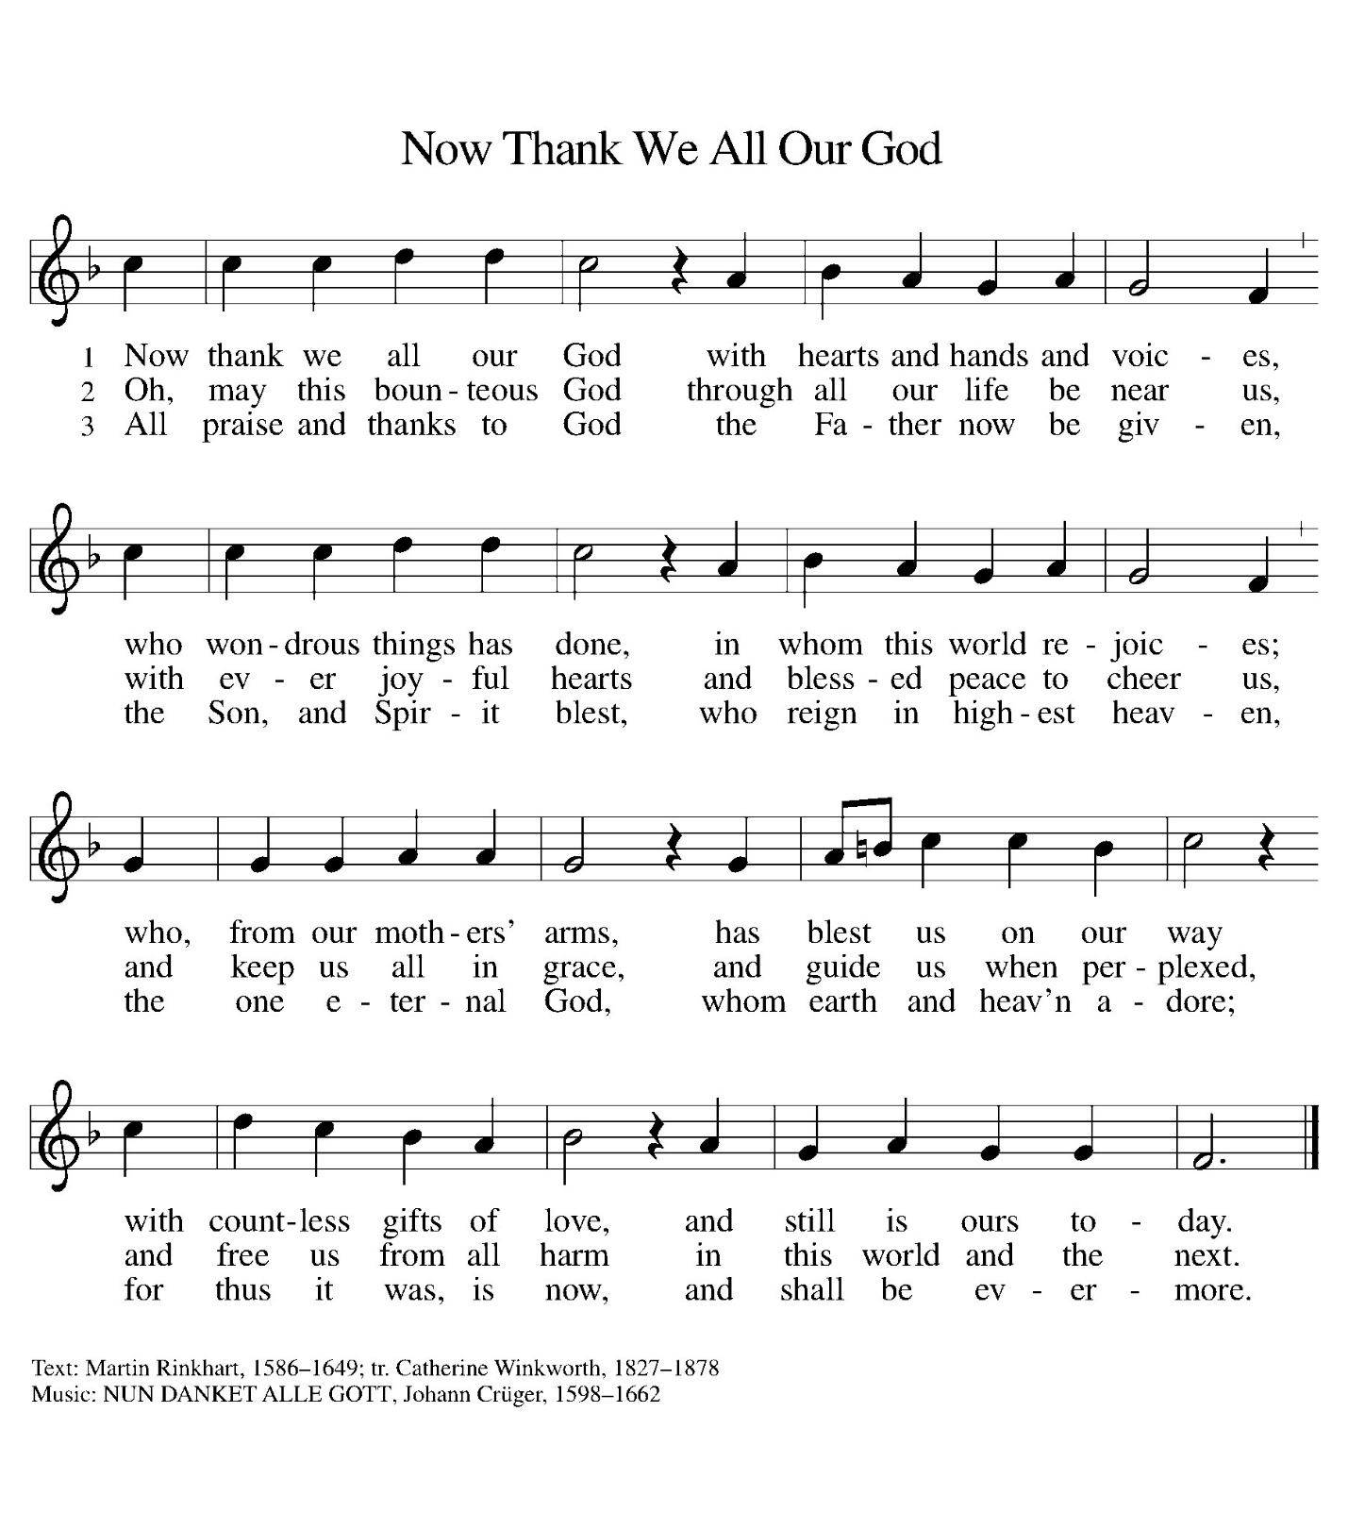
Offering Prayer
God of field and flower, sea and sky, wheat and grape, you have nourished us well with the body and blood of your Son. Strengthened by the body and blood of your Son, send us out to share your good gifts with all who hunger and thirst, and embolden us to love and serve in Christ’s name.
Amen.

Great Thanksgiving
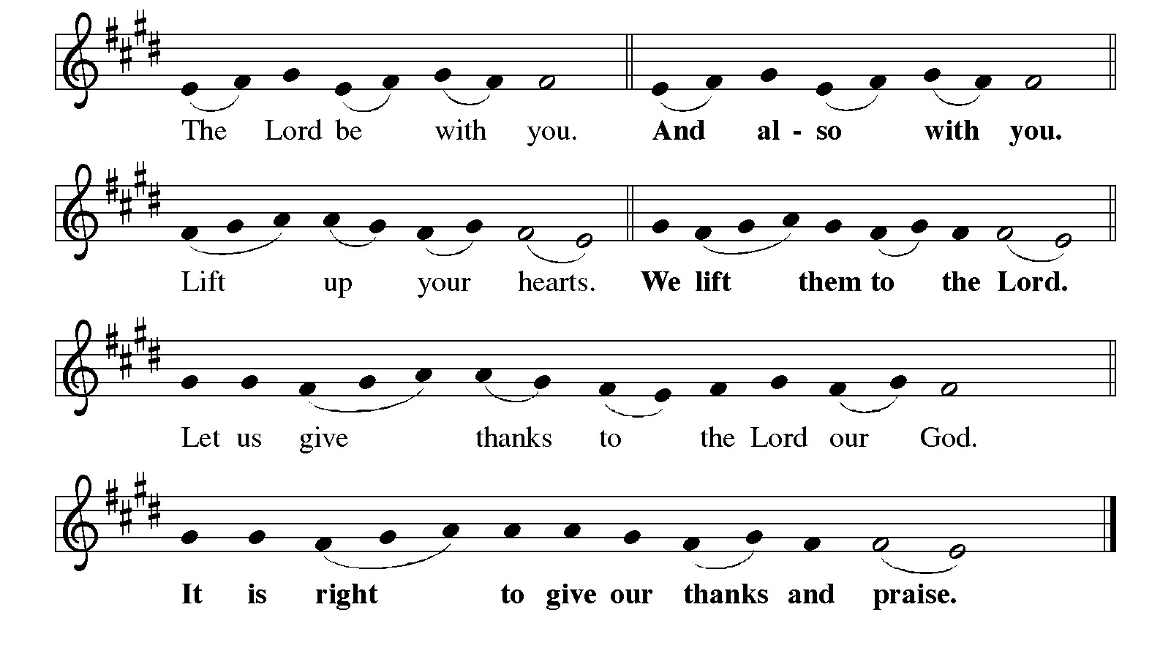
Preface
It is indeed right, our duty and our joy,
……..we praise your name and join their unending hymn:

Holy, Holy, Holy
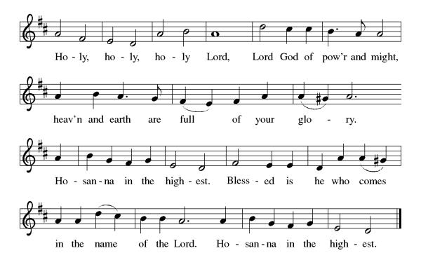
Please kneel or be seated as able.

Thanksgiving at the Table
O God most mighty, O God most merciful,
O God our rock and our salvation,
hear us as we praise, call us to your table, grant us your life.

When the earth was a formless void, you formed order and beauty.
When Abraham and Sarah were barren, you sent them a child;
When the Israelites were enslaved, you led them to freedom.
Ruth faced starvation, David fought Goliath,
and the psalmists cried out for healing,
and full of compassion, you granted the people your life.

You entered our sorrows in Jesus our brother.
He was born among the poor, he lived under oppression,
he wept over the city.
With infinite love, he granted the people your life.

In the night in which he was betrayed,
our Lord Jesus took bread, and gave thanks;
broke it, and gave it to his disciples, saying:
Take and eat; this is my body, given for you.
Do this for the remembrance of me.

Again, after supper, he took the cup,
gave thanks, and gave it for all to drink, saying:
This cup is the new covenant in my blood,
shed for you and for all people for the forgiveness of sin.
Do this for the remembrance of me.

O God, you are Breath: send your Spirit on this meal.
O God, you are Bread: feed us with yourself.
O God, you are Wine: warm our hearts and make us one.
O God, you are Fire: transform us with hope.

Grant us such life,
the life of the Father to the Son,
the life of the Spirit of our risen Savior,
life in you, now and forever.
Amen.

Lord’s Prayer
Gathered into one by the Holy Spirit, let us pray as Jesus taught us.
Our Father, who art in heaven,
hallowed be thy name,
thy kingdom come,
thy will be done,
on earth as it is in heaven.
Give us this day our daily bread;
and forgive us our trespasses,
as we forgive those
who trespass against us;
and lead us not into temptation,
but deliver us from evil.
For thine is the kingdom,
and the power, and the glory,
forever and ever. Amen.

Invitation to Communion
There is a place for you at the table of God. Come, receive the food that does not perish, a taste of eternal life.

Communion Song Lamb of God
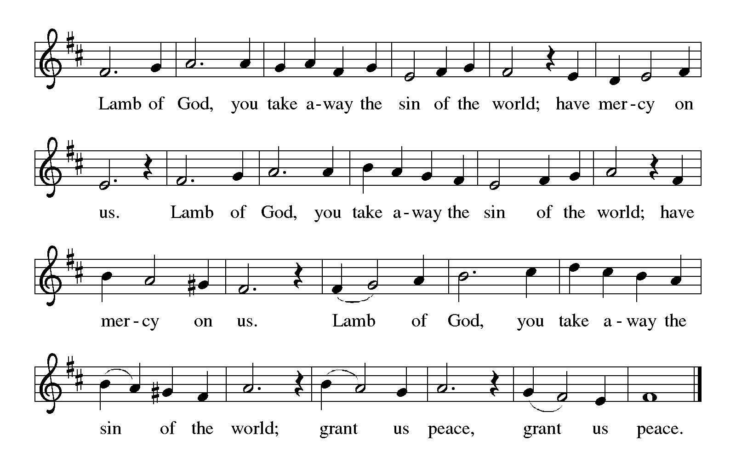

reception of communion
The ushers will direct you forward to receive communion.

Holy Communion is a gift from God for the sake of the world. In Holy Communion we receive the body and blood of Jesus. With this gift we are given the promise of the forgiveness of sin and the gift of salvation. All who are baptized are welcome to receive this gift of grace. You may also come forward with your arms crossed over your chest to receive a blessing.

The pastor has gluten free wafers for those who must be gluten free.

After receiving communion or a blessing, you may light a candle. Also, a healing prayer minister will be in the chapel for those desiring personal prayer.

Communion Music

Now We Join in Celebration ELW 462
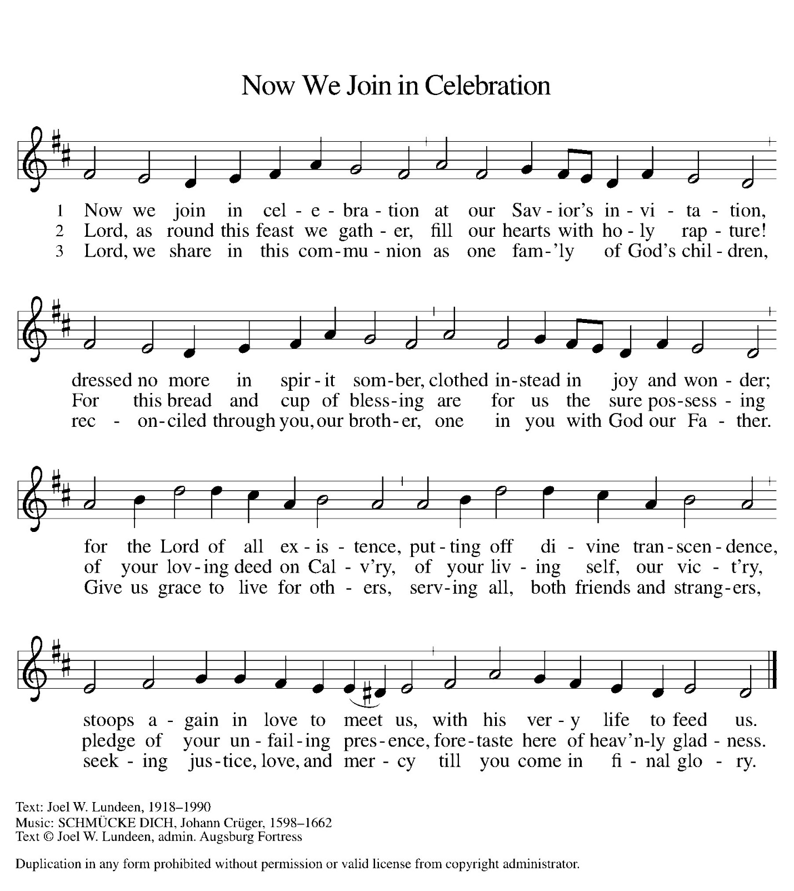

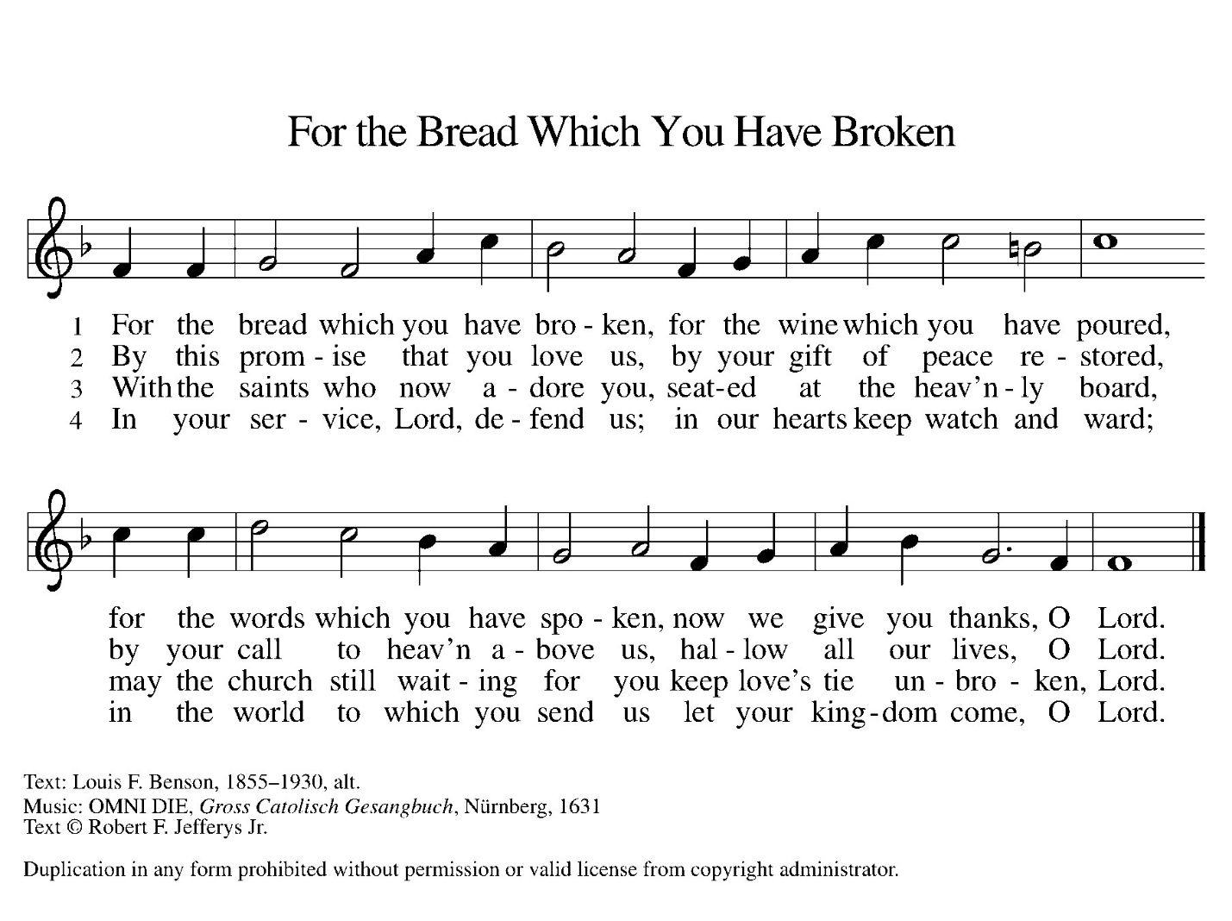
Please stand as able.
Post Communion Blessing
The body and blood of our Lord Jesus Christ ☩
strengthen and preserve you in eternal life.
Amen.

Prayer after Communion
We give you thanks, almighty God, that you have refreshed us through the healing power of this gift of life. In your mercy, strengthen us through this gift, in faith toward you and in fervent love toward one another; for the sake of Jesus Christ our Lord.
Amen.

Sending

Blessing
The God of righteousness,
who gives justice to the oppressed,
who gives food to the hungry,
who sets the prisoners free,
☩ bless you now and forever. Amen.

Sending Song Blessed Assurance ELW 638

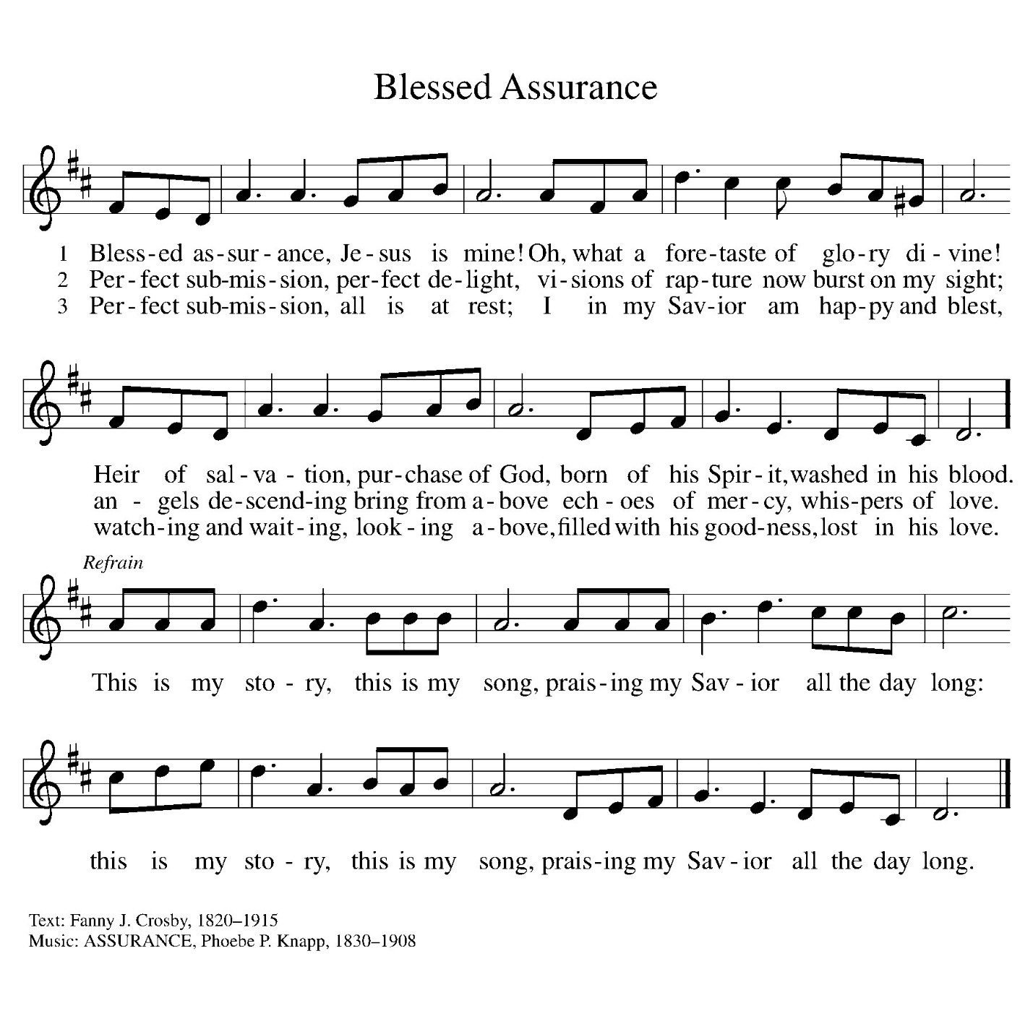
Dismissal
Jesus calls us to be a community,
embracing all; nourishing mind, body and spirit.
We go into the world
Following Jesus – Loving All
Go in peace. Do not lose heart.
Thanks be to God.

POSTLUDE
From sundaysandseasons.com.

Copyright © 2025 Augsburg Fortress. All rights reserved.



Filled with hope through Jesus Christ, we go forth in faith to serve God and our neighbors!



Email: flcg@firstlutherangalveston.com
Web site: firstlutherangalveston.com

Church Office Hours, Monday – Thursday
9:00am to 12:00pm, 12:30pm to 3:00pm

The People of First Lutheran, Ministers
The Reverend Richard A. Rhoades, Senior Pastor
Brandi Painter, Deacon
Don F. Hermanson, Director of Music/Organist
Krista Scheuerman, Coordinator of Youth and Family Ministry
Annie Blancken, Executive Director, LMA
Christina Muehe, Director, Lyceum
Dariana Gonzalez, Communications Coordinator

First Lutheran Church
2415 Avenue G
Galveston, TX 77550
409-762-8477

Thank you for gathering with us in worship!

As you go, know that you are held in the prayers of the congregation.

We look forward to seeing you again!

Join us on Sunday, November 16th for the

Celebration of our 175th anniversary.

Bishop Tracey Breashears Schultz will be present to mark the historic occasion.
A luncheon will follow in the historic Lyceum. Tickets are available and are needed for this part of the celebration.

