

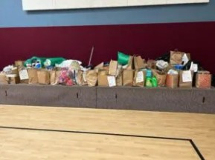
Portland neighbors filled nearly 200 bags of items for the donation drive.

Prince of Peace Lutheran Church Engages Neighbors in Donation Drive
In Portland, Prince of Peace Lutheran Church, led by Pastor Dan Haugen, organized a donation drive for LCSNW to distribute donated items to local refugee families.

Congregants developed the idea of a quarterly drive for donations by distributing bags on neighborhood doorsteps with a list of needed items for newly resettled refugee families. The Prince of Peace congregation gifted nearly 200 bags of new or lightly used needed items, which each donating member left on their front porch to be collected by volunteers and then distributed at LCSNW.

Our team at LCSNW is amazed by the creativity and generosity of the Prince of Peace Lutheran Church community.

“God can do mighty things with a little bit of work; we see His fingerprints throughout all of this,” said Pastor Dan, who also voiced his hopes that other churches will adopt the model of the brown bag neighborhood drop.

Contact Prince of Peace Lutheran Church at (503) 645-1211 to inquire about collaborating or participating with them in a future drive. LCSNW’s volunteer coordinator for Portland, Vancouver and Beaverton is Fiona Evans, fevans@lcsnw.org.

