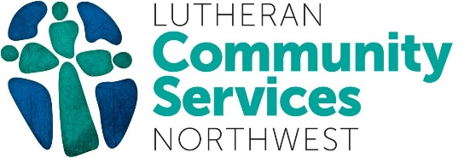

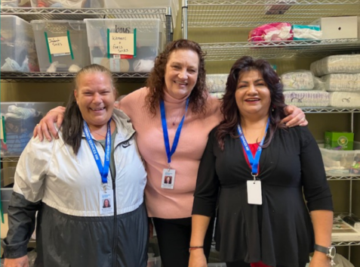
Resource Navigators (from left to right) Melanie and Lori teamed up with Community Resources Center Coordinator Yolanda to help the family of six.

LCSNW Staff Members Are Empowered to Serve Northwest Communities
Three sisters, all of whom are mothers, entered LCSNW’s Everett Community Resource Center (CRC). The family of six was tired, hungry, and without a place to stay. Staff were able to secure shelter for the family, and assist them with other critical needs including medical support, immigration services, and baby supplies.

For Yolanda, a coordinator at the CRC, it is a blessing to serve families in crisis. “It’s hard to hear these stories, but I don’t ever want to lose hope that a better life is possible for everyone we help,” Yolanda shared.

The LCSNW staff is empowered by your community’s spirit of giving. We thank all of our partners and supporters for uplifting our mission of restoring health, justice, and hope in communities.

