Nativity Lutheran Church (Renton) is moving out of our current space while a new facility is being built and have a number of items we will not be storing that we would like to offer to other congregations in the area!

If you are interested in any of these items, please contact the church office (NativityLCoffice@gmail.com or 425-228-5464) for more information.

We’ll be holding a “No-Sale Garage Sale” on Friday, August 19th (9am-3pm) and Saturday, August 20th (9am-2pm). We’d love to get as many of these spoken for before then as possible!

Collapsible projector screen: screen is ~10’ wide and ~8’ tall:
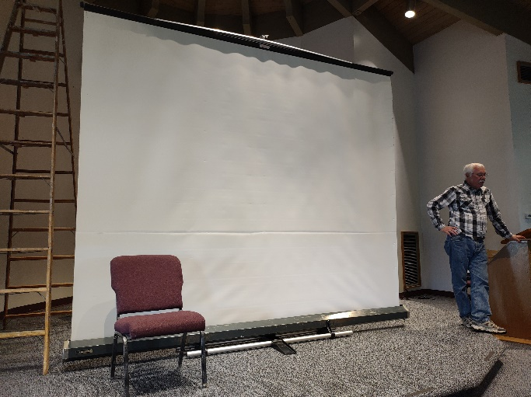
3 two-door cabinets, about 92" x 47" x 26" each.
(One example shown below, basketball for scale):
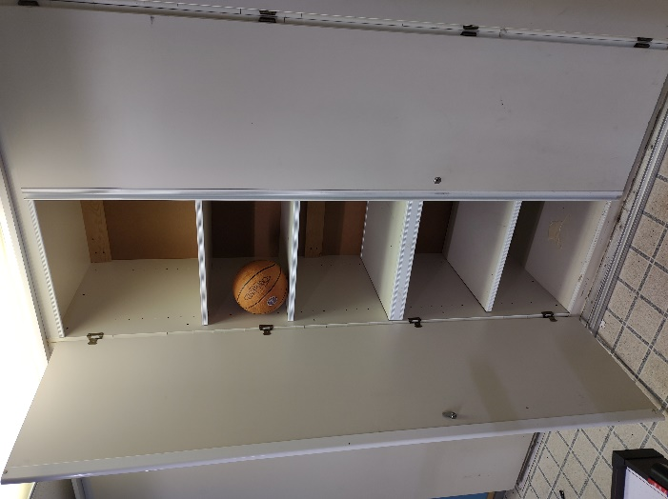
Baptismal Font, Altar, Pulpit (hymnals for scale)

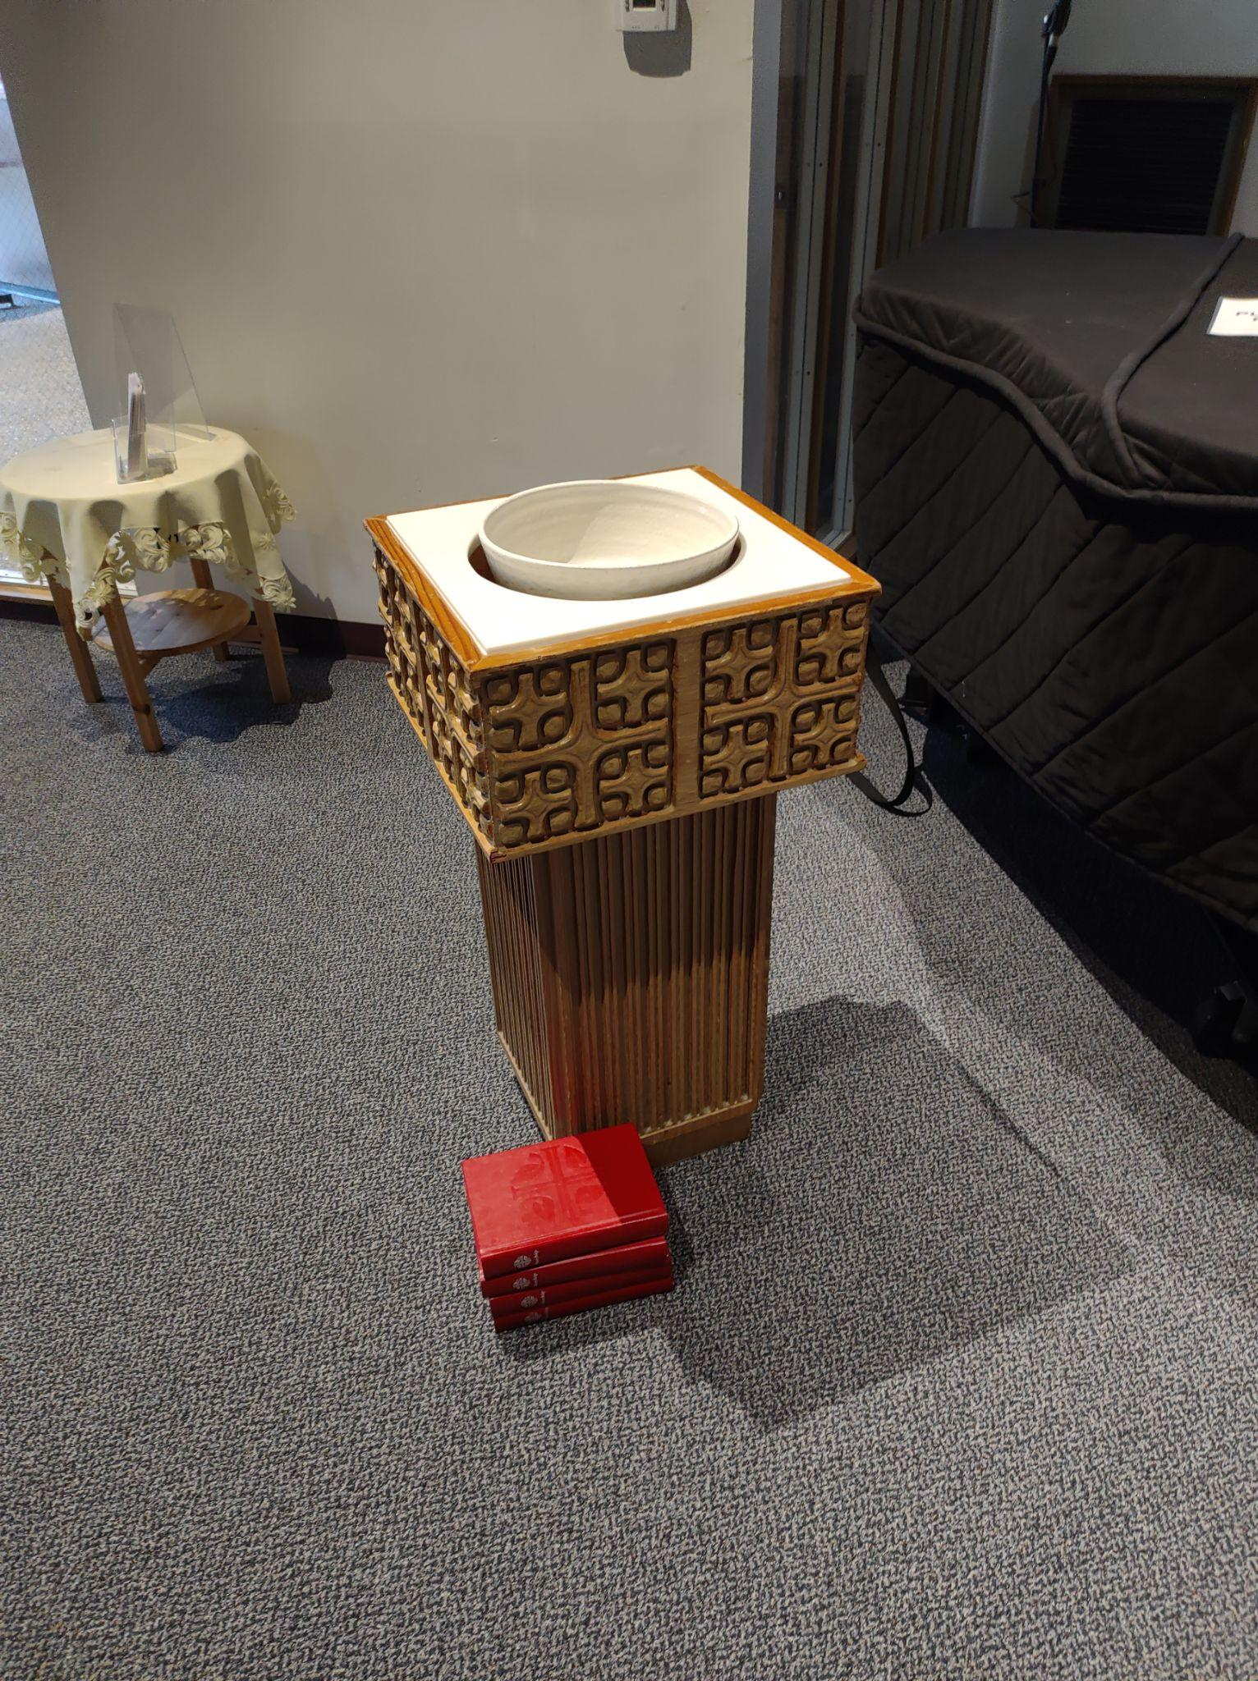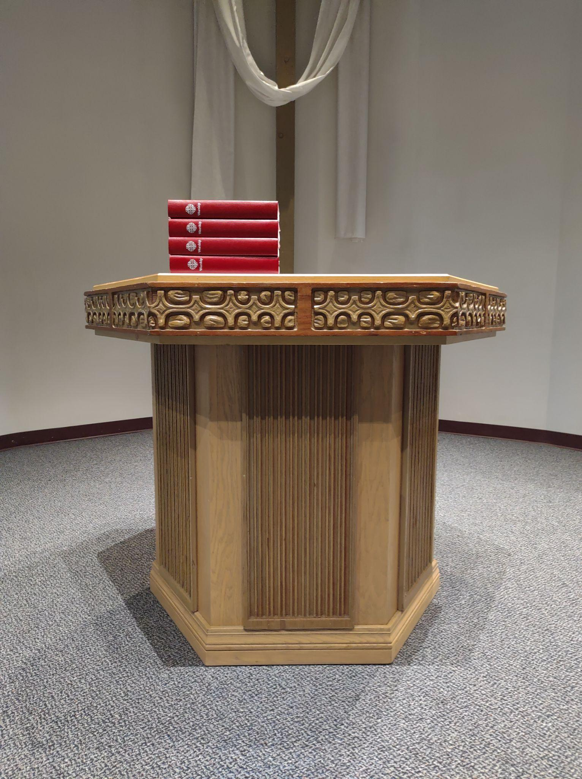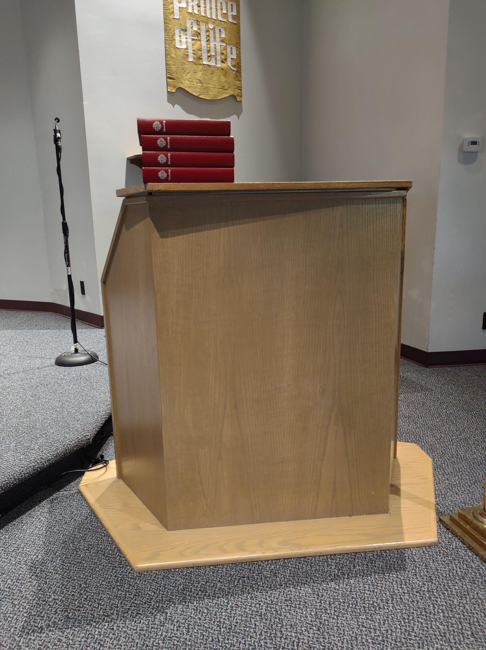

Communion Ware: Chalices, Platters
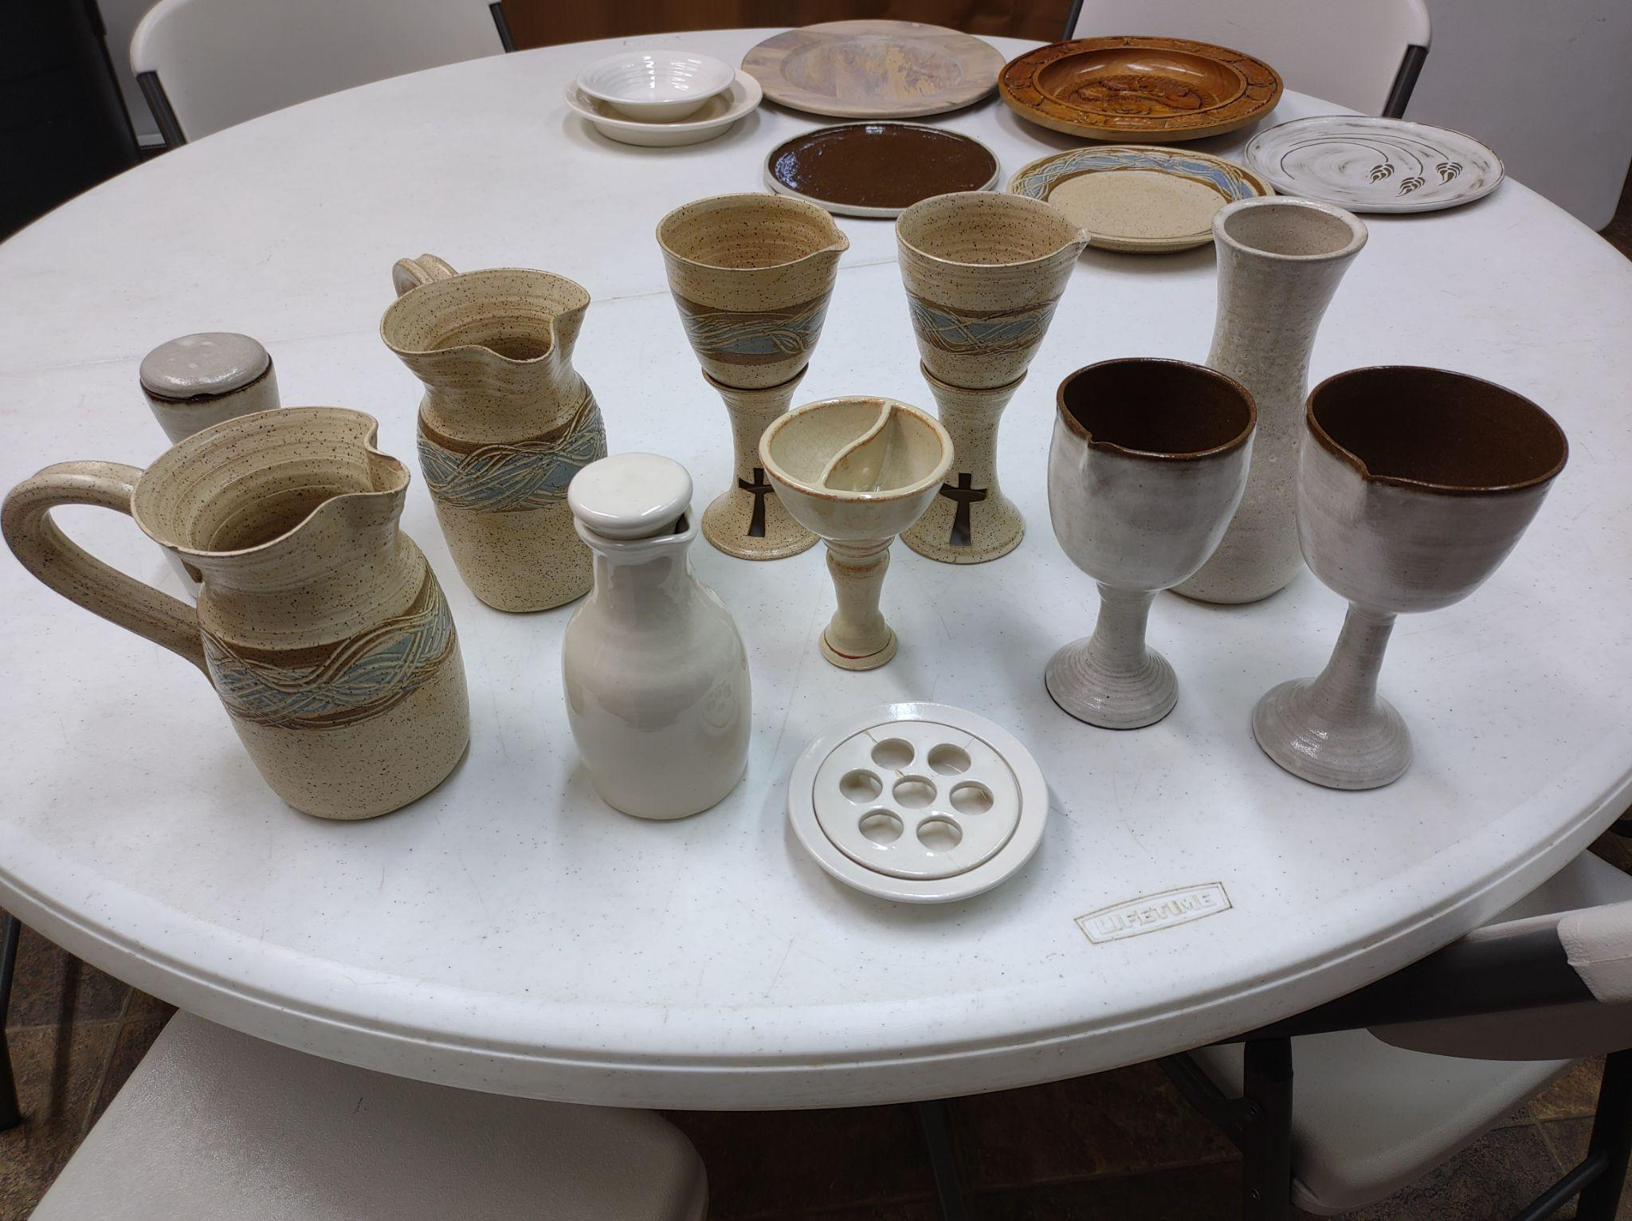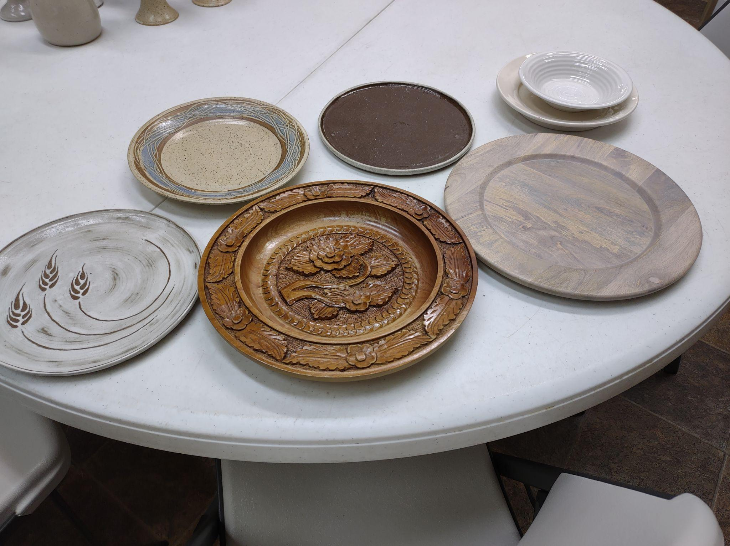

Two wooden chairs:
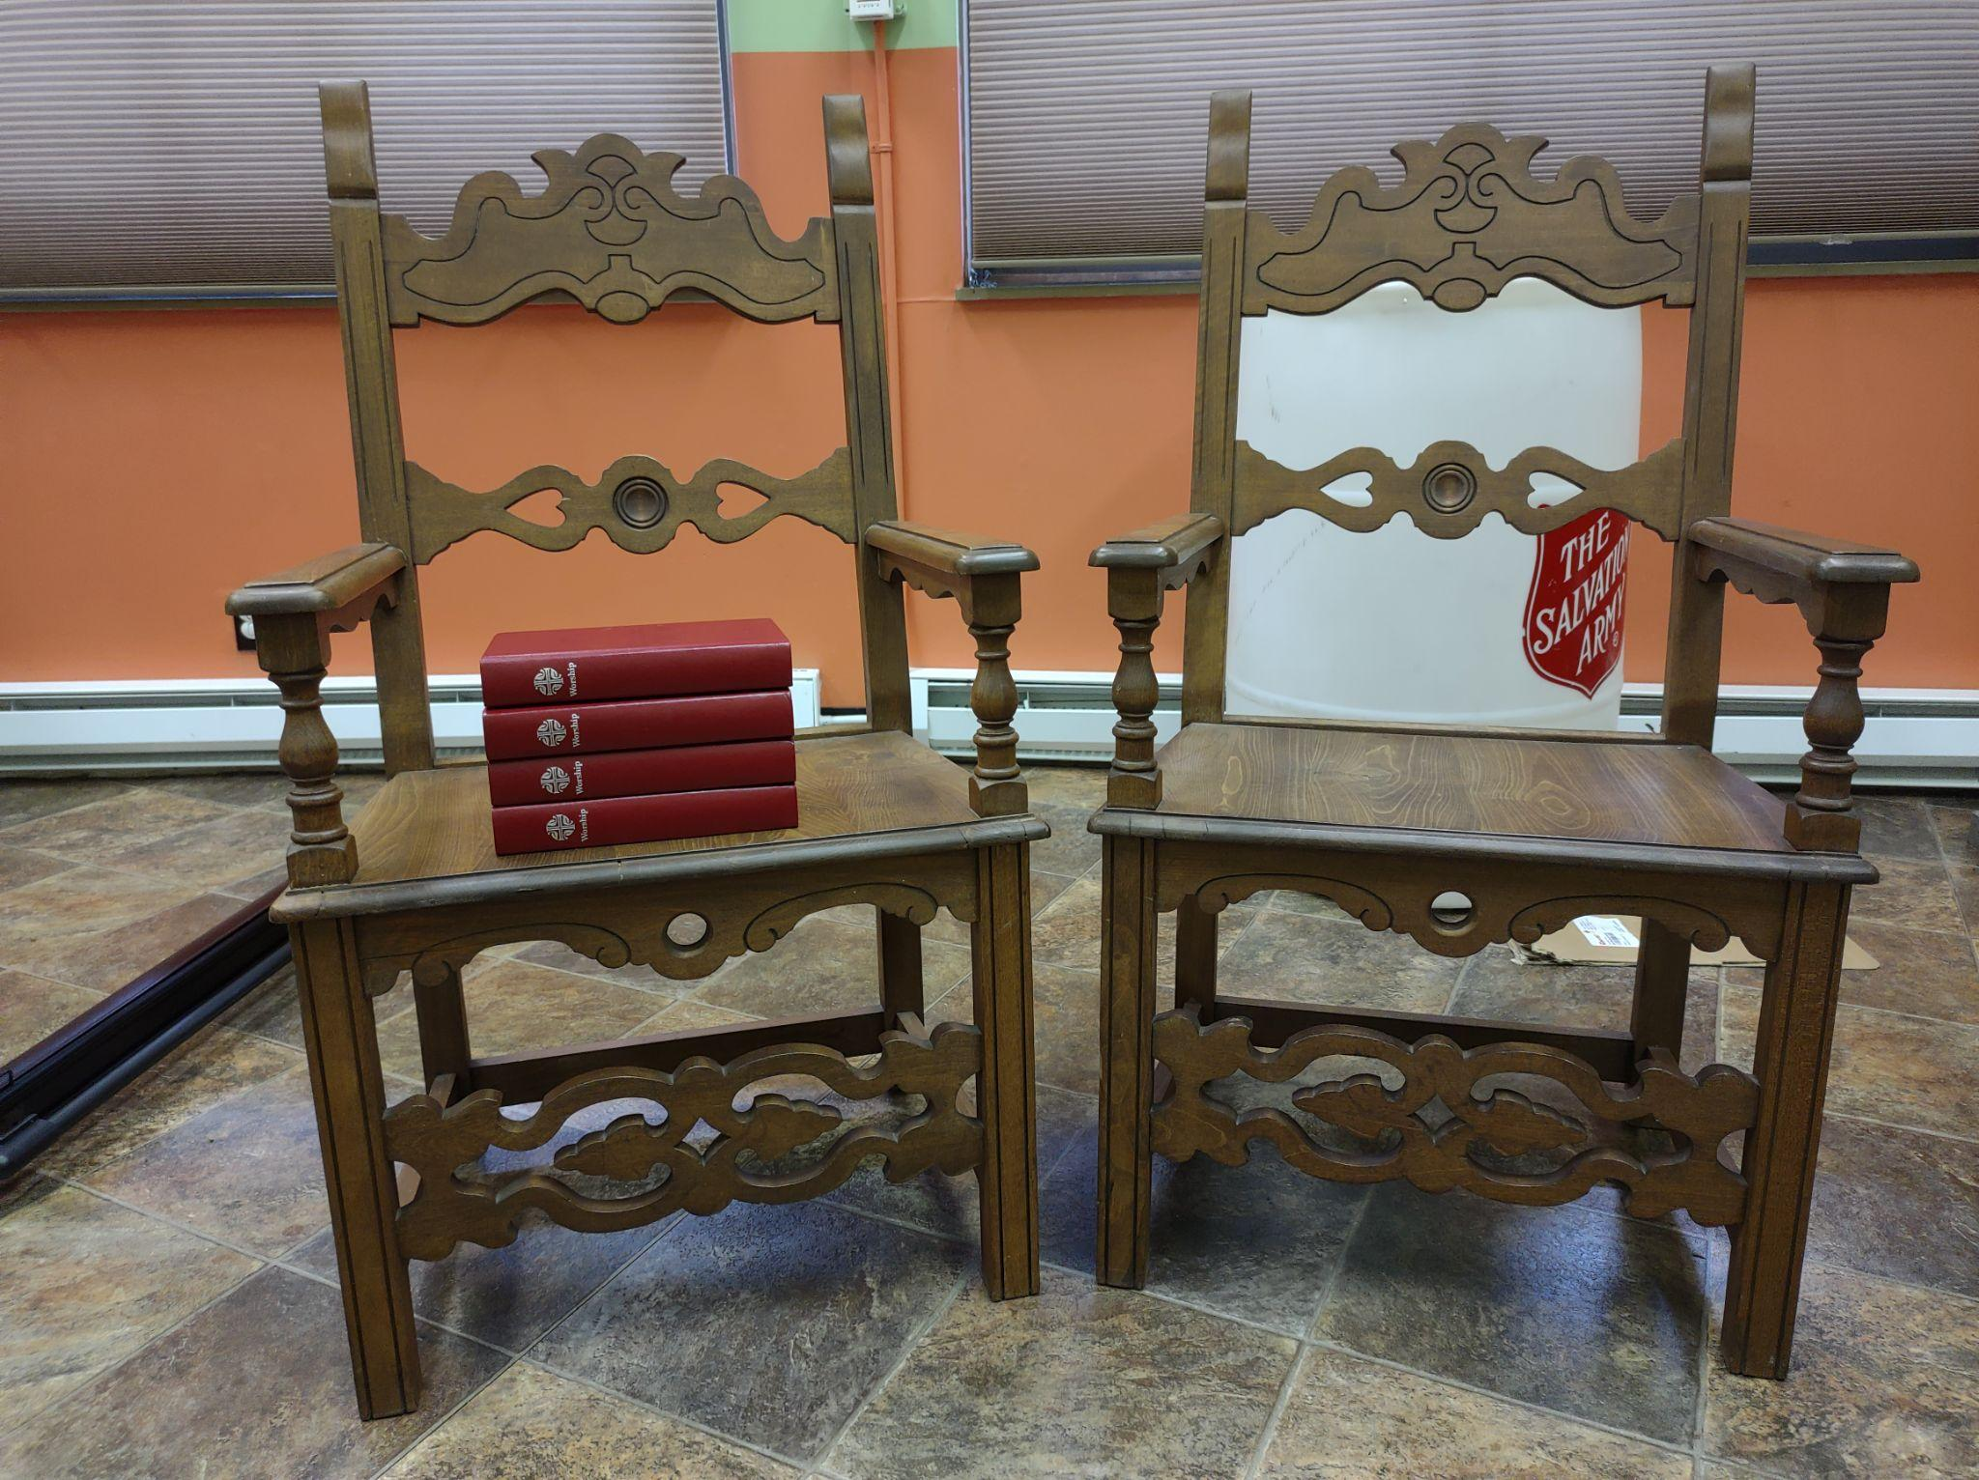

Upright Pianos:
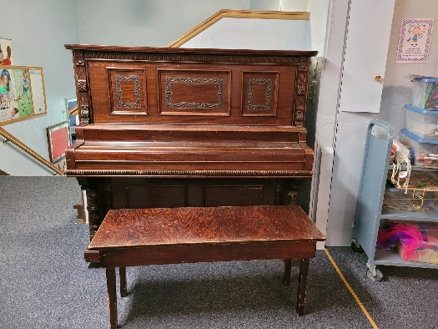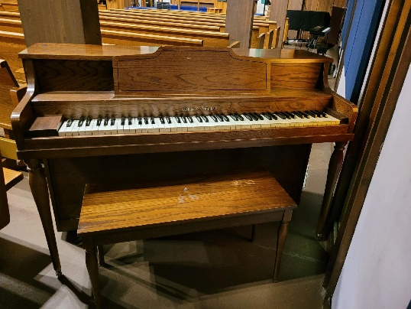
Miscellaneous (100 cup coffee maker, spotlight [multi-color], 2 overhead projectors)
