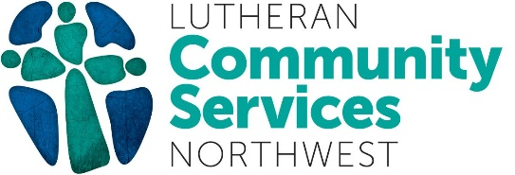

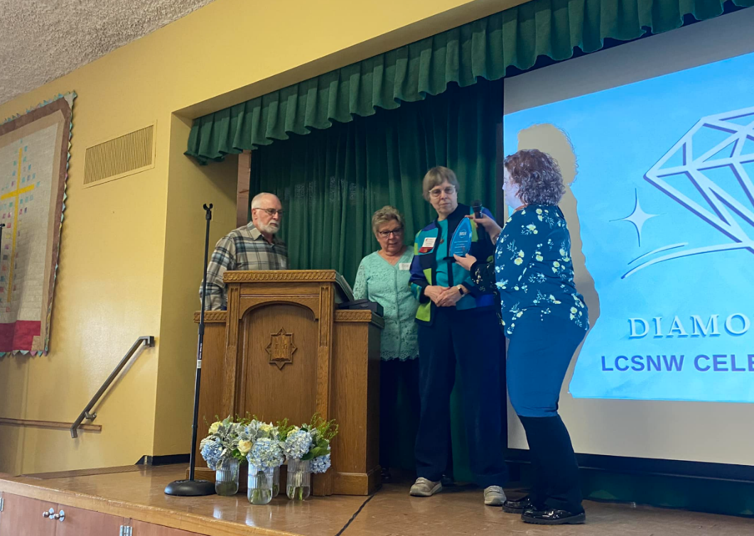
Amy Marinoni, an LCSNW Advancement Manager, presents Kennewick First Lutheran Church with this year’s Wiseman Award.

Kennewick First Lutheran Church Wins Wiseman Award
We are thrilled to celebrate Kennewick First Lutheran Church as this year's Wiseman Award winner!

This award recognizes Tri-Cities area donors who have gone above and beyond to demonstrate true stewardship and community spirit. The congregation of Kennewick First Lutheran Church has offered supporters, volunteers, donors, and overall partners of LCSNW throughout the years. We look forward to many more years serving alongside them.

We are deeply grateful for the partnership and support of all of our church partners. In the spirit of Lutheran fellowship, we extend our deepest gratitude for your commitment to ensure health, justice, and hope.
To learn more about how to get involved with LCSNW as a church partner, click here and reach out directly.

