The International Society Begins Preparations For Centennial Celebrations

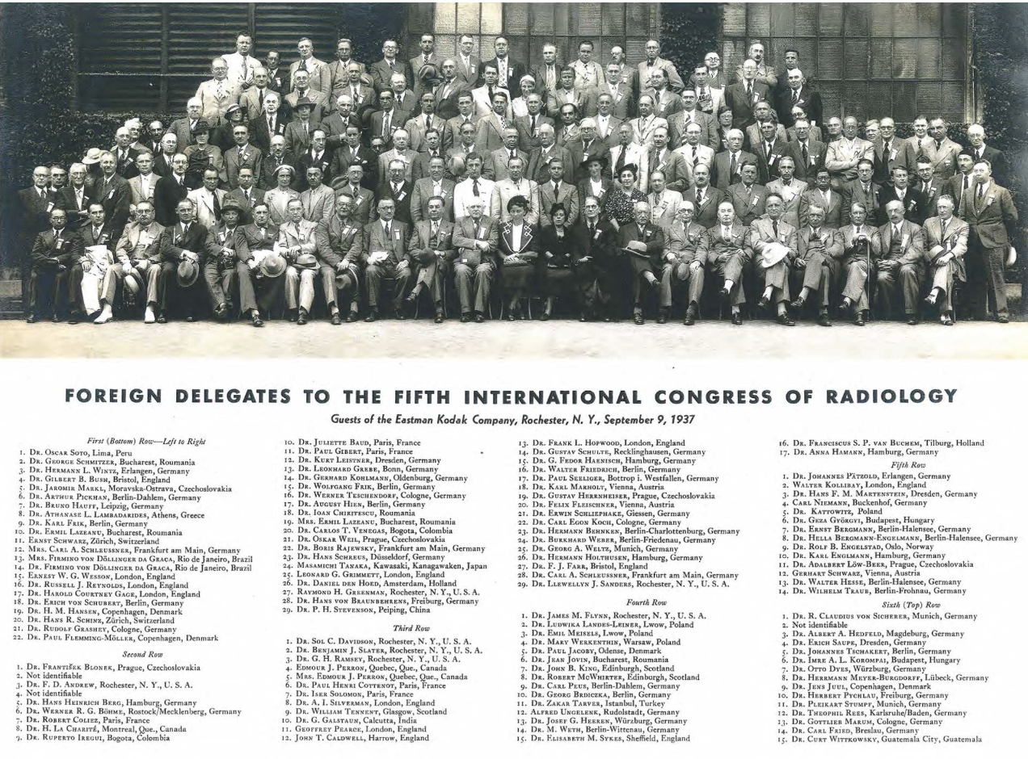
Throughout 2025 and 2026, the International Society of Radiology will celebrate its 100th year anniversary. Thanks to the commitment and work of luminaries like Antoine Béclère and many others, an international effort to assemble physicians from around the world to share their experience in using Roentgens new ray to improve health. That first Congress was held in London in 1925, and although records from the Congress did not survive, that gathering of international experts is considered to represent the beginnings of the International Society of Radiology. Our first documented International Congress of Radiology was held 1937, pictured above, was held in 1937 and over the years the activities of the society focused on education, particularly for those in underserved areas, provide safe and effective radiological care worldwide, and promote health equity by working to increase imaging capacity in low- and middle -income countries.

Our celebrations will include announcements and other activities at regional meetings such as the European Congress of Radiology and the Radiological Society of North America Annual Meeting. We will be promoting our newly established International Society of Radiology Béclère-Fuchs Foundation and conclude the centennial year with special celebrations at the International Congress of Radiology tentatively planned for May 2026.

Our internal Centennial Kickoff will begin with discussions at the upcoming ISR Executive Committee meeting later this summer to finalize the committee structure and timeline. Proposed subcommittees will include content, meetings and education, marketing and promotion, industry outreach and the foundation campaign. If you are interested in participating in any of these areas, please let us know by emailing Martina Szucsich (martina.szucsich@myesr.org) or Meg Samples (msamples@acr.org ). You can also visit and register at the ISR Centennial website at (https://isradiology.org). We look forward to your participation as we celebrate the work and global impact of the International Society of Radiology.

