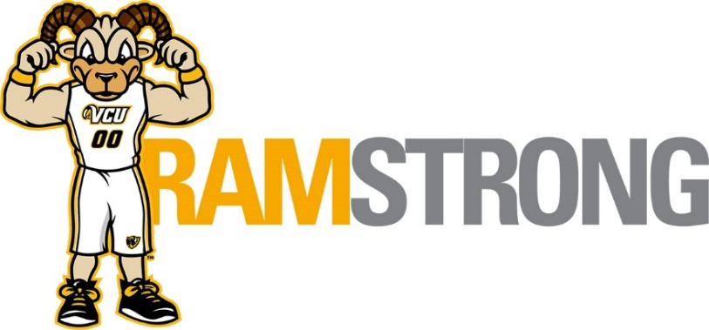
January 2020 - Employee Well-Being Programs
Open to all VCU employees at no cost. All programs begin at 12 noon. Details at
https://hr.vcu.edu/current-employees/worklife/ or https://ramstrong.vcu.edu/

January 8
Yoga (presented by VCU HR and VCU Recreational Sports)
Learn foundational yoga postures to help align, strengthen and promote flexibility in the body. You can expect an emphasis on simplicity, repetition, and easy of movement.
Location - Monroe Park Campus, Cary Street Gym – Mind Body Studio
Register at: Talent@VCU

January 13
3 steps to Overcome Emotional Eating (presented by VCU HR and Pam Losada, Well-Being Coach)
Emotional eating leads to weight gain and poor health, which leads to more stress, which leads to more emotional eating making it a vicious cycle. In this presentation you will learn if you are an emotional eater, what causes emotional eating as well as what is needed to cope with emotions without using food
Location - Monroe Park, Cabell Library 901 Park Avenue, Room 250
Register at: Talent@VCU

January 14
Being a Compassionate Colleague – Understanding Mental Health (presented by VCU HR Employee Relations)
Join us as we explore mental health disorders in order to understand, seek timely intervention, and save lives.
Location - MCV Campus, Main Hospital, 1st Floor, The Learning Center
Register at: Talent@VCU

January 16
In this session we will learn how to have the ability to be fully present in the moment in order to decrease stress to increased levels of focus and happiness.
Location - Monroe Park, Cabell Library 901 Park Avenue, Room 250
Register at: Talent@VCU

January 21
No Sweat Pilates (presented by VCU HR and VCU Recreational Sports)
This form of exercise builds on moves that target the abs, back and overall core strength that mix with focused breathing to help you be strong and flexible.
Location – MCV Campus, Larrick Center
Register at: Talent@VCU

January 27
Find your Fit (presented by VCU HR and VCU Recreational Sports)
Between HIIT, barre, functional training, and the many varieties of yoga, it can be difficult to decipher the purpose and intent of each modality. In this workshop, we'll break down the buzzwords and trends of different fitness formats, and how to effectively exercise for your personal goals and interests.
Location - MCV Campus, Main Hospital, 1st Floor, The Learning Center
Register at: Talent@VCU

Interested in learning more about wellness? Subscribe to the HR Wellness blog at: https://blogs.vcu.edu/hr-worklife/

