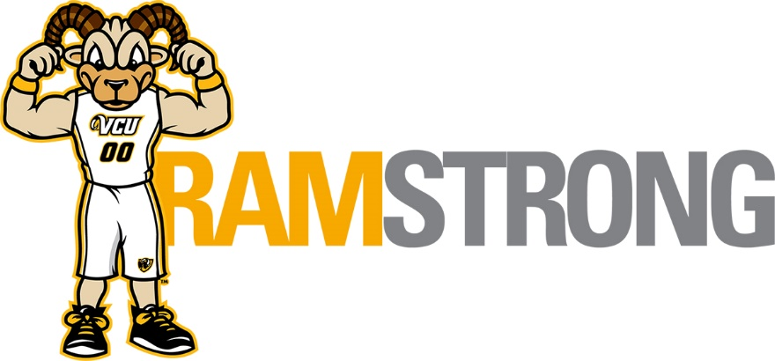
December 2019
Employee Well-Being Programs
Open to all VCU employees at no cost. All programs begin at 12 noon. Details and registration at
https://hr.vcu.edu/current-employees/worklife/ or https://ramstrong.vcu.edu/
December 4
Health & Well-Being in the Workplace (presented by VCU HR and Anthem EAP)
Discover how to enhance your health, well-being and productivity by relieving stress, exploring ergonomics, establishing priorities, and learning the importance of healthy eating and regular exercise.
Location - Monroe Park, Cabell Library 901 Park Avenue, Room 250
Register at Talent@VCU

December 5
Build a Better Meal (presented by VCU HR and CommonHealth)
This program will provide guiding principles to help you plan, shop and prepare meals that fuel your body with the nutrients necessary to be your best.
Location – MCV Campus, Smith Building, 410 N 12th Street, Room 225
Register at Talent@VCU

December 11
Yoga to do at your desk (presented by VCU HR and VCU Recreational Sports)
Join us for the perfect relaxing exercise to improve posture, increase flexibility, reduce stress and improve balance
Location – Monroe Park Campus, Cary Street Gym – Group Exercise Room
Register at Talent@VCU

December 12
Aligning Money and Values (presented by VCU HR and VACU)
This seminar helps participants define and aligning personal values to their financial choices.
Location – MCV Campus, Smith Building, 410 N 12th Street, Room 225
Register at Talent@VCU

December 17
Holiday Survival Guide (presented by VCU HR and Anthem EAP)
Learn how to look for sources of holiday stress and learn strategies for dealing with your emotions, time, relations and money
Location - Monroe Park, Cabell Library 901 Park Avenue, Room 250
Register at Talent@VCU

Interested in learning more about wellness? Subscribe to the HR Wellness blog at: https://blogs.vcu.edu/hr-worklife/

