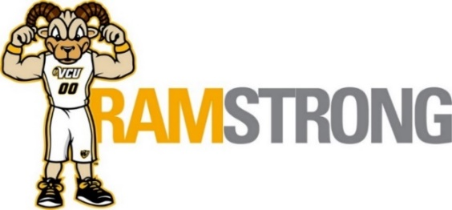
October 2020 - Employee Well-Being Programs
All programs are now virtual
Register in Talent to receive webinar links
__________________________________________________________________________________________________
Thursday, October 1st – 11:15 am
Core with Mady
(Presented by VCU HR and VCU Recreational Sports)
This class will help you build a more stable, powerful abdomen & lower back to improve fitness, straighten posture & provide a foundation to stay active.
Register: Talent@VCU

Friday, October 2nd – 12 noon
Taxes in Retirement – Learn about the new tax cuts and jobs act and how to become tax diversified
(Presented by VCU HR and Assoc of Financial Educators)
Join us as we discuss new tax law changes and how they affect taxes you pay during your retirement.
Register: Talent@VCU

Tuesday, October 6th – 12 noon
Deep Stretch with Jess
(Presented by VCU HR and VCU Recreational Sports)
A slower 30-minute practice focused on active stretching of muscles and opening of connective tissue. Participants are encouraged to have a yoga strap or dish/hand towel for this class.
Register: Talent@VCU

Thursday, October 8th – 12 noon
Aligning Money and Values
(Presented by VCU HR, VCUHS HR, and Virginia Credit Union)
This webinar will help define and align personal values to the financial choices you make every day.
Register: Talent@VCU

Monday, October 12th – 12:30 pm
Tomorrow in Focus: Saving for your ideal retirement
(Presented by VCU HR and TIAA)
You will learn the real benefit of time in regards to saving as well as the essential features of retirement investments.
Register: Talent@VCU

Tuesday, October 13th – 12 noon
Guided Meditation with Chelsea
(Presented by VCU HR and VCU Recreational Sports)
Take a break from responsibilities to find a moment of quiet reflection in the middle of your day with our guided meditation.
Register: Talent@VCU

Wednesday, October 14th -12 pm
Understanding Alzheimer’s & Dementia
(Presented by VCU HR and the Alzheimer’s Association)
Join us for this educational program covering the basics of Alzheimer’s and Dementia and information on how to face and deal with it.
Register: Talent@VCU

Thursday, October 15th – 12 pm
Estate Planning
(Presented by VCU HR and Anthem EAP)
Learn the terms for will planning, guardianships and trusts. We will also go over the pros and cons of different options.
Register: Talent@VCU

Wednesday, October 21st – 12 noon
Investment Basics
(Presented by VCU HR, VCUHS HR, and Virginia Credit Union)
This webinar will teach basic concepts of investing.
Register: Talent@VCU

Thursday, October 22nd – 9 am to 3 pm
FLU IMMUNIZATION CLINIC
By Appointment Only – Click here!
Monroe Park Campus – HR Training Room, 922 W Grace St

Friday, October 23rd – 12 pm – 12:30 pm
What time is it? Tune into your circadian rhythms
(Presented by VCU HR and VCU Recreational Sports)
Timing is everything. We will discuss circadian rhythms – your 24-hour internal clock. Attendees will leave this workshop with strategies on how to work with their circadian rhythms and not against them.
Register: Talent@VCU

Monday, October 26th – 9 am to 3 pm
FLU IMMUNIZATION CLINIC
By Appointment Only – Click here!
MCV Campus – School of Pharmacy, 410 N 12th St, Room 129

Tuesday, October 27th – 12 noon
Alternative Medicine, Fact or Fiction
(Presented by VCU HR & Anthem EAP)
Learn the basics of the most commonly used alternative and complementary healing arts, which includes: Chiropractic, Homeopathy, Herbal and Chinese Medicine, Naturopathy, Acupuncture, and Therapeutic Massage. See how these healing arts can improve your total health and wellness.
Register: Talent@VCU

Wednesday, October 28th – 2:30 pm
Guided Meditation with Mia
(Presented by VCU HR and VCU Recreational Sports)
Take a break from responsibilities to find a moment of quiet reflection in the middle of your day with our guided meditation.
Register: Talent@VCU

Thursday, October 29th – 12 noon
Deciphering Cancer Nutrition Headlines – Fact or Fiction
(Presented by VCU HR & Massey Cancer Center Dietitician)
Join dietitian Allie Farley as she reviews some of the hot topics regarding nutrition and cancer including sugar, comparing organic vs non organic produce, review soy and flaxseeds, critique popular “cancer-curing” diets and evaluate “superfoods”
Register: Talent@VCU

