NEW SELECTION OF BROOM HOUSE BOXES… ORDER YOURS TODAY!
Tel: 0191 371 8839
Email: broomhousedurham@btinternet.com

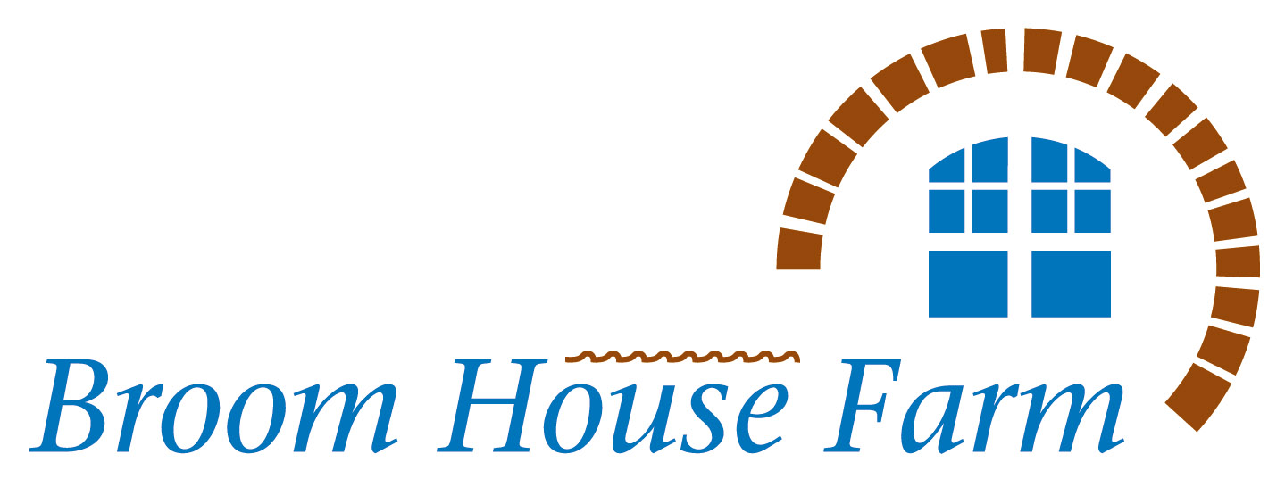

BEEFY BOX
5kg of our delicious Aberdeen Angus Beef for hearty meals
2kg beef steak mince
1kg diced beef
1kg shin beef
1kg casserole steak
Our Price: £40.00
Saving over £4.00
CASSEROLE SPECIAL
Handy freezer packs
2x 500g beef steak mince
500g diced beef
500g diced lamb
500g lamb mince
500g beef roasting joint
Special Price: £28.00
Saving: £3.00
BREAKFAST BOX
Treat Yourself!
6 rashers dry cured bacon
6 rashers streaky bacon
2 packs sausages
6 eggs
6 slices black pudding
Acorn Dairy Butter
Special Price: £20.00
7 DAY BOX
Something tasty for every day of the week!
500g beef steak mince
500g diced beef
6 lamb chops
4 pork chops
4 burgers
1 pack sausages
1 lamb roasting joint
This Box: £40.00
A saving of £4.00

HALF LAMB HAMPER
Half a lamb cut and packed for the freezer in portions to suit you.
Size approx 10kg
£8.50/kg SPECIAL PRICE!
SMALL STUDENT BOX
4 Angus burgers
1 pack sausages
6 rashers dry cured bacon
500g beef steak mince
2 pork chops
2 rump steaks
Special Price: £27.00
a 10% saving
LARGE STUDENT BOX
4 Angus burgers
4 Lamb & mint burgers
2 packs sausages
12 rashers dry cured bacon
500g beef steak mince
500g diced beef
500g stir fry beef strips
2 pork chops
2 rump steaks
Special Price: £50.00
a 10% saving
POT ROASTS BOX
A selection of four tender roasts for the slow cooker
1kg beef brisket
1kg slow roast beef
1kg shoulder lamb
1kg leg mutton
Special Price: £45.00
a 10% saving

BEST BEEF BOX
Our bestselling Aberdeen Angus Beef Box!
2 fillet steaks
2 sirloin steaks
1 rump steak
2x 1kg roasting joints
1.3kg best braising steak
500g beef steak mince
4 Angus burgers
500g beef sausages
Price: £80.00
Saving at least £5.00
FAMILY BEEF BOX
Aberdeen Angus Family Value Meat Box
2 sirloin steaks
2 rump steaks
1 beef roasting joint
1 joint brisket
3x 500g beef steak mince
500g diced beef
1kg casserole steak
8 Angus burgers
1kg beef sausages
Our Price: £80.00
Saving at least £5.00
BROOM HOUSE MIX
1kg steak mince
1kg best braising steak
500g lean diced steak
500g diced lamb
500g lamb mince
2 packs sausages
4 lamb chops
4 burgers
Our Price: £55.00
Saving £5.00

