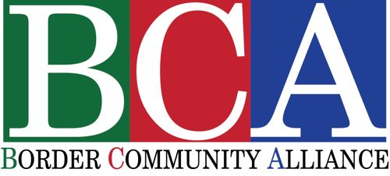
2221 E. Frontage B-201/202
P.O. Box 1863 Tubac, AZ. 85646
520.398.3229

HIGHLIGHTS

- In partnership with FESAC encouraged and supported dozens of Mexican projects and non-profits including:
  - San Juan Bosco migrant shelter
  - Self-employment sewing workshop
  - Deijuven Youth Center
  - ARSOBO
  - Autism center
- Successfully sponsored and launched BYTE – Border Youth Tennis Exchange
- Led more than 40 border awareness tours into Mexico for more than 500 people
- Collaborated with the Mexican Consulate of Nogales, Arizona on various cultural and educational events
- With support from the Greater Green Valley Community Foundation, organized The Borderlands Forum, offering more than 20 classes on topics as diverse as “History of Sonora” to “How to Make Tortillas”
- Media recognition:
  - New York Times – February 11, 2018
  - Arizona Daily Star – March 25, 2018
  - Green Valley News
  - National Public Radio
  - Tubac Villager
- Special classes:
  - “The Mezcales of Sonora” with Bill Steen
  - “Videography in the Borderlands” with Mike Foster
  - “Storytelling as Border Art” with Francisco Cantú, author of the book The Line Becomes a River: Dispatches from the Border

COMING UP – www.bordercommunityalliance.org

May 27/28 – BCA Tour to Northwest Spain begins
June 18 -- Summer internship begins – college/university students
July 27 – Student presentations at Tubac Center for the Arts (5 to 7 pm)

