BORDERLANDS HISTORY & CULTURE ARTICLE # 1
OCTOBER 2018 BCA NEWSLETTER
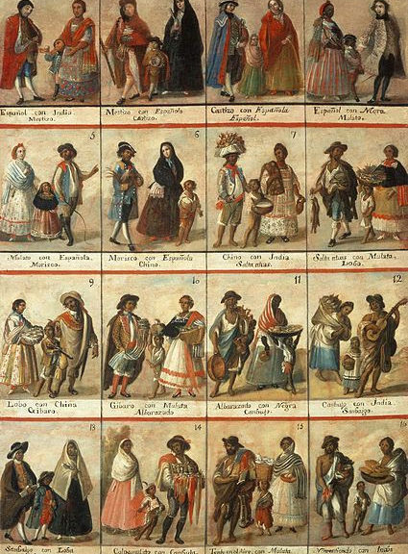

Borderlands stakeholders prior to Mexican Independence (1821): What were the different relationships and how were social and political hierarchies formed?

By Alex La Pierre

Prior to Mexican Independence and at its most basic level in the region of the present-day U.S.-Mexico borderlands there existed two distinct social groups culturally: the Native Americans and the Spanish colonial immigrants. These two groups can be even further categorized into their own social and political hierarchies. The relationship between these two groups can be characterized by the Spanish policy considering the Native Americans as subjects of the crown rather than separate partners (as seen in the French and English colonial empires of the time) and because of this they did not seek to ‘dispossess’ the indigenous of their land, also unique given European imperial tendencies at the time. Furthermore, within the Native American cultural segment, that there were two sociological spheres ordered by their lifeways: 1. semi-sedentary agricultural based tribes who had long been residents of what is now today’s southwest U.S. and northern Mexico, such as the Tohono O’odham and Puebloan peoples of New Mexico and 2. nomadic and recent indigenous arrivals from the north - primarily Athabaskan speakers such as the Apache and Navajo who were newly arriving in this region coming from the north around the same time the Spanish - driven by silver mining and missionization - were pushing in from the south. The semi-sedentary Native American groups frequently allied with the Spanish for protective support against the new nomadic arrivals from the north and in forming their resettlements (reducciones) into missions.
The Spanish colonial immigrant segment of this era in this region can be further partitioned to the ecclesiastical and civil society. The Jesuit and Franciscan priests frequently served as buffers between the local indigenous societies and Spanish civil society - composed of limited numbers of ranchers and miners who typically took Native American women as wives. The Spanish military also played an important role with the frontier partner institution of the presidio, essentially a Spanish military fort with the aim of protecting the frontier mining economy from indigenous nomads (presidios were also the sites of peaceful nomadic indigenous reservations known as establecimientos de la paz in the late colonial era) and excursions by rival European colonial powers such as the French in Texas and Louisiana. The frontier interaction between indigenous and Spanish populations resulted in the birth of a third cultural group, known as mestizos, of dual cultural parentage. The fusion or mestizaje of these two cultural groups, in other words, ‘hybrid residuals’ of encounter gave way to future generations whose folkways and genetics were informed by the coming together of these two disparate cultures originating in the colonialism stretching from the 16th to 19th centuries. This fusion resulted in further complex colonial hierarchical organization - a caste system of racially rooted in a Spanish notion of ‘limpieza de sangre’ an artifact of the Spain’s diverse medieval history - the frequent struggle between the Moors, Jews, and Christians on the Iberian Peninsula.

