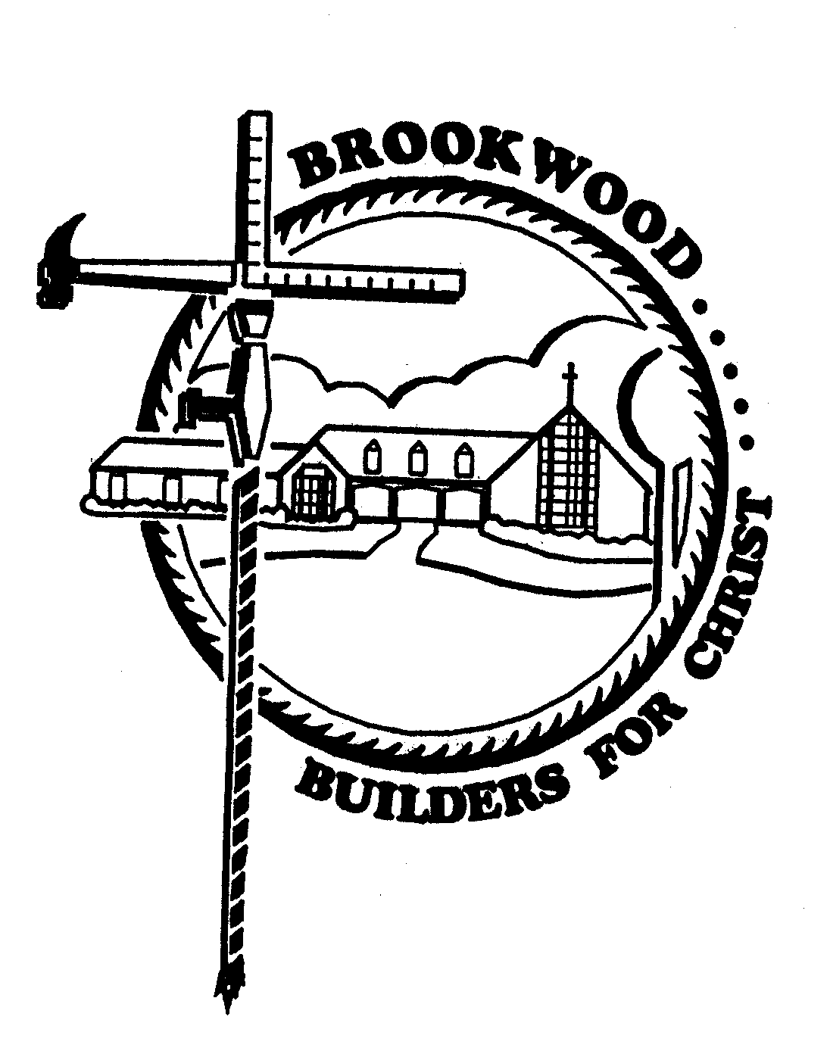
Full Name (as on your Driver’s License___________________________________________
Brookwood Baptist Church Construction Mission Trip
Valley Baptist Church, Appleton, WI
May 18-29, 2021
Note: Advance team will depart on May 13

REGISTRATION FORM
Please complete form and return to Rosanna with $200 deposit by March 8, 2020
Total Cost $650
Please make checks payable to BBC for Construction Mission Trip.
Address____________________________________________________________________
City________________________________________________ State_______ Zip Code________
Home Phone_______________________ Cell Phone_______________________________
Email______________________________________________
Date of Birth(m/d/y)________________________________________
Church Affiliation____________________________________________
Travel Dates__________________ Roommate Preference__________________________________________
Medical History: Please list all medical problems for which you have received medical care in the past 12 months and any other information that you deem important, including medications you are currently taking.
________________________________________________________________________________________
_________________________________________________________________________________________
___________________________________________________________________________________________

Please list any allergies (including food allergies), breathing problems, and chronic conditions of which team leaders should be aware.
___________________________________________________________________________________________
___________________________________________________________________________________________

Your Blood Type_________ Name of Your Primary Physician ________________________________

In Case of Emergency, Please Contact:

Emergency Contact #1:
Name________________________ Relationship to You _________________________
Home Phone_____________________ Cell ___________________________

Emergency Contact #2:

Name_________________________ Relationship to You ___________________________
Home Phone__________ Cell ___________________________________

