

**Benefits of Greens**

By Joy Lenz, RD CD

Late summer is a wonderful time to enjoy fresh greens!  We are fortunate to have them available year-round as well.

There are so many benefits of eating greens.  Leafy greens are loaded with vitamins K, A, C, E, folate, and minerals like calcium, selenium, potassium! They also contain antioxidants like lutein and beta carotene that help us fight disease by reducing oxidative stress.

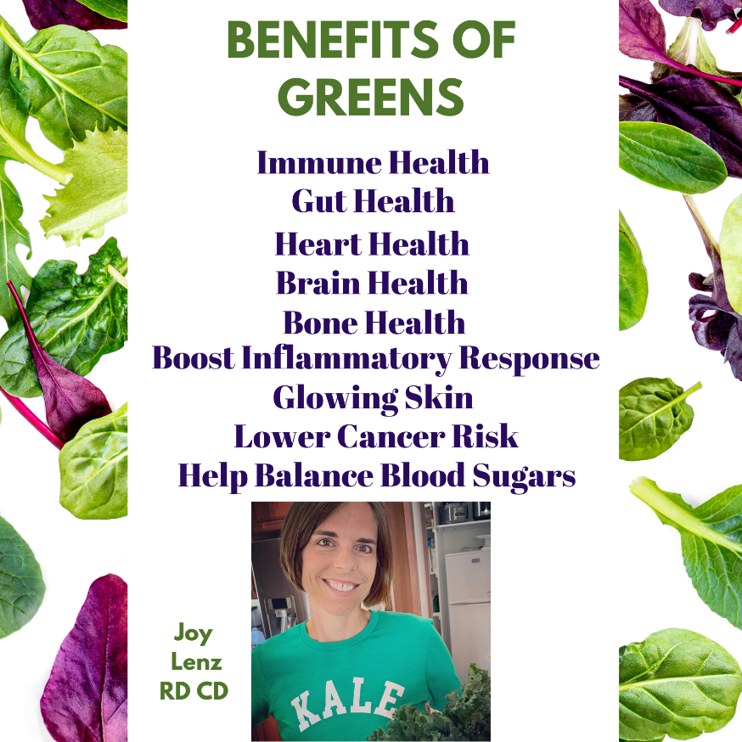Some of the best greens to eat include kale, collard greens, spinach, Swiss chard, arugula, Bak Choy, beet greens, turnip greens, and even “baby” micro greens. Whenever possible, buy organic greens to avoid pesticides and maximize nutrients.

Use greens in big salads, put big handfuls into smoothies, chop and stir into soups, add to stir fries, add to wraps, top vegan pizzas, stir into dairy free risottos, and layer in lasagnas.  If you have never grown micro greens, try your hand at that.  Microgreens are even more rich in nutrients than the mature leafy greens.

I love this encouragement from Dr. Fuhrman (author*Eat to Live).*  “Leafy greens, the most nutrient-rich foods on the planet, were the best predictor of extreme longevity.”

Enjoy leafy greens everyday.  Change it up.  Try different greens.  You’ll get a variety of nutrients for maximum health benefits.

If you want more encouragement and recipes, Joy Lenz RD CD, at The Ommani Center would love to talk to you.  She has a cookbook and can get you well on your way to eating more greens and enjoying a plant-based lifestyle.

**©September2021, Joy Lenz, RD CD is a Registered Dietitian at Ommani. She sees clients who are free of symptoms on Thursdays. She also offers zoom visitation. Call our office at 262.695.5311 to schedule an appointment.**