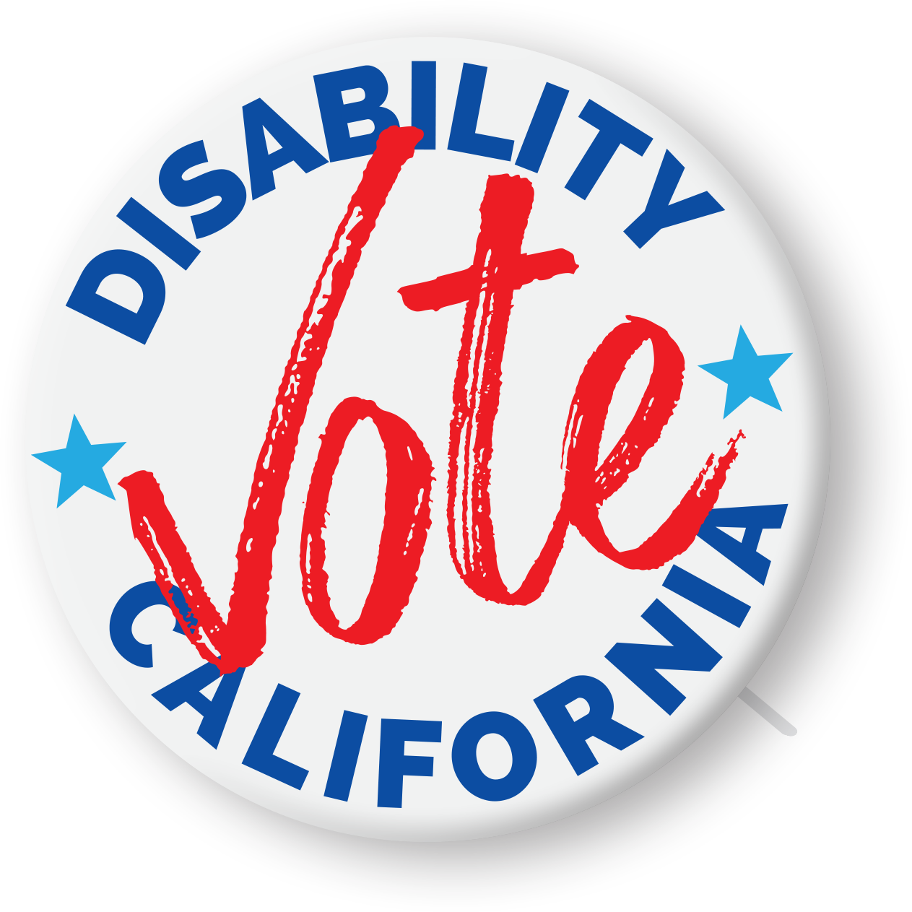
Dear Candidate:
In 2020, approximately 23% of the American electorate — over 35 million individuals — will be people with disabilities. As people with disabilities, we want to live independent lives and contribute our talent and energy to the future success of our great nation. There are over sixty million Americans with disabilities who make remarkable and valuable contributions to our communities. Approximately thirty-five millions of this total number are people eligible to vote in the coming election.
Despite these contributions and despite our numbers, Americans with disabilities continue to face discrimination in many arenas including employment, housing, transportation, health care, and education. Candidates for public office must address these disparities and set forth a vision to ensure the civil rights of people with disabilities and our full inclusion in society.
In an effort to inform our community of your disability policy positions, initiatives, and priorities, the American Association of People with Disabilities (AAPD), the National Council on Independent Living (NCIL), and the REV UP Campaign developed a candidate questionnaire. Disability Vote California, a nonpartisan, Statewide collaboration of advocates and community organizations dedicated to increasing the voice and presence of the disability community in civic affairs has utilized their work to create the attached questionnaire for your consideration. We invite your written responses to these questions. All candidate responses will be posted on our website and will be widely circulated through various newsletters and social media. Candidate responses will be posted exactly as submitted with no editing or commentary. We believe the issues addressed are vital to ensuring all individuals with disabilities have an opportunity to achieve the American Dream, and therefore we request your response.
We greatly appreciate your time and attention to our concerns. If you have any questions, please contact (list contact information for local organizer)
We look forward to sharing your responses with the millions of eligible voters in the disability community!

