July Birthdays
Beverly Littlejohn 1st
June Macciocchi 1st
Oliver Quixtan 1st
Gabriella DiNoble 4th
Brad Ball 4th
Jean Irwin 6th
Connor Coop 6th
Tom Treichel 6th
Josephine Purcell 7th
Jordon Miller 9th
Marla Hicks 11th
Joan Jaicks 12th
Susan Calder 12th
Tanner Hallas 16th
Tommy Hicks 17th
Alexis Crawford 17th
Joe Kennedy 17th
Hardy Bryan 20th
Blake Disler 20th
Rachel Harvard 21st
Grant Dobbs 21st
Emma Kennedy 21st
Aubrey Moorefield 22nd
Carson Coop 22nd
John Stenard 23rd
Gary Hallas 23rd
Mary Clark 23rd
Justin Purcell 23rd
Dick Malmad 24th
Leslie Tiernan-Duffy 24th
Nancy Morgan 24th
Aoife McGrath 24th
Mary Jane Park 26th
Jon Wilson 27th
Vickie LaVelle-Ryan 27th
Hayden Crawford 28th
Jack Cartier 29th
Henry Forrester 30th
Richard Davis 31st

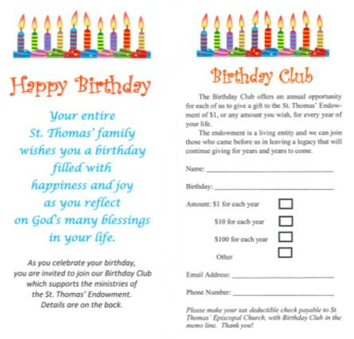

July Anniversaries
Dodd & Heather Disler 1st
Jack & Mary Jane Cartier 3rd
Joe & Julie DiOrio 7th
Hank & Laura Hine 10th
James & Nancy Horner 13th
Bill & Larua Vrooman 17th
Kevin & Amy Kelso 18th
Kevin & Karin Carlan 19th
Mike & Gina White 23rd
Tom & Elizabeth Alison 26th

