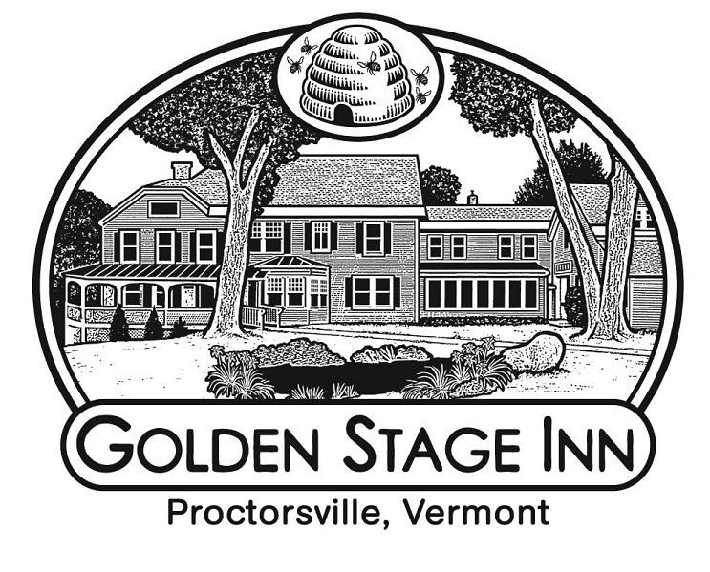
“Inntroduction to Innkeeping”
Workshop Weekend
Golden Stage Inn
Proctorsville, VT
www.goldenstageinn.com

“If you love what you do, you’ll never work a day in your life.”
***
“Entrepreneurs will work 80 hours a week just to avoid working 40.” (L.Greiner)
***
Combine these two sayings, and you’ve got a snapshot of innkeeping. But there’s so much more.
Being an innkeeper is intensive. It demands your time and energy in ways that few other careers do. But innkeeping also offers you the chance to create a work and lifestyle environment of your choosing in a location of your choosing. It allows you the opportunity to use your own creative energy and build something you love. Innkeeping lets you be your own boss and make decisions you believe in. It grants you the chance to make human connections that go beyond mere formalities. Ultimately, the freedom, empowerment, and creativity that go along with innkeeping are so rewarding and rejuvenating that they more than compensate for its heavy demands.
Over thirteen years ago, Michael and Julie-Lynn chose innkeeping as an alternative to their traditional suburban life in southeastern Massachusetts. And they have never looked back. It has been a fantastic journey, filled with excitement, challenge, and both personal and financial growth. Now they’re inviting anyone who has ever been curious about innkeeping as a career to a weekend filled with insights and experience.
Consider joining them for this “Inntroduction to Innkeeping” workshop. Together they will share with you the ups and downs – and inns and outs – of owning and operating an inn. In a “one on one” setting, you will examine the choices you can make that will shape not just your business model, but your lifestyle overall. Michael, a practicing CPA, will share financial insights, from what it takes to purchase an inn, to creative approaches to get financing, to surprising financial benefits to owning an inn. You will be invited behind the scenes, shadowing Mike and Julie and the Golden Stage Inn team as we complete the myriad of tasks that make up a typical day at the inn.
The agenda will be packed but informal, some of the structure provided by guest service and some by the nature of your questions and your interests. While we have a list of topics we intend to cover, we recommend you do some brainstorming in advance and be prepared to guide our conversations to areas for which you need most discussion. Some participants are early in their thinking and just want to know “what is innkeeping like?” while others may need answers to questions about how to choose the right inn, what to focus on first when starting as innkeepers, or how to balance innkeeping with personal life. Whatever it is for you, be sure to share it with us, so we can help you investigate those areas most thoroughly.

A sample itinerary for your Innkeeping Workshop:
- “Cookies, Cocktails, and Conversation” on the first evening
- Enjoy breakfast as a traditional guest on your first morning
- Shadow the innkeepers from 9am – 6pm, infused with guided Q&A sessions with Julie and Michael
- Take-out lunch from Singleton’s General Store included
- Dine on your own for dinner
- On your second morning, come into the kitchen and enjoy a behind-the-scenes experience, watching or assisting, as you choose (breakfast provided, innkeeper style, standing in the kitchen!)
When booking at least a two-night stay, the Add-On cost for this package is $275 plus tax (single or double occupancy).

To book this trip, send an email with your preferred dates to innkeeper@goldenstageinn.com

