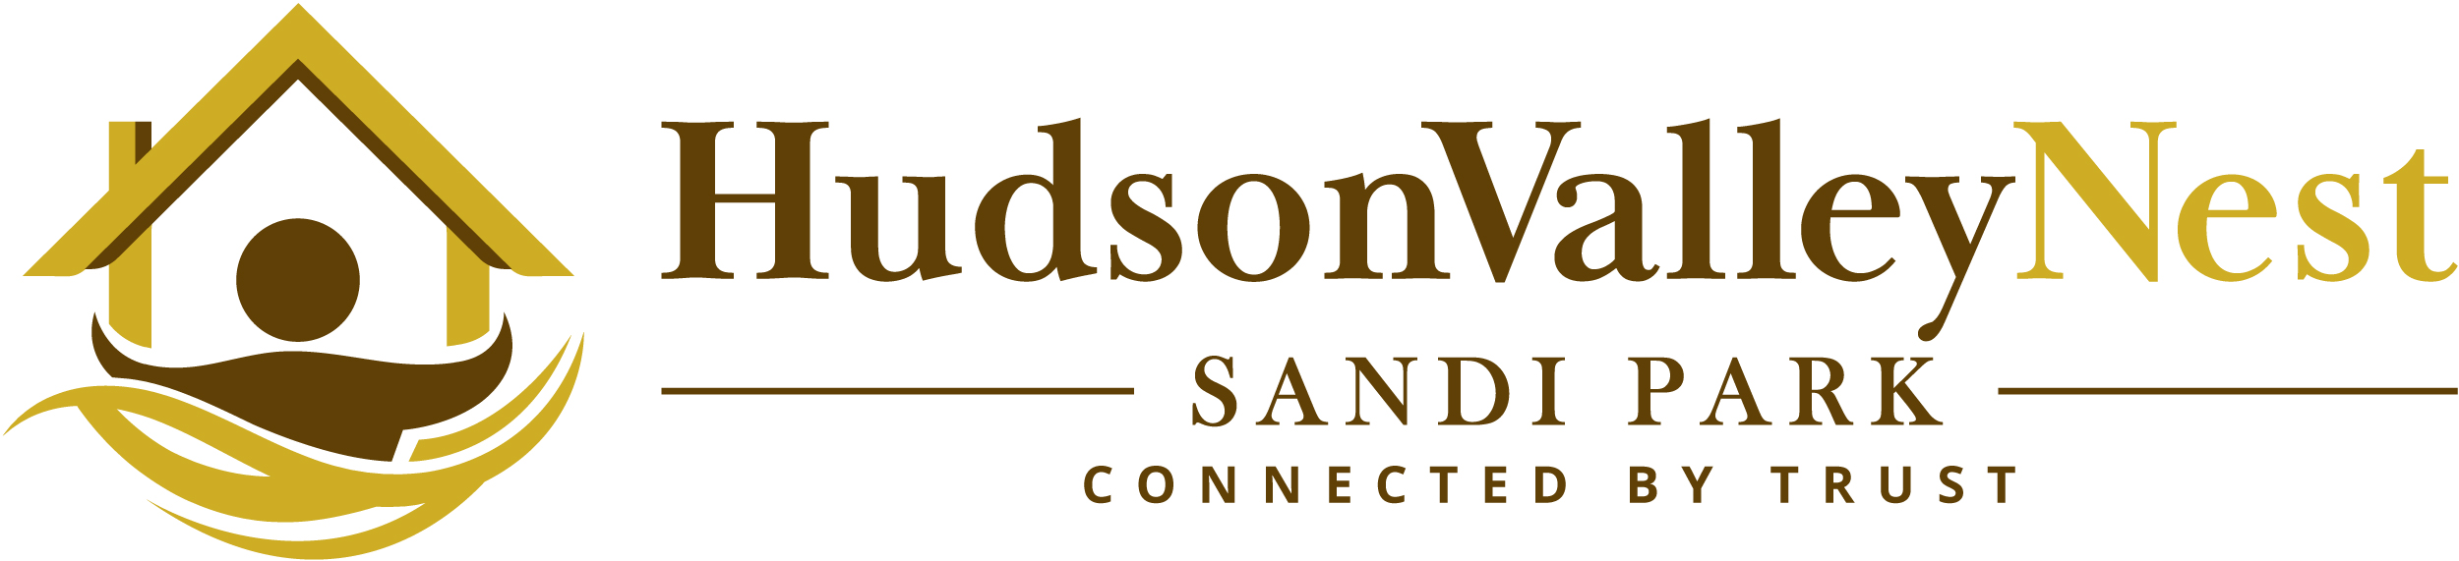

About Sandi
Sandi first came to Dutchess County to brand, position and market a subdivision after representing land and property sales as a top selling broker in Westchester County for nearly two decades. Her work soon caught the attention of two of the largest developers in the County, which led to continued work and relocation of home and business to the area.

Sandi leverages a multi-faceted skill set gained through decades in real estate and consultative marketing with NYC advertising agencies. Sandi’s portfolio runs full depth. She has represented singular land parcels to 100+ residential subdivisions; modest homes to some of the highest end luxury sales in Westchester and Dutchess Counties.

Simply put, Sandi has perfected the art of property sales and marketing. She holds a broker’s license and is a multiple year recipient of the President's Circle award for top sales. Sandi leverages her extensive online and traditional marketing expertise to best expose her clients’ home to targeted buyers. Sandi also maintains membership with a number of multiple listing services to maximize exposure to the agent community. These services include HGAR/OneKey (Westchester, Putnam, Rockland, Long Island, NYC, Sullivan, Delaware County, Connecticut and New Jersey) and Mid-Hudson MLS (Dutchess, Ulster, Columbia, Greene and Orange counties.)

Sandi maintains offices in LaGrangeville and Rhinebeck to best accommodate her varied client base.
Contact:
Sandi Park
Associate Real Estate Broker
Berkshire Hathaway Home Services
Hudson Valley Properties
www.hudsonvalleynest.com
M: 914-522-6282
sandipark@gmail.com

