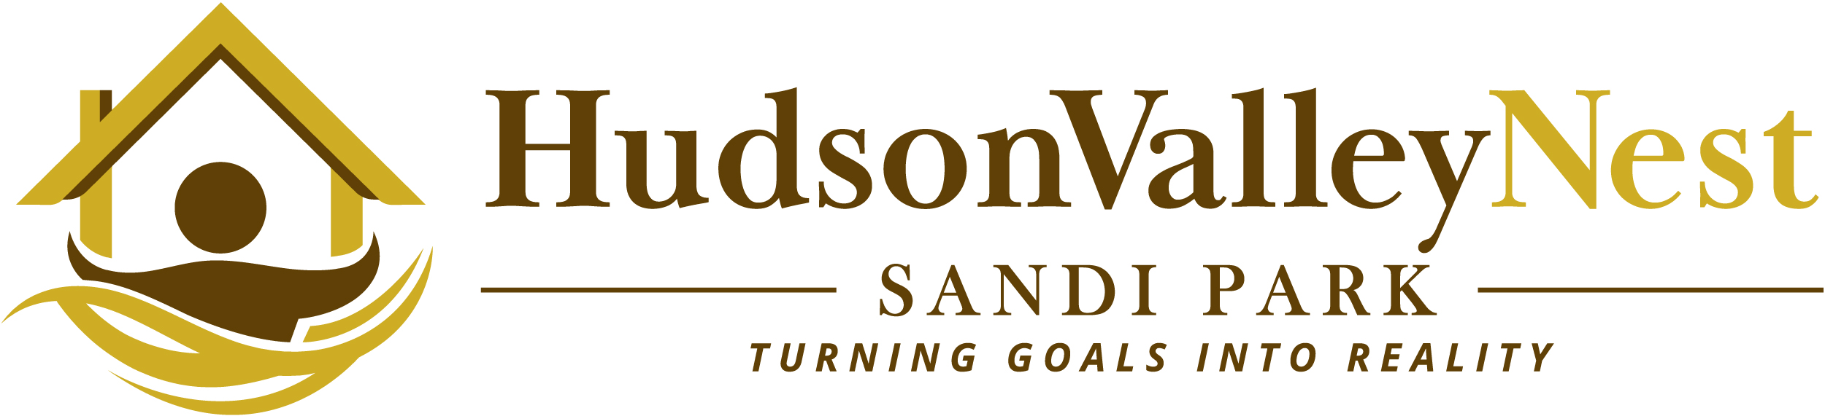

About Sandi

At the helm of Hudson Valley Nest, you'll find Sandi Park, a real estate veteran who has perfected the art of property sales and marketing. Not only does Sandi know the local real estate market inside and out, she brings decades of expertise in marketing, sales, project management and negotiation. Sandi strives every day to exceed expectations – one client at a time.
Sandi first came to Dutchess County to establish pricing, brand and marketing for a subdivision after representing land and property sales in Westchester County for many years. Sandi developed a passion for land development and new construction through working with multiple builders, developers, investors, landowners, engineers, architects and others in the homebuilding industry. Sandi has represented her clients in various capacities, including as spokesperson at town board meetings.
As sales and marketing director during pre-construction for a traditional neighborhood development in Red Hook, New York, Sandi developed marketing strategy, brand and collateral along with an email newsletter and branded online marketing efforts for the project. Sandi obtained certification from New York University in construction project management and is also a certified new home specialist.
Sandi holds a broker’s license and is a multiple year recipient of the President's Circle award for top sales. Her offices are located in LaGrangeville and Rhinebeck, New York.

Member:
Westchester/Putnam multiple listing service (HGAR) and
Mid-Hudson multiple listing service

Contact:
Sandi Park
M: 914-522-6282
sandipark@gmail.com

