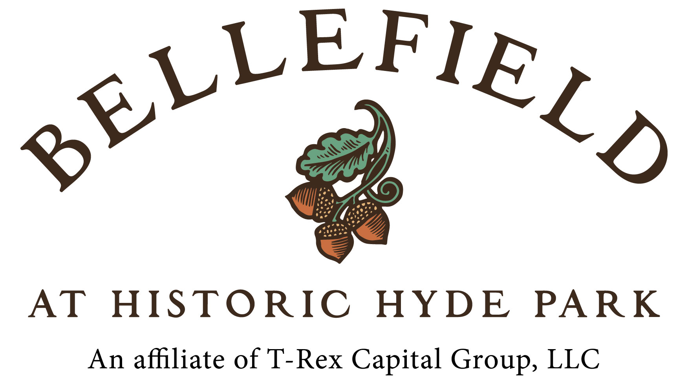

By Sandi Park

I’m all about new urbanism. Two years ago, I connected with the first new urbanist architect I had ever known and, shortly thereafter, had the pleasure to work with. I can’t say I got lucky to meet such a talented and infectiously passionate professional, as I don’t believe in luck. I can say, however, that I hold deep gratitude, as it was through the time he generously shared, in discussions, and under his tutelage, that I found my own passion for new urbanist architectural design. Thank you, Gio.

In new urbanist design, the character of a community is developed through cumulative design elements coming together to build a holistic whole. Buildings are incorporated with places to gather. There is an ease of accessibility to town centers and amenities while offering walkable streets designed for people and bikes - not just cars. The roads are engineered in a way that naturally reduce speed. The new urbanist approach to design has shown itself as a magnet for multi-generational living. A subset of new urbanism, the traditional neighborhood development (“TND”), places the car secondary to front door living and opts to locate cars and garages in alleys behind residences. This is in dramatic contrast with suburban sprawl which places cars and host garages or driveways at equal importance to the front door. According to David Pace, a veteran of Disney’s Celebration and Baldwin Park’s managing director, “The value of homes in new urbanist developments is generally, and often dramatically, higher than conventional subdivisions.”

Reclaiming underutilized and neglected places is a special function in new urban design and building. Tom Mulroy, Chief Executive Officer of T-Rex Capital, is poised to do just that with Bellefield at Historic Hyde Park on Route 9. I caught up with Tom on site to discuss this exciting project, slated for an April start. To date, Baldwin Park in Orlando has been my favorite TND of those visited out of state, but Tom has piqued my interest to see Serenbe, an agri-hood in Georgia he respectfully cited. Taking a look at Serenbe can help give a visual of an up and running example of Mr. Mulroy’s inspiration. Serenbe’s tag line encapsulates new urbanist design quite well: The best reason to live here is the life here. (http://www.serenbe.com )

Bellefield at Historic Hyde Park (www.bellefieldhydepark.com) is located directly across Route 9 from the Culinary Institute of America (CIA). Outside of the academic population and restaurant patrons, the CIA offers outstanding weekend and week-long boot camps that are well attended by locals and visitors. While still by no means a chef, I had a blast in a multitude of weekend boot camps, which served to boost my culinary confidence. (Let’s just say, my overall culinary aptitude needed a good dose of confidence.) Then there are the wineries – including Brotherhood, the country’s oldest continuously running winery and Millbrook Winery, which was nominated by Wine Enthusiast for “Top American Winery of the Year.” These are just two of several fine wineries dotting the wine trail that runs through Dutchess and neighboring counties. Hiking, biking, festivals, arts – the options are boundless for the 25 million yearly visitors to the Hudson Valley region; five million of which come to Dutchess County alone. To offer perspective, Napa Valley enjoys three million tourists per year. We’re sitting on a gem of a county, and I would say Bellefield at Historic Hyde Park may very well be the Jewel of Dutchess.

With a mile of prime Route 9 frontage, half of the 340-acre site will remain wooded, 120 acres will be utilized for a building envelope, and 48 acres will be devoted to agriculture. Ten miles of walking trails will connect with the Dutchess County trail system. Two hotels with pool and other amenities for residents and guests; 32 hotel villas; over 500 residences consisting of townhomes, condos and rentals in a phased buildout; an amphitheater; and two million square feet of mixed-use space, including a “culinary corridor” of boutique shops and goods, will seamlessly integrate to form this new community. As though this wasn’t enough, the site’s elevation delivers coveted Hudson Valley views. Slam dunk.

In a County where approvals can be challenging, Bellefield at Historic Hyde Park is ready to roll. Their fully owned sewer district with its 456,000 gallon-per-day capacity, is in place for phased tap, along with fiber, cable and gas. Relics found on the property from its 500 year history, including the Roosevelt era, will remain. Clearing will be kept to a minimum, including the active preservation of a 400 year old sycamore tree. The phased project is scheduled to commence in April with The Inn at Bellefield, a soft branded all-suite Residence Inn offering 137 rooms to be constructed by PC Construction and managed by The Shaner Hospitality Group, also a partner on the project. Bob McCarthy, Marriott International Chief Operating Officer veteran for over three decades, is a managing partner. This project is a top watch.

Contact Sandi if interested in involvement:

Sandi Park
Associate Real Estate Broker
New Construction & Land Specialist
HudsonValleyNest/Berkshire Hathaway
914-522-6282
sandipark@gmail.com

# # #
Want your project featured in the next newsletter or interested in other opportunities in the Hudson Valley Region? Contact Sandi.

