2022-2023 Summer Reading Assignment
Grade 9 Honors

OVERALL ASSIGNMENT: The summer project requires you to read the short story “The Scarlet Ibis” by James Hurst and annotate the short story. Your annotated short story is due on the first day of class.
Directions:
- BEFORE reading the short story, complete the Anticipation Guide, being sure to provide an explanation for your responses—(Page 2).
- Read and annotate the short story “The Scarlet Ibis” by James Hurst. See the annotation guidelines below. (A copy of the story is on pages 6-11.)
- Be prepared to discuss the text and complete assignments related to the text when school begins.

Activity 1: Anticipation Guide—“The Scarlet Ibis”

For each of the following statements, circle Agree or Disagree.
- Older siblings should have a responsibility to help younger siblings. | Agree | Disagree
Explanation:

- People generally live up to the expectations of others. | Agree | Disagree
Explanation:

- Every American has the right to life, liberty, and the pursuit of happiness—even if the person has a disability. | Agree | Disagree
Explanation:

- Nothing is impossible. | Agree | Disagree
Explanation:

- Pushing yourself beyond your limits is always a good idea. | Agree | Disagree
Explanation:

- Trying to please other people is more important than trying to please yourself. | Agree | Disagree
Explanation:

- It is better to have loved and lost than never to have loved at all. | Agree | Disagree
Explanation:

Activity 2: Reading and Annotating the Text: Thinking critically and analyzing a text
Your assignment: Please annotate the short story. You can use sticky notes, two column notes, or preferably write on the pages of the short story. Please note that annotating includes both marking what you feel is important and commenting on what you have marked.

Annotation: the act of making notes in/on a text as you read so that it shows your critical thinking and analysis of the text. Think of annotation as writing notes that provide active interaction with a text while make your thinking obvious to an outside observer.

Also, remember that the point of annotating a text is not to pass judgment on the text, to give it a thumbs up or a thumbs down, especially when you have not looked at the work on a higher level. “There is no reason to assume that your initial reaction is the most reliable measure of the worth of a literary work” (Jago et al).

Three Levels of Annotation and Examples
Your annotations should attend to all three levels of thinking as listed below:

Level 1 | Level 2 | Level 3
Literal—found directly in the text | Interpretive/Analytical—found by making inferences | Universal/Thematic—found outside of the text
Questions/notes that check for understanding | Questions/notes about the author’s choices | Questions/notes about how the text relates to the world outside the text, including how it relates to my life and what I know

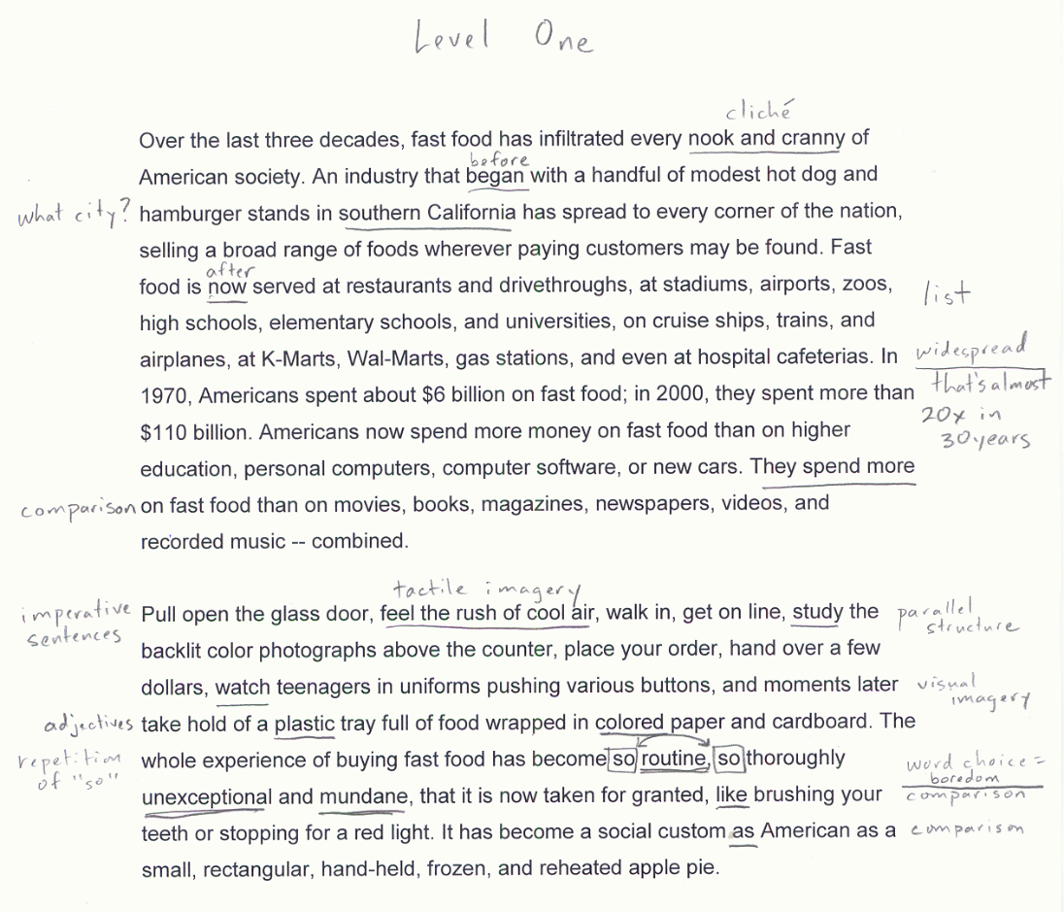
Level 1 Annotations
- are factual
- identify main points/events in the text
- lead to an accurate and thorough summary of the text
Examples:
- defines unknown vocabulary
- notes important main points/claims over the scope of the whole work.
- notes tone/connotatively charged diction
- identifies most of the figurative language/rhetorical strategies in the passages
- comments on the form/format/structure and shifts in style/structure
- determines point of view
- lists character traits

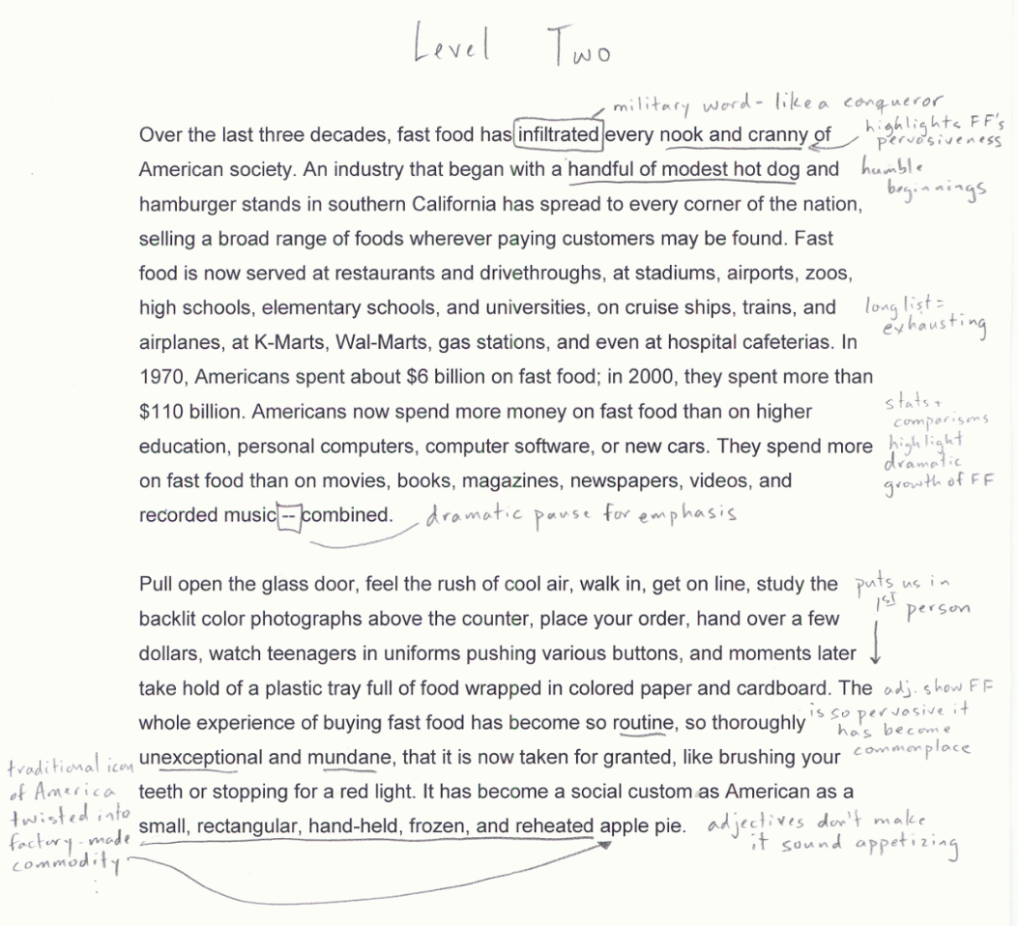
Level 2 Annotations
- are inferential
- speculate about motive/purpose of author
- follow patterns and identify relationships among parts of the text
Examples:
- identifies the function of language/rhetorical strategies in the passages
- identifies the function of the style/structure
- makes inferences
- makes predictions and hypotheses
- notes patterns/motifs
- evaluates the author/character’s arguments/claims and may challenge these claims

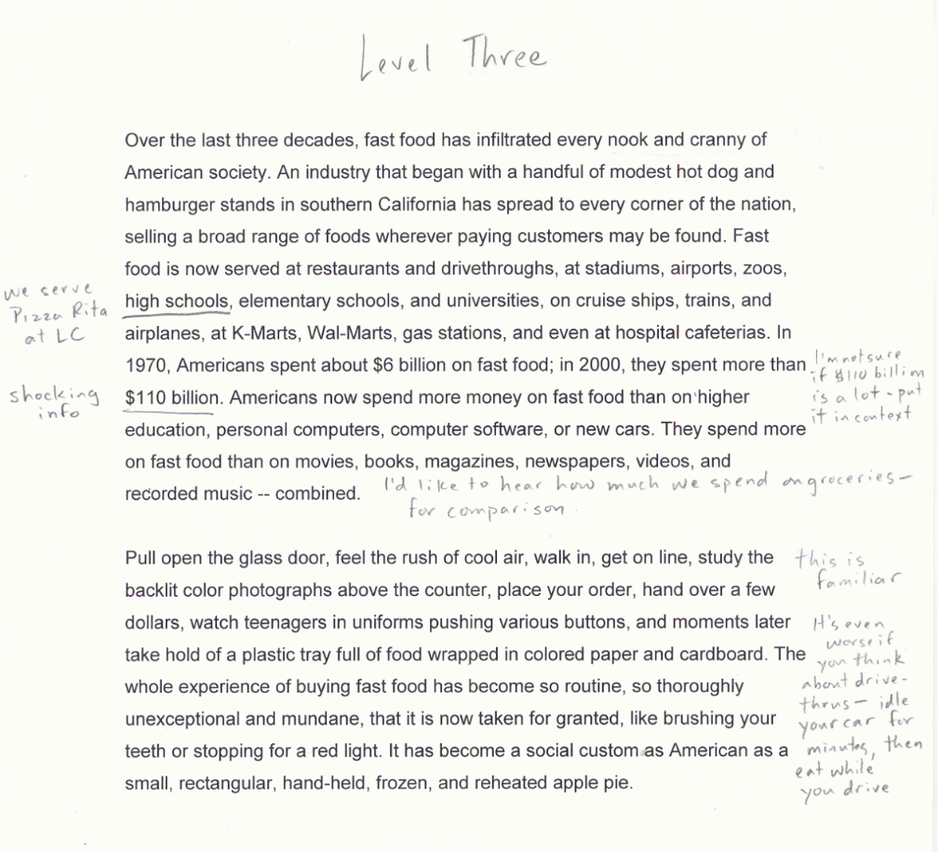
Level 3 Annotations
- are reflective
- link text to prior knowledge, other texts, or personal experiences

Examples:
- notes personal responses/emotional connections
- asks questions and theorizes answers
- makes connections outside of the text
- notes universal human behaviors, themes
There are three ways that you can annotate the text for this assignment:
1) Mark the Text | 2) Use Post-Its | 3) Create a Double Entry Journal
Please buy a book and mark the text and in the margins if you want to be able to write in the book. Your teacher will collect the book and assess your annotations using the rubric. | If you would like to annotate the text using post-its, please check out a book from the book room. Annotate the text on post-its and place them in the book. Your teacher will collect the book and post-its to assess your annotations using the rubric. | If you would like to interact with the text using a double entry journal, please create a journal using the annotation symbols and textual evidence to demonstrate your interaction with the text.  I’m not sure if $110 billion is a lot of money – put it in context  “in 2000, they spent more than $110” (page 17)  Text and Page Number  Connections and Insights
Summer Reading Annotations Rubric
Little Evidence  1 | Approaching Standard  2 | Adequate Annotations  3 | Effective Annotations  4
The student annotates too few sections of the text.  The meanings of the student’s annotations are not clear to the reader.  - The student’s notes do not show understanding of the text in a way that is clear to the reader  - The students notes are limited to highlighting without annotating the highlights  - The student’s annotations are limited to personal responses | The student annotates some of the scope of the text though some lapses in legibility may occur.  The student’s annotations are sometimes difficult for a reader to understand what he/she thinking as he/she read.  - The student’s annotations are limited to personal responses or paraphrase more than analysis  - The student does not note some obvious strategies used by the writer.  - The student does not attend to main points/claims over the scope of the whole work.  - Student does not identify some obvious figurative language/rhetorical strategies at work in the passage. | The student annotates the majority of the scope of the text on a variety of levels.  The annotations make clear to the reader what the writer was thinking as he/she read:  The annotations attend to a variety of levels of thinking. For instance, the student:  Level one:  - notes important main points/claims over the scope of the whole work.  - notes tone/connotatively charged diction  - identifies most of the figurative language/rhetorical strategies in the passages  - comments on the form/format/structure and shifts in style/structure  Level two:  - identifies the function of language/rhetorical strategies in the passages  - identifies the function of the style/structure  - makes inferences  - evaluates the author/character’s arguments/claims and may challenge these claims  Level 3:  - notes personal responses/emotional connections  - asks questions and theorizes answers  - makes connections outside of the text  - notes universal human behaviors, themes | The student annotates the text with clear, thorough insight and apt observations.  - All of the annotations are easily interpreted by the reader.  - The student pays particular attention to analyzing the function of figurative/rhetorical strategies at work in the passage.  - The student recognizes patterns and identifies complicated themes at work in the text

The Scarlet Ibis
by James Hurst

1
I
t was in the clove of seasons, summer was dead but autumn had not yet been born, that the ibis lit in the bleeding tree. The flower garden was stained with rotting brown magnolia petals and ironweeds grew rank amid the purple phlox. The five o'clocks by the chimney still marked time, but the oriole nest in the elm was untenanted and rocked back and forth like an empty cradle. The last graveyard flowers were blooming, and their smell drifted across the cotton field and through every room of our house, speaking softly the names of our dead.
It's strange that all this is still so clear to me, now that summer has long since fled and time has had its way. A grindstone stands where the bleeding tree stood, just outside the kitchen door, and now if an oriole sings in the elm, its song seems to die up in the leaves, a silvery dust. The flower garden is prim, the house a gleaming white, and the pale fence across the yard stands straight and spruce. But sometimes (like right now), as I sit in the cool, green-draped parlor, the grindstone begins to turn, and time with all its changes is ground away—and I remember Doodle.
2
Doodle was just about the craziest brother a boy ever had. Of course, he wasn't crazy crazy like old Miss Leedie, who was in love with President Wilson and wrote him a letter every day, but was a nice crazy, like someone you meet in your dreams. He was born when I was six and was, from the outset, a disappointment. He seemed all head, with a tiny body which was red and shriveled like an old man's. Everybody thought he was going to die—everybody except Aunt Nicey, who had delivered him. She said he would live because he was born in a caul, and cauls were made from Jesus' nightgown. Daddy had Mr. Heath, the carpenter, build a little mahogany coffin for him. But he didn't die, and when he was three months old, Mama and Daddy decided they might as well name him.
They named him William Armstrong, which is like tying a big tail on a small kite. Such a name sounds good only on a tombstone. I thought myself pretty smart at many things, like holding my breath, running, jumping, or climbing the vines in Old Woman Swamp, and I wanted more than anything else someone to race to Horsehead Landing, someone to box with, and someone to perch with in the top fork of the great pine behind the barn, where across the fields and swamps you could see the sea. I wanted a brother. But Mama, crying, told me that even if William Armstrong lived, he would never do these things with me. He might not, she sobbed, even be "all there." He might, as long as he lived, lie on the rubber sheet in the center of the bed in the front bedroom where the white Marquette curtains billowed out in the afternoon sea breeze, rustling like palmetto fronds.
It was bad enough having an invalid brother, but having one who possibly was not all there was unbearable, so I began to make plans to kill him by smothering him with a pillow. However, one afternoon as I watched him, my head poked between the iron posts of the foot of the bed, he looked straight at me and grinned. I skipped through the rooms, down the echoing halls, shouting, "Mama, he smiled. He's all there! He's all there!" and he was.
When he was two, if you laid him on his stomach, he began to move himself, straining terribly. The doctor said that with his weak heart this strain would probably kill him, but it didn't. Trembling, he'd push himself up, turning first red, then a soft purple, and finally collapse back onto the bed like an old worn-out doll. I can still see Mama watching him, her hand pressed tight across her mouth, her eyes wide and unblinking. But he learned to crawl (it was his third winter), and we brought him out of the front bedroom, putting him on the rug before the fireplace. For the first time he became one of us.
3
As long as he lay all the time in bed, we called him William Armstrong, even though it was formal and sounded as if we were referring to one of our ancestors, but with his creeping around on the deerskin rug and beginning to talk, something had to be done about his name. It was I who renamed him. When he crawled, he crawled backwards, as if he were in reverse and couldn't change gears. If you called him, he'd turn around as if he were going in the other direction, then he'd back right up to you to be picked up. Crawling backward made him look like a doodlebug, so I began to call him Doodle, and in time even Mama and Daddy thought it was a better name than William Armstrong. Only Aunt Nicey disagreed. She said caul babies should be treated with special respect since they might turn out to be saints. Renaming my brother was perhaps the kindest thing I ever did for him, because nobody expects much from someone called Doodle.
Although Doodle learned to crawl, he showed no signs of walking, but he wasn't idle. He talked so much that we all quit listening to what he said. It was about this time that Daddy built him a go-cart and I had to pull him around. At first I just paraded him up and down the piazza, but then he started crying to be taken out into the yard, and it ended up by my having to lug him wherever I went. If I so much as picked up my cap, he'd start crying to go with me and Mama would call from where she was, "Take Doodle with you."
He was a burden in many ways. The doctor had said that he mustn't get too excited, too hot, too cold, or too tired and that he must always be treated gently. A long list of don'ts went with him, all of which I ignored once we got out of the house. To discourage his coming with me, I'd run with him across the ends of the cotton rows and careen him around corners on two wheels. Sometimes I accidentally turned him over, but he never told Mama. His skin was very sensitive, and he had to wear a big straw hat whenever he went out. When the going got rough and he had to cling to the sides of the go-cart, the hat slipped all the way down over his ears. He was a sight. Finally, I could see I was licked. Doodle was my brother and he was going to cling to me forever, no matter what I did, so I dragged him across tile burning cotton field to share with him the only beauty I knew, Old Woman Swamp. I pulled the go-cart through the saw-tooth fern, down into the green dimness where the palmetto fronds whispered by the stream. I lifted him out and set him down in the soft rubber grass beside a tall pine. His eyes were round with wonder as he gazed about him, and his little hands began to stroke the rubber grass. Then he began to cry.
“For heaven’s sake, what’s the matter?” I asked, annoyed.
“It’s so pretty,” he said. “So pretty, pretty, pretty.”
After the day Doodle and I often went down into Old Woman Swamp. I would gather wild-flowers, wild violets, honeysuckle, yellow jasmine, snakeflowers, and water lilies, and with wire grass we’d weave them into necklaces and crowns. We’d bedeck ourselves with our handiwork and loll about thus beautified, beyond the touch of the everyday world. Then when the slanted rays of the sun burned orange in the tops of the pines, we’d drop our jewels into the stream and watch them float away toward the seat.
There is within me (and with sadness I have watched it in others) a knot of cruelty borne by the stream of love, much as our blood sometimes bears the seed of our destruction, and at times I was mean to Doodle. One day I took him up to the barn loft and showed him his casket, telling him how we all had believed he would die. It was covered with a film of Paris green sprinkled to kill the rats, and screech owls had built a nest inside it.
Doodle studied the mahogany box for a long time, then said, “It’s not mine.”
“It is,” I said. “And before I’ll help you down from the loft, you’re going to have to touch it.”
“I won’t touch it.” he said sullenly.
“Then I’ll leave you here by yourself,” I threatened, and made as if I were going down.
Doodle was frightened of being left. “Don’t go leave me, Brother,” he cried, and he leaned toward the coffin. His hand, trembling, reached out, and when he touched the casket he screamed. A screech owl flapped out of the box into our faces, scaring us and covering us with Paris green. Doodle was paralyzed, so I put him on my shoulder and carried him down the ladder, and even when we were outside in the bright sunshine, he clung to me, crying, “Don't leave me. Don't leave me."
4
When Doodle was five years old, I was embarrassed at having a brother of that age who couldn't walk, so I set out to teach him. We were down in Old Woman Swamp and it was spring and the sick-sweet smell of bay flowers hung everywhere like a mournful song. "I'm going to teach you to walk, Doodle," I said.
He was sitting comfortably on the soft grass, leaning back against the pine. "Why?" he asked.
I hadn't expected such an answer. "So I won't have to haul you around all the time."
"I can't walk, Brother," he said.
"Who says so?" I demanded.
"Mama, the doctor—everybody.”
"Oh, you can walk," I said, and I took him by the arms and stood him up. He collapsed onto the grass like a half-empty flour sack. It was as if he had no bones in his little legs.
"Don't hurt me, Brother," he warned.
"Shut up. I'm not going to hurt you. I'm going to teach you to walk." I heaved him up again, and again he collapsed.
This time he did not lift his face up out of the rubber grass. "I just can't do it. Let's make honeysuckle wreaths."
"Oh yes you can, Doodle," I said. "All you got to do is try. Now come on," and I hauled him up once more.
It seemed so hopeless from the beginning that it's a miracle I didn't give up. But all of us must have something or someone to be proud of, and Doodle had become mine. I did not know then that pride is a wonderful, terrible thing, a seed that bears two vines, life and death. Every day that summer we went to the pine beside the stream of Old Woman Swamp, and I put him on his feet at least a hundred times each afternoon. Occasionally I too became discouraged because it didn't seem as if he was trying, and I would say, "Doodle, don't you want to learn to walk?"
He'd nod his head, and I'd say, "Well, if you don't keep trying, you'll never learn." Then I'd paint for him a picture of us as old men, white-haired, him with a long white beard and me still pulling him around in the go-cart. This never failed to make him try again.
Finally one day, after many weeks of practicing, he stood alone for a few seconds. When he fell, I grabbed him in my arms and hugged him, our laughter pealing through the swamp like a ringing bell. Now we knew it could be done. Hope no longer hid in the dark palmetto thicket but perched like a cardinal in the lacy toothbrush tree, brilliantly visible. "Yes, yes," I cried, and he cried it too, and the grass beneath us was soft and the smell of the swamp was sweet.
With success so imminent, we decided not to tell anyone until he could actually walk. Each day, barring rain, we sneaked into Old Woman Swamp, and by cotton-picking time Doodle was ready to show what he could do. He still wasn't able to walk far, but we could wait no longer. Keeping a nice secret is very hard to do, like holding your breath. We chose to reveal all on October eighth, Doodle's sixth birthday, and for weeks ahead we mooned around the house, promising everybody a most spectacular surprise. Aunt Nicey said that, after so much talk, if we produced anything less tremendous than the Resurrection, she was going to be disappointed.
At breakfast on our chosen day, when Mama, Daddy, and Aunt Nicey were in the dining room, I brought Doodle to the door in the go-cart just as usual and had them turn their backs, making them cross their hearts and hope to die if they peeked. I helped Doodle up, and when he was standing alone I let them look. There wasn't a sound as Doodle walked slowly across the room and sat down at his place at the table. Then Mama began to cry and ran over to him, hugging him and kissing him. Daddy hugged him too, so I went to Aunt Nicey, who was thanks praying in the doorway, and began to waltz her around. We danced together quite well until she came down on my big toe with her brogans, hurting me so badly I thought I was crippled for life.
Doodle told them it was I who had taught him to walk, so everyone wanted to hug me, and I began to cry.
"What are you crying for?" asked Daddy, but I couldn't answer. They did not know that I did it for myself, that pride, whose slave I was, spoke to me louder than all their voices, and that Doodle walked only because I was ashamed of having a crippled brother.
5
Within a few months Doodle had learned to walk well and his go-cart was put up in the barn loft (it's still there) beside his little mahogany coffin. Now, when we roamed off together, resting often, we never turned back until our destination had been reached, and to help pass the time, we took up lying. From the beginning Doodle was a terrible liar and he got me in the habit. Had anyone stopped to listen to us, we would have been sent off to Dix Hill.
My lies were scary, involved, and usually pointless, but Doodle's were twice as crazy. People in his stories all had wings and flew wherever they wanted to go. His favorite lie was about a boy named Peter who had a pet peacock with a ten-foot tail. Peter wore a golden robe that glittered so brightly that when he walked through the sunflowers they turned away from the sun to face him. When Peter was ready to go to sleep, the peacock spread his magnificent tail, enfolding the boy gently like a closing go-to-sleep flower, burying him in the glorious iridescent, rustling vortex. Yes, I must admit it. Doodle could beat me lying.
Doodle and I spent lots of time thinking about our future. We decided that when we were grown we'd live in Old Woman Swamp and pick dog-tongue for a living. Beside the stream, he planned, we'd build us a house of whispering leaves and the swamp birds would be our chickens. All day long (when we weren't gathering dog-tongue) we'd swing through the cypresses on the rope vines, and if it rained we'd huddle beneath an umbrella tree and play stickfrog. Mama and Daddy could come and live with us if they wanted to. He even came up with the idea that he could marry Mama and I could marry Daddy. Of course, I was old enough to know this wouldn't work out, but the picture he painted was so beautiful and serene that all I could do was whisper Yes, yes.
Once I had succeeded in teaching Doodle to walk, I began to believe in my own infallibility, and I prepared a terrific development program for him, unknown to Mama and Daddy, of course. I would teach him to run, to swim, to climb trees, and to fight. He, too, now believed in my infallibility, so we set the deadline for these accomplishments less that a year away, when, it had been decided, Doodle could start to school.
That winter we didn't make much progress, for I was in school and Doodle suffered from one bad cold after another. But when spring came, rich and warm, we raised our sights again. Success lay at the end of summer like a pot of gold, and our campaign got off to a good start. On hot days, Doodle and I went down to Horsehead Landing, and I gave him swimming lessons or showed him how to row a boat. Sometimes we descended into the cool greenness of Old Woman Swamp and climbed the rope vines or boxed scientifically beneath the pine where he had learned to walk. Promise hung about us like the leaves, and wherever we looked, ferns unfurled and birds broke into song.
That summer, the summer of 1918, was blighted. In May and June there was no rain and the crops withered, curled up, then died under the thirsty sun. One morning in July a hurricane came out of the east, tipping over the oaks in the yard and splitting the limbs of the elm trees. That afternoon it roared back out of the west, blew the fallen oaks around, snapping their roots and tearing them out of the earth like a hawk at the entrails of a chicken. Cotton bolls were wrenched from the stalks and lay like green walnuts in the valleys between the rows, while the cornfield leaned over uniformly so that the tassels touched the ground. Doodle and I followed Daddy out into the cotton field, where he stood, shoulders sagging, surveying the ruin. When his chin sank down onto his chest, we were frightened, and Doodle slipped his hand into mine. Suddenly Daddy straightened his shoulders, raised a giant knuckle fist, and with a voice that seemed to rumble out of the earth itself began cursing the weather and the Republican Party. Doodle and I prodding each other and giggling, went back to the house, knowing that everything would be all right.
And during that summer, strange names were heard through the house: Chateau-Thierry, Amiens, Soissons, and in her blessing at the supper table, Mama once said, "And bless the Pearsons, whose boy Joe was lost at Belleau Wood."
So we came to that clove of seasons. School was only a few weeks away, and Doodle was far behind schedule. He could barely clear the ground when climbing up the rope vines, and his swimming was certainly not passable. We decided to double our efforts, to make that list drive and reach our pot of gold. I made him swim until he turned blue. and row until he couldn't lift an oar. Wherever we went, I purposely walked fast, and although he kept up, his face turned red and his eyes became glazed. Once, he could go no further, so he collapsed on the ground and began to cry.
"Aw, come on, Doodle," I urged. "You can do it. Do you want to be different from everybody else when you start school?"
"Does it make any difference?"
"It certainly does," I said. "Now, come on," and I helped him up. As we slipped through dog days, Doodle began to look feverish, and Mama felt his forehead, asking him if he felt ill. At night he didn't sleep well, and sometimes he had nightmares, crying out until I touched him and said, "Wake up, Doodle. Wake up.”
It was Saturday noon, just a few days before school was to start. I should have already admitted defeat, but my pride wouldn't let me. The excitement of our program had now been gone for weeks, but still we kept on with a tired doggedness. It was too late to turn back, for we had both wandered too far into a net of expectations and left no crumbs behind.
6
Daddy, Mama, Doodle, and I were seated at the dining-room table having lunch. It was a hot day, with all the windows and doors open in case a breeze should come. In the kitchen Aunt Nicey was humming softly. After a long silence, Daddy spoke. "It's so calm. I wouldn't be surprised if we had a storm this afternoon."
"I haven't heard a rain frog," said Mama, who believed in signs, as she served the bread around the table.
"I did," declared Doodle. "Down in the swamp-"
"He didn't," I said contrarily.
"You did, eh?" said Daddy, ignoring my denial.
"I certainly did," Doodle reiterated, scowling at me over the top of his iced-tea glass, and we were quiet again.
Suddenly, from out in the yard, came a strange croaking noise. Doodle stopped eating, with a piece of bread poised ready for his mouth, his eyes popped round like two blue buttons. "What's that?" he whispered.
I jumped up, knocking over my chair, and had reached the door when Mama called, "Pick up the chair, sit down again, and say excuse me."
By the time I had done this Doodle had excused himself and had slipped out into the yard. He was looking up into the bleeding tree. "It's a great big red bird!" he called.
The bird croaked loudly again, and Mama and Daddy came out into the yard. We shaded our eyes with our hands against the hazy glare of the sun and peered up through the still leaves. On the topmost branch a bird the size of a chicken, with scarlet feathers and long legs, was perched precariously. Its wings hung down loosely, and as we watched, a feather dropped away and floated slowly down through the green leaves.
"It's not even frightened of us," Mama said.
"It looks tired," Daddy added. "Or maybe sick."
Doodle's hands were clasped at his throat, and I had never seen him stand still so long. "What is it it?" he asked.
Daddy shook his head. “I don’t know, maybe its—.”
At that moment the bird began to flutter, but the wings were uncoordinated, and amid much flapping and a spray of flying feathers, it tumbled down, bumping through the limbs of the bleeding tree and landing at our feet with a thud. Its long, graceful neck jerked twice into an S, then straightened out, and the bird was still. A white veil came over the eyes and the long white beak unhinged. Its legs were crossed and its clawlike feet were delicately curved at rest. Even death did not mar its grace, for it lay on the earth like a broken vase of red flowers, and we stood around it, awed by its exotic⁷ beauty.
"It's dead," Mama said.
"What is it?" Doodle repeated.
"Go bring me the bird book," said Daddy.
I ran into the house and brought back the bird book. As we watched, Daddy thumbed through its pages. "It's a scarlet ibis," he said, pointing to the picture. "It lives in the tropics-South America to Florida. A storm must have brought it here."
Sadly, we all looked back at the bird. A scarlet ibis! How many miles it had traveled to die like this, in our yard, beneath the bleeding tree.
"Let's finish lunch," Mama said, nudging us back toward the dining room.
"I'm not hungry," said Doodle, and he knelt down beside the ibis.
"We've got peach cobbler for dessert," Mama tempted from the doorway.
Doodle remained kneeling. "I'm going to bury him."
"Don't you dare touch him," Mama warned. "There's no telling what disease he might have had."
"All right," said Doodle. "I won't."
Daddy, Mama, and I went back to the dining-room table, but we watched Doodle through the open door. He took out a piece of string from his pocket and, without touching the ibis, looped one end around its neck. Slowly, while singing softly "Shall We Gather at the River," he carried the bird around to the front yard and dug a hole in the flower garden, next to the petunia bed. Now we were watching him through the front window, but he didn't know it. His awkwardness at digging the hole with a shovel whose handle was twice as long as he was made us laugh, and we covered our mouths with our hands so he wouldn't hear.
When Doodle came into the dining room, he found us seriously eating our cobbler. He was pale, and lingered just inside the screen door. "Did you get the scarlet ibis buried?" asked Daddy.
Doodle didn't speak but nodded his head.
"Go wash your hands, and then you can have some peach cobbler," said Mama.
"I'm not hungry," he said.
"Dead birds is bad luck," said Aunt Nicey, poking her head from the kitchen door. "Specially red dead birds!"
As soon as I had finished eating, Doodle and I hurried off to Horsehead Landing. Time was short, and Doodle still had a long way to go if he was going to keep up with the other boys when he started school. The sun, gilded with the yellow cast of autumn, still burned fiercely, but the dark green woods through which we passed were shady and cool. When we reached the landing, Doodle said he was too tired to swim, so we got into a skiff and floated down the creek with the tide. Far off in the marsh a rail was scolding, and over on the beach locusts were singing in the myrtle trees. Doodle did not speak and kept his head turned away, letting one hand trail limply in the water.
7
After we had drifted a long way, I put the oars in place and made Doodle row back against the tide. Black clouds began to gather in the southwest, and he kept watching them, trying to pull the oars a little faster. When we reached Horsehead Landing, lightning was playing across half the sky and thunder roared out, hiding even the sound of the sea. The sun disappeared and darkness descended, almost like night. Flocks of marsh crows flew by, heading inland to their roosting trees; and two egrets, squawking, arose from the oyster-rock shallows and careened away.
Doodle was both tired and frightened, and when he stepped from the skiff he collapsed onto the mud, sending an armada of fiddler crabs rustling off into the marsh grass. I helped him up, and as he wiped the mud off his trousers, he smiled at me ashamedly. He had failed and we both knew it, so we started back home, racing the storm. We never spoke (What are the words that can solder cracked pride?), but I knew he was watching me, watching for a sign of mercy. The lightning was near now, and from fear he walked so close behind me he kept stepping on my heels. The faster I walked, the faster he walked, so I began to run. The rain was coming, roaring through the pines, and then, like a bursting Roman candle, a gum tree ahead of us was shattered by a bold of lightning. When the deafening peal of thunder had died, and in the moment before the rain arrived, I heard Doodle, who had fallen behind, cry out, "Brother, Brother, don't leave me! Don't leave me!"
The knowledge that Doodle's and my plans had come to naught was bitter, and that streak of cruelty within me awakened. I ran as fast as I could, leaving him far behind with a wall of rain dividing us. The drops stung my face like nettles, and the wind flared the wet glistening leaves of the bordering trees. Soon I could hear his voice no more.
I hadn’t run too far before I became tired, and the flood of childish spite evanesced as well. I stopped and waited for Doodle. The sound of rain was everywhere, but the wind had died and it fell straight down in parallel paths like ropes hanging from the sky. As I waited, I peered through the downpour, but no one came. Finally I went back and found him huddled beneath a red nightshade bush beside the road. He was sitting on the ground, his face buried in his arms, which were resting on his drawn-up knees. "Let's go, Doodle," I said.
He didn't answer, so I placed my hand on his forehead and lifted his head. Limply, he fell backwards onto the earth. He had been bleeding from the mouth, and his neck and the front of his shirt were stained a brilliant red.
"Doodle! Doodle!" I cried, shaking him, but there was no answer but the ropy rain. He lay very awkwardly, with his head thrown far back, making his vermilion neck appear unusually long and slim. His little legs, bent sharply at the knees, had never before seemed so fragile, so thin.
I began to weep, and the tear-blurred vision in red before me looked very familiar. "Doodle!" I screamed above the pounding storm and threw my body to the earth above his. For a long time, it seemed forever, I lay there crying, sheltering my fallen scarlet ibis from the heresy of rain.

clove: a separation or split
rank: growing wildly and vigorously
caul: a thin membrane that covers the head of some babies at birth
palmetto fronds: the fanlike leaves of a kind of palm tree
piazza: a large covered porch
Paris green: a poisonous green powder used to kill pests
the Resurrection: The rising of Jesus Christ from the dead after his burial
brogans: Heavy, ankle-high work shoes
lying: Here used to refer to the telling of tall tales, not untruths intended to deceive
vortex: A whirlpool or whirlwind; here, a reference to the funnel-shaped covering of feathrers
entrails: Internal organs
Republican Party: In 1918, most Southerners were Democrats
Chateau-Thierry, Amiens, Soissons, Belleau Wood: Places in France where famous battle were fought near the end of World War I
dog days: The hot, uncomfortable days between early July and early September (named after the Dog Star, Sirius, which rises and sets with the sun at that time)
solder: To join or bond together
naught: Nothing
nettles: Weeds covered with stinging hairs
evanesced: Disappeared; vanished
vermillion: Bright red or scarlet
heresy: action or opinion contrary to what is generally though of as right.

