Graduation Ceremony Directions

What to bring / What not to bring
- Cap, gown, & tassel - hang up your gown ASAP so the wrinkles will release.
- Honor cords, stoles, and medals from LC and cultural organizations.
- Graduation is a formal event, please dress accordingly. Don’t wear T-shirts, jeans, or shorts.
- Dress like you would for an important interview.
- Shoes - highly suggested to NOT wear spiked heels (the floor is grooved and has small holes)
- Do NOT bring bags, backpacks, purses, yearbooks, noisemakers, silly string, beach balls, costume, signs…

Order of the Ceremony

- Prelude Music - performed while we line up behind the scenes.
- Processional - “Pomp and Circumstance” - this is our walkout song.
- Welcome comments by Principal Corley
- Land Acknowledgement & Pledge of Allegiance by Padmaja Senthil Kumar & Grace Schneider
- Greetings and Comments by Superintendent Dr. Adam Swinyard
- Summa Cum Laude Speeches by Padmaja & Grace
- Presentation of Class by Mr. Corley
- Presentation of Diplomas by School Board member Hilary Kozel, Dr. Swinyard, Mr. Corley, Mr. Ochse & Mrs. Donahue
- Tassel Change announcement by Mr. Corley - led by Padmaja & Grace
- Recessional song begins (the “LC Fight Song”), and we file out.
- Pick up Diplomas behind the curtain and leave out the side doors to reunite with family.

Arrival & Staging

- Arrive no later than 10:00am at the Podium. You will be required to go through security. Proceed to the lower level of the Podium to the staging area.
- You may not leave the staging area once you arrive. You will stay with your assigned letter group (look for the signs). Get into line - follow the directions of the staff member overseeing your section.
- Don’t bring cell phones, purses, or valuables that can’t fit in a pocket under your gown (you won’t return to the staging area, so there is nowhere to store any items you can’t carry in a pocket).
- No balloons, noise makers, air horns, etc. These will be taken by security. Any disruptive behavior will result in your diploma being withheld until you attend a meeting with your parents, Mr. Corley, and the Superintendent Dr. Adam Swinyard.
- Dress like you are going to an important interview - long pants (not shorts) or a dress, iron/steam your gown (be sure to use a cool iron!).
  - NO costumes or inappropriate clothing will be allowed. This event is about the group and not individuals.
- The floor of the Podium is uneven, so it is important to wear comfortable shoes. AVOID SPIKE HEELS.
- You will get your actual diploma after the ceremony once you exit the Podium floor. Your diploma will be withheld if you have any unpaid fees or if you are in Running Start (until transcripts are finalized).
- Plan for where to meet your family after the ceremony.

Line Up Backstage - Find the letter group for your last name
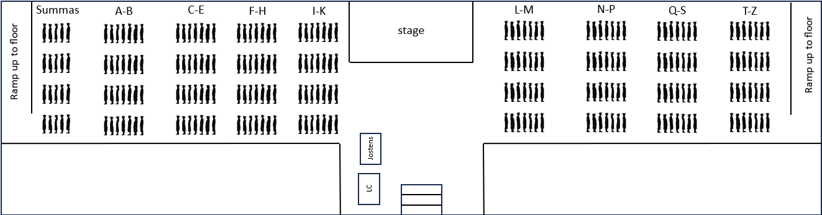
K-M
I-J

Processional

- In the staging area, listen to directions from LC staff to get into position. You will be standing before the ceremony - there is nowhere to sit. Half of the class will enter on the left and the other half on the right. Keep track of the name card that your section leader will give you, this is what you hand the counselor.
- When “Pomp and Circumstance” begins to play, you will be directed to begin marching into the ceremony.
- You will enter from your side in a nice single file line (walk at a nice even pace with the music) and your side will meet up with the other half of the class in the middle of the floor. From there, you will walk side by side up the middle aisle until you reach your seats. You will then break off into your assigned row.
- REMAIN STANDING until told to sit by the speaker.

Ceremony Events

- Remaining standing until the speaker requests the class to sit down.
- Mr. Corley will begin the ceremony.
- Standing, Sitting & Receiving Diploma Covers
  - The 1st row left side (Summas are first) will be signaled by Mr. Bruce & Mr. Bouge to stand and line up to move towards the stage. Follow Mr. Bruce and Mr. Bouge’s directions to the stage and up the ramp!
  - Give your name card to the counselor and begin walking to center stage to receive your diploma cover.
  - Take your diploma cover from the school board member with your LEFT hand and shake with your RIGHT hand (under the diploma). Shake hands with the others on the stage. Exit on the opposite side of the stage.
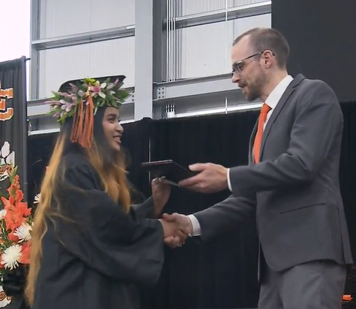
Shake underneath w/your RIGHT hand
Take diploma w/your LEFT hand
  - Stop and get your photo taken after you leave the stage (even if you aren’t purchasing pictures).
  - Follow directions from the staff to return to your seats. You will walk around the right side of students and back to the middle aisle row to your seat.
  - NEXT ROW: Mr. Bruce & Mr. Bouge will signal the graduate on the outside of the next row. The entire row stands and proceeds to the diploma cover line like the previous line(s).

Moving the Tassels, Recessional and Getting Your Real Diploma

- After everyone receives their diploma cover, Mr. Corley will motion for the graduates to stand. The whole class will then stand and the Summa speakers will direct you to change your tassel from the right side to the left all at the same time.
- The music begins for the recessional (walking out) - The LC Fight Song!
- 1st rows left and right exit to outer aisle (follow the directions of the staff!). You will be exiting out of the front right of the Podium behind the curtains to the side of the stage. Staff will direct the subsequent rows on when to exit.
- Get in line based on last name to pick up your diploma before you leave the Podium. If you have any unpaid fees, your diploma will be held at LC until that is taken care of. Meet your families outside the Podium. CONGRATULATIONS!

Entering the Ceremony – STAY STANDING!
Left side seats
(Summas, A-J)
Right side seats
(K-Z)
Mr.
Johnson
Mrs. Glines
Mr. Bouge
Mr. Bruce
Audience
(floor and bleacher seating)
Backstage organizing area

Line up by 2 Summa speakers, then Summas by alpha, then last name A-J
Line up by
last name K-Z
Follow the directions of the staff and you’ll do great!
Audience
(floor and bleacher seating)

STAGE
RAMP UP
RAMP DOWN
Mrs.
Meyer
Mr. High-Edward
Dorian Photo
Diploma Table
Band & Orchestra

Mrs.
Donahue
Mr.
Corley

School
Board
Dr.
Swinyard
Ms. Lane
Mr.
Ochse

Receiving Your Diploma
Left side seats
(Summas, A-J)
Right side seats
(K-Z)
Mr.
Johnson
Mrs. Glines
Mr. Bouge
Mr. Bruce

STAGE
RAMP UP
RAMP DOWN
Mrs.
Meyer
Mr. High-Edward
Dorian Photo
Diploma Table
Mrs.
Donahue
Mr.
Corley

School
Board
Dr.
Swinyard
Ms. Lane
Mr.
Ochse

X
X
X
X
X
X

Exiting the Ceremony – WAIT FOR DIRECTION
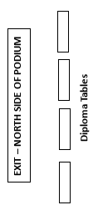
curtain
Left side seats.
(Summas, A-J)
Right side seats
(K-Z)
Mr.
Johnson
Mrs. Glines
Mr.
Bouge
Mr.
Bruce

STAGE
RAMP UP
Mrs.
Meyer
Diploma Table
Mrs.
Donahue
Mr.
Corley

School
Board
Dr.
Swinyard
Ms.
Lane
Mr.
Ochse

