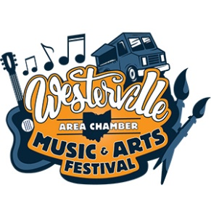
2022 Westerville Music & Arts Festival Guide
This 16-page glossy event booklet is the place for information about the festival including a schedule of entertainment, artists, food vendors, a map, and more.

Distribution: The Festival Guide will be delivered to over 26,394 households throughout the Westerville ThisWeek/News & Public Opinion on July 7. An additional 5,500 copies will be distributed at the festival.
Advertiser’s logos will appear in ¼ page promotional ads that run through Gahanna, New Albany, and Delaware on June 30 and July 7.
Important Dates
Publishes: July 7
Space Reservation: June 3
All ads final by: June 10
Ad size | Dimensions | Rate
Back Cover | 4.87” x 7.87” | $1500
Inside Front Cover | 4.87” x 7.87” | $1000
Inside Back Cover | 4.87” x 7.87” | $850
Full Page | 4.87” x 7.87” | $750
½ Page | 4.87” x 3.84” | $500
¼ Page | 2.43” x 3.84” | $250

Contact Stacey Rusterholz to reserve your space today! 614-882-8917 or srusterholz@westervillechamber.com

