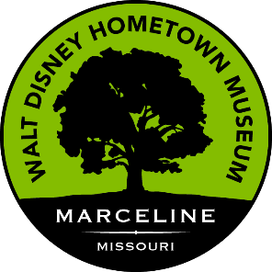

55+ Take Two!

Join the next 55+ TAKE TWO Day Trip to Chariton County Missouri. We will enjoy two favorites from this area. First, we will visit the Walt Disney Hometown Museum, the Disney Family Farm and Main Street USA, all in Marceline. Then we’ll travel to the 1820 Family Restaurant in Keytesville.

Friday, August 16, 2024, meeting at the church at 12:30 p.m. and returning around 8:30 p.m. This trip is for all walking abilities. On Main Street USA you can walk as much or as little as desired.

The 1820 Family restaurant requires us to let them know what we want as an entre to go along with the family style sides and dessert. Please go to [www.1820thefr.com](http://www.1820thefr.com) and click on “see the menu” tab to decide the entre you want. When you call the church office to reserve your place you will need to let us know your choice. The cost of the trip is $20 (museum/transportation/gratuity) + entre price ($48.50 or $28.50). Payment to church office holds your place on the bus. The first 12 to pay get to enjoy this fun, social event. Reservations close Sunday, August 11.