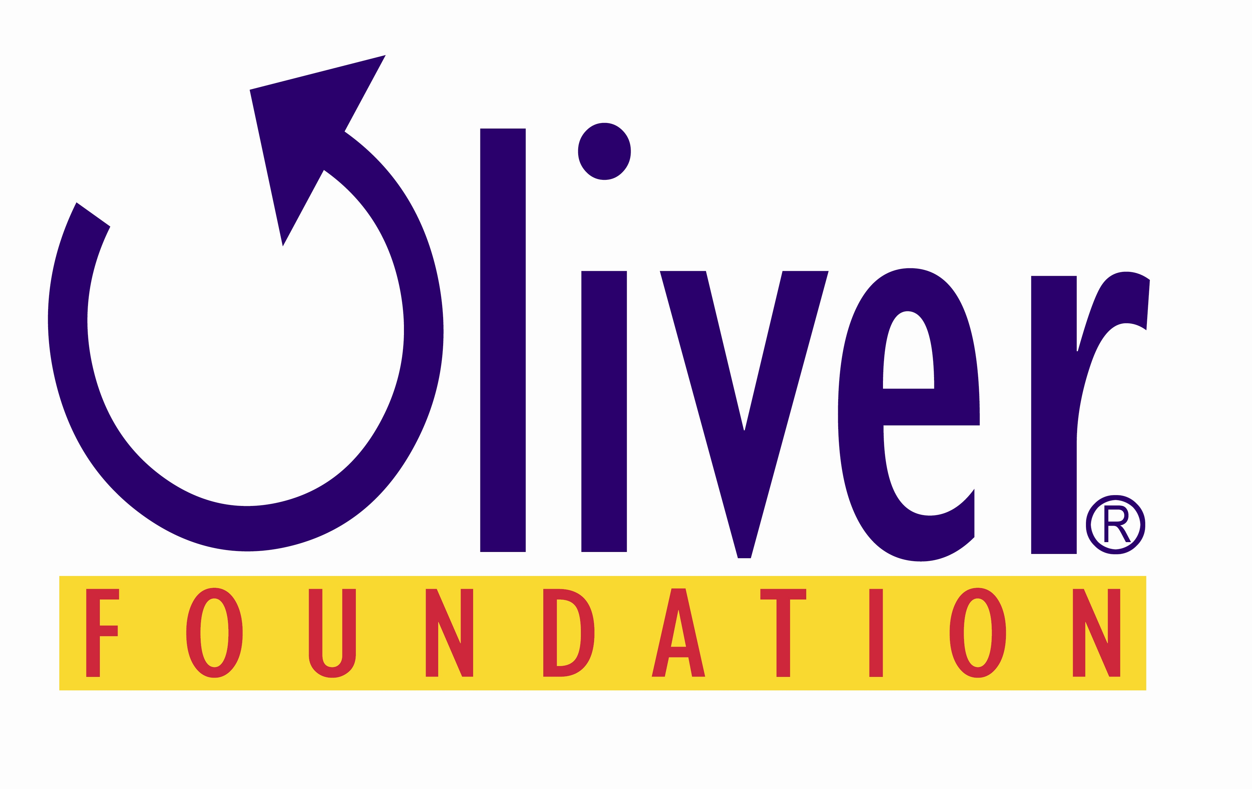
Are You Ready to Rodeo?
2021 Houston Livestock Show & Rodeo
*March 2 – March 21, 2021
* All dates are tentative and are subject to change
Contest Instructions

Its Rodeo time again in Houston, so get out your hats and put on your boots! Send us those healthy activities and win a chance to go the Houston Livestock Show & Rodeo. We want to
Know what types of Healthy Activities are occurring on your campus.

All entries will be judged on creativity, excitement and success of the activity. The winning entries will receive four (4) tickets to a Rodeo performance, plus a parking pass. Great seats - Club level, 45 yd. line and parking right across the street!

INSTRUCTIONS FOR THE RODEO CONTEST FORM:

CAMPUS: Include your home campus where the activity took place.

SUBMITTED BY: Your name and grade level. If more than one class participated in the activity, include all names. Only 4 tickets will be awarded per entry.

DATE SUBMITTED: The date you turn in your entry form.

DESCRIBE IN DETAIL: Tell us about your healthy activity. Include where you found your idea. Was it from a resource the Oliver Foundation provided or found online? Remember to include the website address if applicable. Is there a policy change on your campus reinforcing healthy choices and physical activity? List your source of inspiration. Include the date/dates it occurred. Give as much detail as possible.

IS THE ACTIVITY REPRODUCIBLE? Can another teacher or campus use it? If yes, be sure to give enough detail in your description so we can provide this to other campuses.

HAVE YOU INCLUDED 2-3 OF THE 7 HEALTHY MESSAGES?

DO YOU HAVE FOLLOW-UP ACTIVITES PLANNED TO REINFORCE THE ACTIVITY? If you had an assembly about eating 5 servings of fruits and vegetables every day, how are you then taking that message back to your classroom? Include these activities in your detailed description above.

LESSON PLAN INCLUDED? A copy of your lesson plan or the lesson plan found in the resource should be included.

PICTURES or VIDEO INCLUDED? Pictures can be digital or prints. This is required to verify the activity has taken place.

PERFORMANCE DATE REQUEST: A list of available performances will be provided to the selected entries by February 15, 2021. Please list 1st, 2nd and 3rd choices for date/performer.

ALL ENTRIES MUST BE RECEIVED BY FEBRUARY 10, 2021 AT 4:00PM.

Submit via E-mail to sjbristow@oliverfoundation.org

16th Annual Rodeo Contest
2021 Houston Livestock Show & Rodeo
March 2 – March 21, 2021
All dates are tentative and are subject to change

CAMPUS:

DATE SUBMITTED:

Program/Activity Title: Healthy Holidays Make You Bright

DESCRIBE IN DETAIL THE ACTIVITY. INCLUDE DATE/DATES, SOURCE OF EVENT.

Is this activity reproducible? Can another teacher or campus use activity?

Yes____ No____

Was this a one-time activity to create excitement?

Yes___ No___

Do you have follow-up activities planned to reinforce the activity? If so, explain.

Yes___ No___

Lesson Plan included?

Yes___ __

Pictures and /or video included? (Required)

Oliver Foundation
5535 Memorial Dr. Suite F, #256
Houston Texas 77007
www.oliverfoundation.org
713-202-2973

