Rabbi Benjamin Chaidell 11-23-25
Hot Topics: The Bamber Family of Russell Street
- Asher Bamber (from Marie Daly, Waltham Historical Society)
Asher Bamber was born in Konin, Poland on 22 March 1834, and was the son of Eleazer Bamber and Natalie (or Hannah) Steinert. He died in Brookline, Massachusetts on 20 April 1907. He was buried in Temple Ohabei Shalom Cemetery in East Boston. He arrived in New York City on 20 September 1850. He had a brother, Isaac Bamber, who died in 1904 in the West End, Boston. Asher married Rosetta Stein, probably in Boston ca 1860. She was born on 4 June 1841 in Germany, and she died in Brookline on 10 June 1924.

Golde Bamber was the oldest child of Asher Bamber and Rosetta Stein, and was likely born in Boston on 5 January 1862. The next child, Celia Bamber, was born on 23 June 1863 in Boston. A son, Moses Bamber, was born in Waltham on 29 December 1866. By 1865, the Bamber family was living in Waltham, and by 1871, the family lived on Water Street, near Charles Street, with Asher’s brother, Isaac, and Edward Bamber. By 1875, Asher Bamber was living on Russell Street, at what is now the parking lot of Hannaford’s Market. By 1884, the Bamber family moved to Boston.

What motivated young Jews like Asher Bamber and Rosetta Stein to move to Boston?

What do you think brought the Bambers to Waltham?
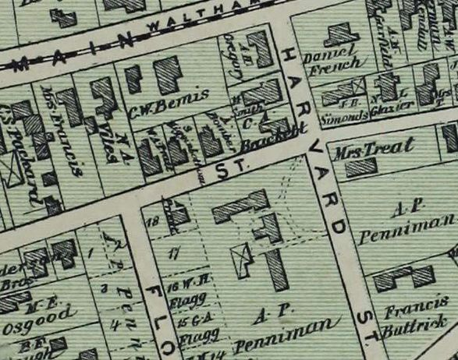
1875 map, showing Russell Street, house of Asher Bamber. Future location of Temple Beth Israel across Russell Street on A. P. Penniman estate

Asher Bamber Passport Application

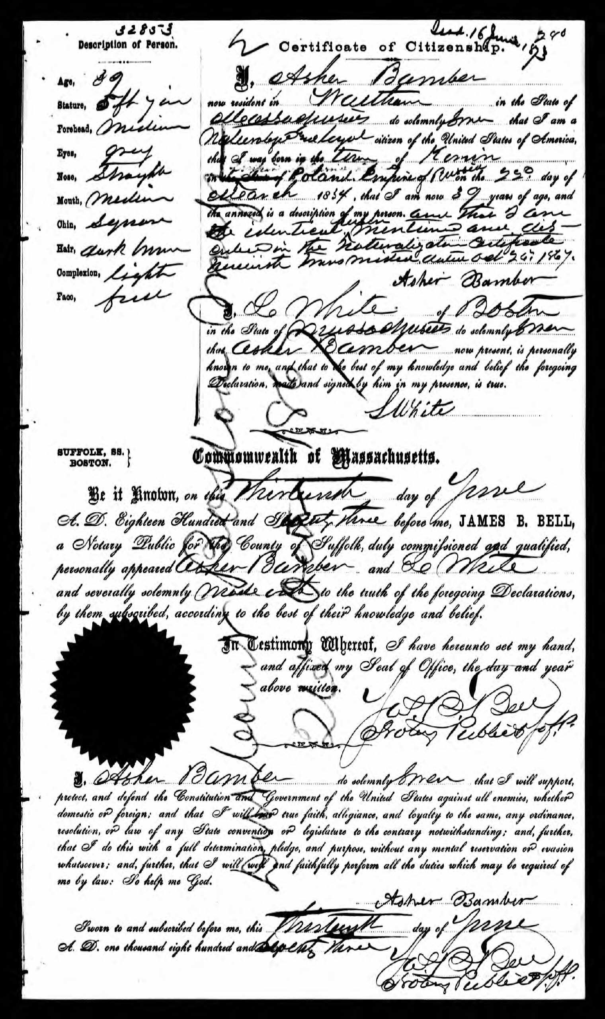

- 707-709 Main Street (from Waltham Historical Society Report)
Timeline:
1860 Census, Asher Bamber & John Munster both listed in North End of Boston (different addresses)
1865 Census, Asher Bamber & John Munster listed in Waltham (different addresses)
1873 Passenger list, Asher Bamber & John Munster travel from Boston to Liverpool on steamer, Olympus [Boston Globe, 8 July 1873]
1874 Deed, June, Otis E. Hunt M.D. of Newton to Asher Bamber & John Munster [MLR 1312/52]
1874 Mortgage, Asher Bamber & John Munster to Otis E. Hunt [MLR 1312/53]
1874 Lease, July, Asher Bamber & John Munster to Thomas Kelley & Patrick Coann [MLR 1315/53] includes erection of carriage house and livery stable
1877 Waltham directory, 1) Asher Bamber, merchant tailor and ready made clothing, Prospect Block, Main, house Russell St., near Harvard; 2) Boston Branch Grocery, F. J. Perkins, manager, Prospect Block, Main; 3) Meinard Rottler, restaurant, Prospect Block, h. 15 Central; 4) Coen & Kelley (Patrick Coen & Thomas Kelley), livery stable, rear Prospect Block, Main;
1883 Death, John Munster
1886 Boston directory, Asher Bamber, clerk, h. 47 E. Newton
1889 Bankruptcy, Asher Bamber
1902 Foreclosure deed & Affidavit of sale, Otis E. Hunt to Melvin M. Johnson [MLR 2960/81-83]
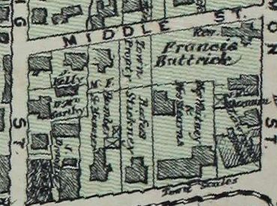
1875 map showing owners, Bamber & Munster

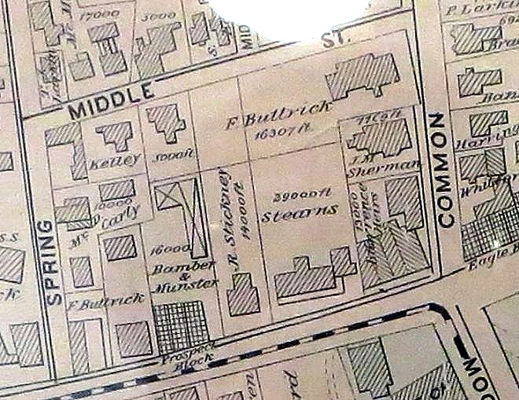
1886 map, Prospect Block
- Golde Bamber (1862-1951)
Article in Jewish Women’s Archive Shalvi/Hyman Encyclopedia of Jewish Women

Golde Bamber was born in 1862 to an elite German Jewish family in Boston. As an influx of Eastern European immigrants exploded Boston’s Jewish population in the 1880s, Bamber was compelled to join Jewish leadership in the city dedicated to serving this new immigrant community. On Bamber’s recommendation, the Hebrew Industrial School for Girls was opened in 1890, and Bamber served as its director for four decades. She supported vocational training, and she believed that Jewish and American traditions were compatible. The school was highly successful – it served as a pioneering model for the entire settlement house movement in the Northeast. In 1922, the school became the Hecht Neighborhood House. Bamber continued serving as its director, introducing one of the nation’s first nursery schools there in 1925.

Article
Described as a stiff Victorian woman from an old Boston Jewish family, Golde Bamber applied her education and cultured upbringing to become one of Boston’s pioneer social reformers and educators among the city’s Eastern European immigrants.

Born in Boston in 1862, Bamber was raised among the city’s small, elite German Jewish community. In 1879, she graduated from the Boston University’s School of Oratory and began teaching elocution lessons privately and at the Young Men’s Hebrew Association. But the great tide of Eastern European immigrants that exploded Boston’s Jewish population from approximately five thousand in 1880 to forty thousand by 1900 drew Bamber’s attention, and she joined the female Jewish leadership in Boston dedicated to relieving the immigrants’ poverty and preparing them for life as fully integrated American citizens.

Invited by Lina Hecht in 1889 to evaluate Hecht’s new Jewish Sunday school, Bamber instead recommended a program that would teach immigrant girls skills in sewing and cooking, as well as provide a basic American and Jewish education. In January 1890, the Hebrew Industrial School for Girls (HIS) opened with twenty pupils on Hanover Street in Boston’s North End. Funded by Lina and Jacob Hecht, Bamber served as the school’s superintendent and director for four decades. In 1892, its partner Hebrew Industrial School for Boys opened on Chambers Street in Boston’s West End. In their first five years alone, Bamber’s schools trained more than twelve hundred children to be “wage earners, breadwinners, and self-respecting citizens,” overcoming initial opposition within the Jewish community to vocational training and manual labor.

Educational clubs, vocational classes, even a “Soap and Water” club, taught good citizenship, self-sufficiency, American manners and morals, and the foundations of Jewish knowledge and culture. The school’s motto, “A good Israelite will make a better citizen,” summarized Bamber’s conviction that Jewish and American traditions were compatible and productive, and not antithetical as Boston’s virulent anti-immigration movement argued. Much of Boston’s non-Jewish leadership agreed.

The HIS’s successes garnered financial and political support from Boston’s leading Brahmin philanthropists and institutions, including Unitarian Reverend Edward Everett Hale who asserted that “the much-dreaded Russian Jew … because he has been welcomed with wisdom and kindness, proves to be ... a model emigrant.” Bamber’s HIS, along with Boston’s North Bennett Street Industrial School, served as a pioneering model for the entire settlement house movement in the Northeast. Bamber’s own achievements were recognized by Massachusetts Governor Curtis Guild, who appointed her a trustee for the Lyman School for Boys.

Bamber kept her own education current with her innovations. During the 1890s and early 1900s, she studied vocational guidance and social work with Frederick Allen at Harvard College and Simmons College of Social Work. By the end of World War I, the settlement house approach of the HIS had run its course, and Bamber changed her school with the times. In 1922, the school’s name changed to the Hecht Neighborhood House, and with funds from the bequest of Lina Hecht, purchased a Charles Bullfinch-designed house on Bowdoin Street in the West End. Bamber served as director until her retirement in 1930, introducing one of the nation’s first nursery schools there in 1925 and transforming the institution from a vocational and educational institution for Jewish children and women to a full-service, nonsectarian community center for the West End’s broadly mixed ethnic population.

Golde Bamber was a leader in the emergence of a young, educated, professional class of Jewish women—both from established and immigrant families—who worked cooperatively to create Boston’s new charitable and educational infrastructure for the early twentieth century. Bamber envisioned, institutionalized, and directed new educational structures for the new social landscape. Her pioneering work influenced settlement house, vocational, Jewish, and nursery school education well beyond Boston and well beyond her lifetime.

Bibliography
Bamber, Golde. “Russians in Boston.” Lend a Hand 8 (1892): 168–172
Combined Jewish Philanthropies of Greater Boston. Papers. American Jewish Historical Society, Waltham, MA/New York, NY
Hecht Neighborhood House. Papers. American Jewish Historical Society, Waltham, MA/New York, NY
Solomon, Barbara Miller. Pioneers in Service: The History of the Associated Jewish Philanthropies of Boston. Boston: Associated Jewish Philanthropies, 1956

What characterized Golde Bamber’s approach to integrating immigrants? Do you agree?
Where do you see the legacy of her work today?

- American Jewish Year Book, 5664-5665 (1904-1905)
Bamber, Golde. Superintendent Hebrew Industrial School of Boston.

Born January 5, 1869, Boston, Mass. Daughter of Asher Bamber and Rosetta Stein. Educated in Waltham public and Boston private schools; and Boston University School of Oratory. Director Hebrew Women's Sewing Society; member Advisory Board, Boston Trade School for Girls, and Organization Committee, North and West End Social Union. Was special teacher of physical culture and oratory to grammar and high school teachers, and to pupils of graduating classes, Waltham public schools. Founder of Ways and Means Club, and of Young Women's Union for Philanthropic Endeavor. Delegate to World's Fair Congress of Religions at Chicago. Went to Europe in 1894 to study educational and industrial phases of life. Has written magazine articles and educational papers. Address: 68 Waumbeck, Boston, Mass.

The Jews of Boston, p. 226

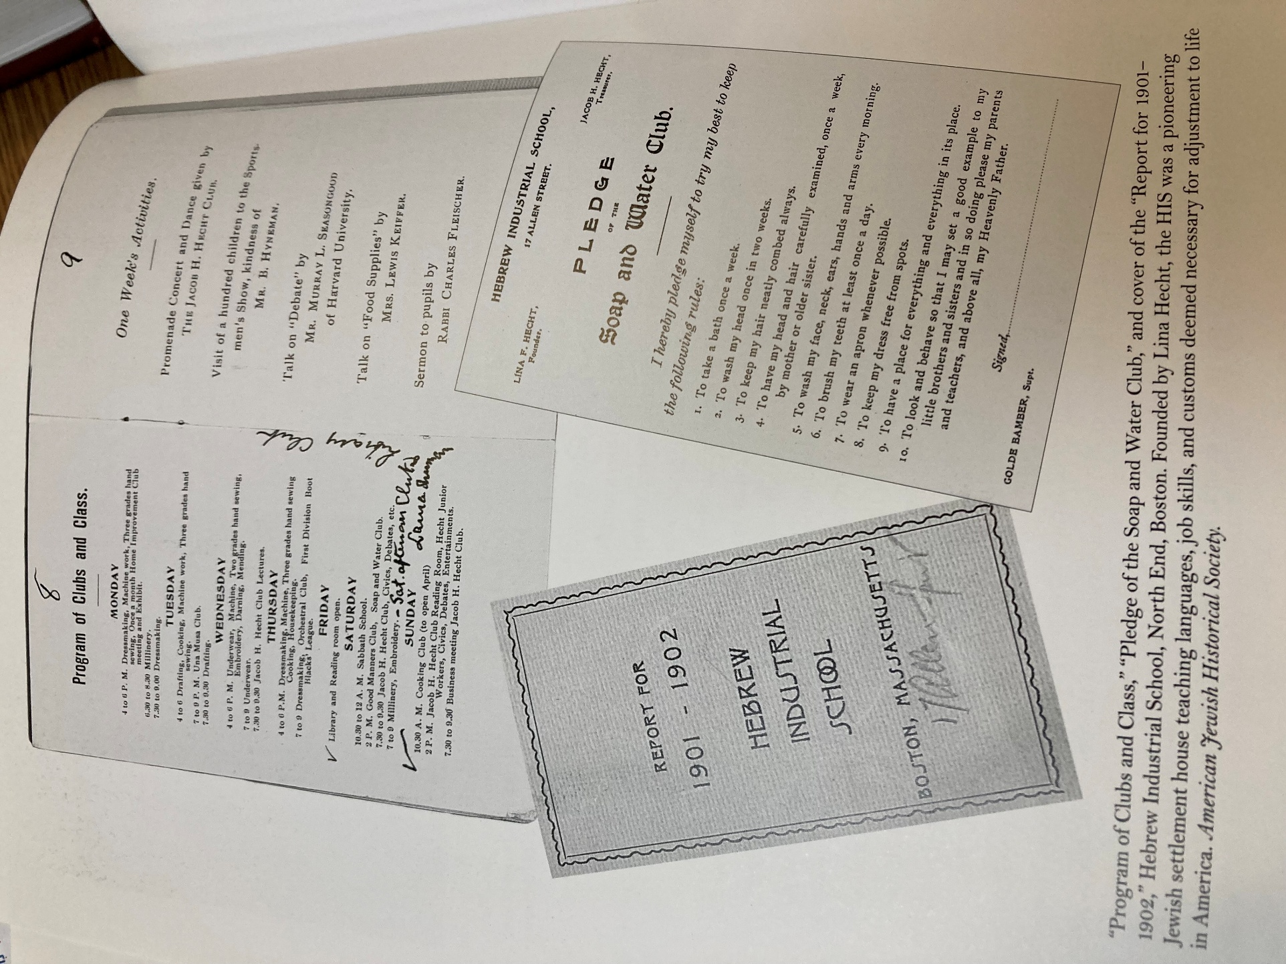

https://jwa.org/encyclopedia/article/bamber-golde
https://www.bjpa.org/content/upload/bjpa/7com/7communal.pdf

